 NASA PROCEDURAL REQUIREMENTS

NPR: 7123.1

Effective Date: March 13, 2006

Expiration Date: March 13, 2011

NASA Systems Engineering Processes and Requirements

Responsible Office: Office of the Chief Engineer

NASA Procedural Requirements

NPR 7123.1

Effective Date:

Expiration Date:

NASA Systems Engineering Processes and Requirements

Responsible Office: Office of the Chief Engineer

Table of Contents

Cover
Preface
P.1 Purpose
P.2 Applicability and Scope
P.3 Authority
P.4 References
Prologue
Chapter 1. Introduction
1.1 Background
1.2 Framework for Systems Engineering Procedural Requirements
1.3 Systems Engineering Management Plan
1.4 Document Organization
Chapter 2. Institutional and Programmatic Requirements
2.1 Roles and Responsibilities
2.2 Implementation Architecture
2.3 Designated Governing Authority
Chapter 3. Requirements for Common Technical Processes
3.1 Introduction
3.2 Process Requirements
Chapter 4. NASA Oversight Activities on Contracted Projects
4.1 Introduction
4.2 Activities Prior to Contract Award
4.3 During Contract Performance
4.4 Contract Completion
Chapter 5. Systems Engineering Technical Reviews
5.1 Life Cycle
5.2 Technical Review Requirements
5.3 Minimum Set of Technical Reviews
Chapter 6. Systems Engineering Management Plan
6.1 Systems Engineering Management Plan Function
6.2 Roles and Responsibilities
Appendix A. Definitions
Appendix B. Acronyms
Appendix C. Practices for Common Technical Processes
C.1 System Design Processes
C.2 Product Realization Processes
C.3 Technical Management Processes
Appendix D. Systems Engineering Management Plan
D.1 Purpose and Use
D.2 Terms Used
D.3 SEMP Preparation
D.4 SEMP Annotated Outline
Appendix E. Hierarchy of Related NASA Documents
Appendix F. Tailoring
Appendix G. Technical Review Entrance and Success Criteria
G.1 Mission Concept Review (MCR)
G.2 System Requirements Review (SRR) and/or Mission Definition Review (MDR)
G.3 System Definition Review (SDR)
G.4 Preliminary Design Review (PDR)
G.5 Critical Design Review (CDR)
G.6 Test Readiness Review (TRR)
G.7 Systems Acceptance Review (SAR)
G.8 Flight Readiness Review (FRR)
G.9 Operational Readiness Review (ORR)
G.10 Periodic Technical Review (PTR)
G.11 Decommissioning Review (DR)
G.12 Technical Peer Reviews
Appendix H. Templates
H-1 Sample SE NPR Implementation Plan Template
H-2 SE NPR Center Survey
Appendix I. Additional Reading
Appendix J. Index

Table of Figures

Figure 1-1 – SE Framework
Figure 2-1 – Implementation Architecture
Figure 3-1 – SE Engine
Figure 3-2 – Application of SE Engine Processes within System Structure
Figure 5-1 – Product Line Life Cycle
Figure A-1 – Product-Based WBS Model Example
Figure C-1 – Stakeholder Expectation Definition Process
Figure C-2 – Technical Requirements Definition Process
Figure C-3 – Logical Decomposition Process
Figure C-4 – Design Solution Definition Process
Figure C-5a –Sequencing of Design Realization Processes
Figure C-5b – Product Implementation Process
Figure C-6 – Product Integration Process
Figure C-7 – Product Verification Process
Figure C-8 – Product Validation Process
Figure C-9 – Product Transition Process
Figure C-10 – Technical Planning Process
Figure C-11 – Requirements Management Process
Figure C-12 – Interface Management Process
Figure C-13 – Technical Risk Management Process
Figure C-14 – Configuration Management Process
Figure C-15 – Technical Data Management Process
Figure C-16 – Technical Assessment Process
Figure C-17 – Decision Analysis Process
Table of Tables

Table G-1 – MCR Entrance and Success Criteria
Table G-2 – SRR and/or MDR Entrance and Success Criteria
Table G-3 – SDR Entrance and Success Criteria
Table G-4 – PDR Entrance and Success Criteria
Table G-5 – CDR Entrance and Success Criteria
Table G-6 – TRR Entrance and Success Criteria
Table G-7 – SAR Entrance and Success Criteria
Table G-8 – FRR Entrance and Success Criteria
Table G-9 – ORR Entrance and Success Criteria
Table G-10 – DR Entrance and Success Criteria

Preface
P.1 Purpose
The purpose of this document is to clearly articulate and establish the requirements on the implementing organization for performing, supporting, and evaluating systems engineering. Systems engineering is a logical systems approach performed by multidisciplinary teams to engineer and integrate NASA’s systems to ensure NASA products meet customers’ needs. Implementation of this systems approach will enhance NASA’s core engineering, management, and scientific capabilities and processes to ensure safety and mission success, increase performance, and reduce cost. This systems approach is applied to all elements of a system and all hierarchical levels of a system over the complete project life cycle.

P.2 Applicability and Scope
- This NASA Procedural Requirement (NPR) applies to NASA Headquarters and NASA Centers, including component facilities and technical and service support centers. It also applies to the Jet Propulsion Laboratory to the extent specified in its contracts with NASA. This NPR applies to NASA employees and their service contractors that use NASA processes to augment and support NASA technical work. NASA NPRs and this Systems Engineering NPR (SE NPR) do not apply to NASA contracts except as the NASA technical team flows down the systems engineering responsibilities to all members of the system team including contractors and subcontractors. (See Chapter 4.)
- The scope of this document encompasses the common technical processes for large and small projects and activities in flight systems and ground support (FS&GS) projects, advanced technology development (ATD) projects with deliverables to FS&GS projects, information systems and technology projects, and institutional projects (IP). Application of this NPR to Construction of Facilities (CoF) and Environmental Compliance and Restoration (ECR) projects (or portions thereof) should be scaled in accordance with the level of systems engineering for the function of the structure and documented in the systems engineering management plan (SEMP) (as required). In this sense, the design of facilities (or parts of facilities) for processing FS&GS would require appropriate application of systems engineering effort, ensuring that interfaces with and functional requirements of the FS&GS systems engineering are addressed. The design of administrative facilities or soil remediation projects may not require the application of specific systems engineering efforts. Engineering requirements for CoF and ECR projects are specified in NPR 8820.2 and NPR 8590.1, respectively. Applying the common technical processes and reviews may also benefit basic and applied research (BAR) and other ATD projects. They are recommended but not required for those BAR and ATD projects.
- In this document, the word “project” generally refers to a unit of work performed in programs, projects, and activities. Management of a work unit is referred to as “project management,” which includes managing programs, projects, and activities. A project is (1) A specific investment having defined goals, objectives, requirements, life-cycle cost, a beginning, and an end. A project yields new or revised products or services that directly address NASA’s strategic needs. They may be performed wholly in-house; by Government, industry, academia partnerships; or through contracts with private industry. (2) A unit of work performed in programs, projects, and activities.
- The requirements enumerated in this document are applicable to all new programs and projects as well as all programs and projects currently in Formulation Phase as of the effective date of this document. (See NPR 7120.5 for definitions of program phases.) This NPR also applies to programs and projects in their Implementation phase as of the effective date of this document. However, they may request permission from the designated governing authority to be allowed to continue without complying with all or sections of this NPR.
- Many other discipline areas such as safety, reliability, maintainability, quality assurance, information technology, security, logistics, environmental, etc. perform functions during project life-cycle phases that influence or are influenced by the engineering functions performed and need to be fully integrated with the engineering functions. The description of these disciplines and their relationship to the overall management life cycle are defined in other NASA directives, for example, the safety, reliability, maintainability, and quality assurance discipline pertinent requirement activities are defined in the 8700 series of directives.
P.3 Authority
- 42 U.S.C. 2473(c)(1), Section 203(c)(1), National Aeronautics and Space Act of 1958, as amended.
- NPD 1000.0, Strategic Management & Governance Handbook.
- NPD 1000.3, The NASA Organization.
- NPD 7120.4, Program/Project Management.
P.4 References
- NPD 8700, NASA Safety and Mission Assurance (SMA) Policy documents.
- NPR 7120.5, NASA Program and Project Management Processes and Requirements.
- NPD 2820.1, NASA Software Policy.
- NPR 7150.2, NASA Software Engineering Requirements.
- NPR 8000.4, Risk Management Procedural Requirements.
- SP-6105, NASA Systems Engineering Handbook.
- NPD 1080.1 NASA Science Policy.
- NPR 1080.1 NASA Science Management.
- NPR 8820.2 Facility Project Implementation Guide.
- NPD 1440.6, NASA Records Management.
- NPR 1441.1, NASA Records Retention Schedules.

/S/Christopher J. Scolese
Chief Engineer
DISTRIBUTION:
NODIS
Prologue
- NASA missions are becoming increasingly complex, and the challenge of engineering systems to meet the cost, schedule, and performance requirements within acceptable levels of risk requires revitalizing systems engineering. Functional and physical interfaces are expanding in number and complexity. Software and embedded hardware must be integrated with platforms of varying complexity. Pre-planned project development and the extension of system applications drive higher levels of integration. A driver of increasing system complexity is the significant reduction of operations staff to reduce life-cycle cost and incorporation of their workload into the system. In addition, systems are moving toward increased autonomy with stored knowledge, data gathering, intra- and inter-system communications, and decision-making capabilities.
- The engineering of NASA systems requires the application of a systematic, disciplined engineering approach that is quantifiable, recursive, iterative, and repeatable for the development, operation, maintenance, and disposal of systems integrated into a whole throughout the life cycle of a project or program. The emphasis of systems engineering is on safely achieving stakeholder functional, physical, and operational performance requirements in the intended use environments over the system’s planned life within cost and schedule constraints.
- While rising to the greater challenge, NASA must also address concerns over past failures. The need for this SE NPR was driven both by past experience and evolving NASA program requirements. Drawing on the result of reports and findings, the Office of the Chief Engineer (OCE) initiated a revitalization of engineering to provide for future missions. This NPR satisfies the component of the revitalization that calls for Agency-level requirements to establish standard technical practices for systems engineering.
- The vision for systems engineering is to “develop and implement a framework and promote the environment for excellence and the revolutionary advancement of systems engineering capability to anticipate and meet the needs of NASA programs and projects.” A robust approach is required to meet the Agency’s objectives. Achieving the goal requires systems level thinking on the part of all project participants to accomplish the engineering of NASA systems.
- This transformation is necessary to provide consistency across the Agency and advance the practice in NASA. This SE NPR will then be applicable to not just the discipline of systems engineering, but the technical teams that perform the activities to engineer the missions for the Agency.
- This document establishes the common technical processes for implementing NASA products and systems, as directed by NPD 7120.4, Program/Project Management. Additionally, this NPR establishes the common NASA systems engineering technical model and presents tailoring and waiver guidelines. This document complements the administration, management, and review of all programs and projects, as specified in NPR 7120.5, NASA Program and Project Management Processes and Requirements.

Introduction

Background

Systems engineering at NASA requires the application of a systematic, disciplined engineering approach that is quantifiable, recursive, iterative, and repeatable for the development, operation, maintenance, and disposal of systems integrated into a whole throughout the life cycle of a project or program. The emphasis of systems engineering is on safely achieving stakeholder functional, physical, and operational performance requirements in the intended use environments over the system’s planned life within cost and schedule constraints.

This NPR establishes a core set of common Agency-level technical processes and requirements needed to define, develop, realize, and integrate the quality of the system products created and acquired by or for NASA. The processes described in this document build upon and apply best practices and lessons learned from NASA, other governmental agencies, and industry to clearly delineate a successful model to complete comprehensive technical work, reduce program and technical risk, and improve mission success. The set of common processes in this NPR may be supplemented and tailored to achieve specific project requirements. (See Appendix F. Tailoring.)

Under the lean governance of the updated NPD 1000.0, the relationship of the program/project management and the technical team was clarified to reflect new technical authority. The program/project manager (PM) has overall responsibility for their program/project. The technical team works with and for the PM to accomplish the goals of the project. Due to this updated governance, there is a need to clearly define the role of the systems engineering management plan (SEMP) and how it will be developed. The technical team, working under the overall program management plan (PMP), develops and updates the SEMP as necessary. The technical team works with the PM to review the content and obtain concurrence. This allows for thorough discussion and coordination of how the proposed technical activities would impact the programmatic, cost, and schedule aspects of the project. However, in cases of pure technical issues and for approval of requested waivers to technical requirements, the technical team also has an independent route through the technical designated governing authority (DGA) (as described in Section 2.3) to resolve issues with program/project management. Once all issues are resolved, the PM signs the SEMP. It then goes to the DGA for final signature. The DGA signature assures that an independent review has evaluated the technical aspects of the technical plans and allows for approval of technical waivers or tailoring of the requirements of this NPR and other relevant technical standards that pertain to this NPR.

Precedence
The order of precedence in case of conflict between requirements is 42 U.S.C. 2473(c)(1), Section 203(c)(1), National Aeronautics and Space Act of 1958, as amended; NPD 1000.0, Strategic Management & Governance Handbook; NPD 1000.3, The NASA Organization; NPD 7120.4, Program/Project Management; and NPR 7123.1, NASA Systems Engineering Processes and Requirements.

Requirement Verbs
In this NPR, a requirement is identified by “shall,” a good practice by “should,” permission by “may,” or “can,” expected outcome or action by “will,” and descriptive material by “is” or “are” (or another verb form of “to be”).

Figures
Figures within this NPR are not intended to be prescriptive but notional.

Framework for Systems Engineering Procedural Requirements
There are three major groupings of requirements within the Office of the Chief Engineer (OCE), i.e., program management requirements, systems engineering requirements, and independent review. This NPR focuses on the systems engineering requirements. (See Appendix E for the hierarchy of related documents.)

Systems Engineering Framework

The common systems engineering framework consists of three elements that make up NASA systems engineering capability. The relationship of the three elements is illustrated in Figure 1-1. The integrated implementation of the three elements of the SE Framework is intended to improve the overall capability required for the efficient and effective engineering of NASA systems. The SE processes are one element of the larger context to produce quality products and achieve mission success. This NPR addresses the SE processes. The larger SE framework also includes the workforce and tools and methods. OCE initiatives to address these other elements include revision of the NASA handbook on systems engineering and development of tools and an assessment model. Together, these elements comprise the capability of an organization to perform successful SE. Each element is described below.

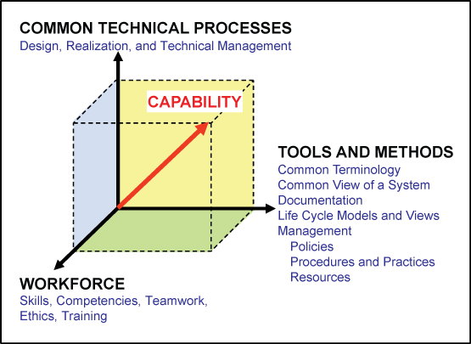
Figure 1-1 – SE Framework

Element 1: Common Technical Processes. The common technical processes of this NPR provide what has to be done to engineer system products within a project and why. These processes are applied to the hardware, software, and human parts of a system as one integrated whole. Within this NPR, the contribution of this element to improvement of SE capability is made not only by the common set of technical processes but also by inclusion of:
- Concepts and terminology that are basic to consistent application and communication of the common technical processes Agency-wide.
- A structure for when the common technical processes are applied.

Element 2: Tools and Methods. Tools and methods enable the efficient and effective completion of the activities and tasks of the common technical processes. An essential contribution of this element to SE capability is the improvement of the engineering infrastructure through the three Agency-wide initiatives listed below.
- Infusion of advanced methods and tools in the SE processes to achieve greater efficiency, collaboration, and communication among distributed teams.
- Preparation of a NASA handbook on SE methodologies intended to provide a source for various methods and procedures that Centers can draw upon to plan implementation of the required processes in their projects. This will be an update of the current NASA Systems Engineering Handbook (SP-6105) that will be aligned with NPR 7120.5 and the SE NPR.
- Creation or adoption of an assessment model to measure the SE capability of projects within NASA and to assess the improvements of capability resulting from implementation of the SE NPR, use of adopted methods and tools, and workforce engineering training.

Element 3: Workforce. A well-trained, knowledgeable, and experienced technical workforce is essential for improving SE capability. The workforce must be able to apply NASA and Center standardized methods and tools for the completion of the required SE processes within the context of the program or project to which they are assigned. In addition, they must be able to effectively communicate requirements and solutions to customers, other engineers, and management to work efficiently and effectively on a team. Issues of recruitment, retention, and training are aspects included in this element. The OCE will facilitate the training of the NASA workforce on the application of this and associated NPRs.

SE Capability. Together, the three elements of Figure 1-1 comprise an Agency-wide capability to perform successful SE in the engineering of NASA system products.

Systems Engineering Management Plan
A Systems Engineering Management Plan (SEMP) is used to establish the technical content of the engineering work early in the Formulation Phase for each project and updated throughout the project life cycle. The SEMP provides the specifics of the technical effort and describes what technical processes will be used, how the processes will be applied using appropriate activities, how the project will be organized to accomplish the activities, and the cost and schedule associated with accomplishing the activities. The process activities are driven by the critical or key events during any phase of a life cycle (including operations) that set the objectives and work product outputs of the processes and how the processes are integrated. (See Chapter 6 for a description of the SEMP and Appendix D for an annotated outline for the SEMP.) The SEMP provides the communication bridge between the project management team and the technical implementation teams and within technical teams. The SEMP provides the framework to realize the appropriate work products that meet the entry and exit criteria of the applicable project life-cycle phases and provides management with necessary information for making decisions.

Document Organization
This document is organized into the following chapters.
- The Preface describes items such as the applicability, scope, authority, and references of this SE NPR.
- The Prologue describes the purpose and vision for this SE NPR.
- Chapter 1 describes the SE framework and introduces the SEMP.
- Chapter 2 describes the institutional and programmatic requirements, including roles and responsibilities.
- Chapter 3 describes the core set of common Agency-level technical processes and requirements for engineering NASA system products throughout the product life cycle. Appendix C contains supplemental amplifying material.
- Chapter 4 describes the activities and requirements to be accomplished by assigned NASA technical teams or individuals (NASA employees and their service support contractors) when performing technical oversight of a prime or external contractor.
- Chapter 5 describes the technical reviews throughout the SE life cycles with clear differentiation between management reviews and engineering reviews.
- Chapter 6 describes the SEMP in general detail, including the SEMP role, functions, and content. Appendix D provides details of a generic SEMP annotated outline.

Institutional and Programmatic Requirements

Roles and Responsibilities

General

The roles and responsibilities of senior management are defined in part in NPD 1000.0, Strategic Management & Governance Handbook. NPR 7120.5, NASA Program and Project Management Processes and Requirements; NPD 7120.4, Program/Project Management Policies; and other NASA directives define the explicit program/project management responsibilities of program and project managers. This NPR establishes systems engineering processes and responsibilities for their implementation.

The OCE under the authority of this SE NPR shall ensure compliance with this SE NPR.

For programs and projects involving more than one Center, the lead organization shall develop documentation to describe the hierarchy and reconciliation of Center plans implementing this NPR. The governing mission directorate determines whether a Center executes a project in a lead role or in a peer role. For Centers in peer roles, compliance should be jointly negotiated.

For systems that contain software, the technical team shall ensure that software developed internally within NASA or acquired complies with NPD 2820.1, NASA Software Policy and NPR 7150.2, NASA Software Engineering Requirements. Note that NPR 7150.2 elaborates on the requirements in this document and determines the applicability of requirements based on the Agency's software classification. Also note that NPR 7150.2 contains additional Agency requirements for the acquisition, development, maintenance, and management of software.

The OCE shall be the clearinghouse for systems engineering policies to ensure compatibility across NASA. In the event of differences between program or project offices and the OCE staff, the conflict will ultimately reach the NASA Chief Engineer or mission director level. If agreement is not achieved at this level, the conflict will be brought to the NASA Administrator for resolution.

In this document, the phrase “the Center Directors shall…” means the roles and responsibilities of the Center Directors may be further delegated within the organization as appropriate to the scope and scale of the system.

Center Directors

Center Directors oversee and manage the infrastructure for the successful execution of technical authority, support, and assurance of all programs and projects.

Center Directors shall perform the following activities or delegate them to the appropriate Center organization:
- Develop the SE NPR Implementation Plan per the template in Appendix H-1 describing how the requirements of this SE NPR will be applied to the programs and projects under their cognizance or authority.
- Establish policies, procedures, and processes to execute the requirements of this SE NPR.
- Assess and take corrective actions to improve the execution of the requirements of this SE NPR.
- Perform the SE NPR Center Survey in accordance with Appendix H-2 for the purpose of providing feedback on the SE NPR. The initial Center Survey will be submitted nine months from the effective date of this SE NPR. Subsequent updates will be upon the request of the OCE, no earlier than nine months after the initial submission. The Center Survey will use the common survey tool in Appendix H-2 and will be submitted through the Center System Engineering Working Group (SEWG) representative.
- Select appropriate standards applicable to projects under their control.

Technical Teams
Each technical team shall execute the Center processes intended to implement this SE NPR under the oversight of the Center Directors in accordance with the SEMP. The makeup and organization of each technical team is the responsibility of each Center or program and includes the personnel required to implement the project.

Implementation Architecture

Implementation Plan

Figure 2-1 illustrates the engineering implementation flow and key documents. NPD 7120.4 establishes the policy for engineering and program and project management for the Agency. From that direction, the OCE developed and published this SE NPR, which is consistent and complementary to NPR 7120.5 and other pertinent Agency direction. The requirements established in this SE NPR will flow down to the implementing organizations and Centers.

The Center Directors shall submit their SE NPR Implementation Plan to the OCE within six months after the effective date of this NPR. The plan will be updated as required. The SE NPR Implementation Plan will be provided to mission directorates for review and comment. This SE NPR Implementation Plan will be approved by the OCE and include the applicable documents employed by the individual Centers. These Center documents may include Center PRs, work instructions, standards, rules, as well as other Center-unique documentation. The SE NPR is a requirements document that specifies what needs to be accomplished at an Agency level. There will also be a body of knowledge developed to assist in the implementation of the NPR. This body of knowledge will include an updated NASA Systems Engineering Handbook (SP-6105) as well as best practices, standards, and templates.

The Center Directors shall develop and document in the SE NPR Implementation Plan how the particular Center will assess compliance to the SE NPR and provide regular updates to the OCE. In addition, the OCE will conduct periodic updates at the Centers to obtain feedback on the effectiveness of the SE NPR to facilitate updating the NPR.
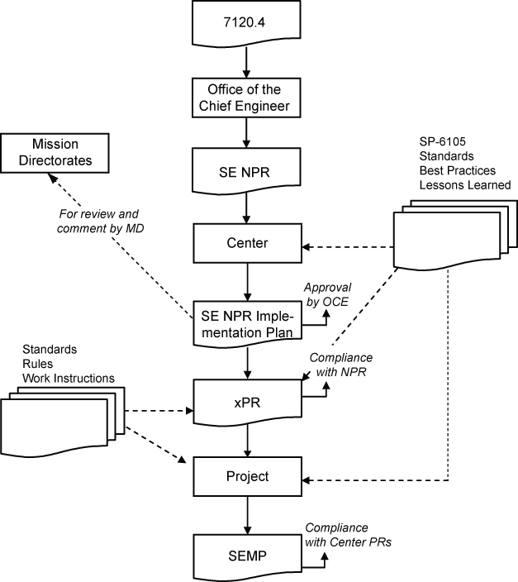
Figure 2-1 – Implementation Architecture

Designated Governing Authority
The designated governing authority (DGA) for the technical effort in this SE NPR is the Center Director or the person or organization that has been designated by them to ensure the appropriate level of technical management oversight. The DGA is assigned primary responsibility for evaluating the technical content of a particular program or project to ensure that it is meeting the commitments specified in the key management documents. Typically, the DGA is the final approval signature on the Systems Engineering Management Plans, waiver authorizations, and other key technical documents. While overall management of the project SEMPs, technical reviews, and similar project-specific SE products and reviews is the responsibility of the program/project manager, who is expected to sign the documents, the DGA has the final approval signature to ensure independent assessment of technical content and waiver authorizations that pertain to this NPR.

Tailoring and Waivers

The appropriate DGA shall have responsibility to approve or disapprove any SE NPR requirement that is either tailored or waived. Approved tailoring or waivering will be documented in the SEMP, as per the directions provided in appendices D and F.

The amount of detail, formality, and rigor required for the implementation of this SE NPR’s requirements is tailorable based on the size and complexity of each project and acceptable risk, subject to approval by the project manager and the DGA.

A waiver is a documented agreement intentionally releasing a program or project from meeting a requirement. Waivers are required to release a program or project from meeting a requirement in the execution of the processes described in this SE NPR.

Requirements for Common Technical Processes

Introduction

This chapter establishes the core set of common technical processes and requirements to be used by NASA projects in engineering system products during applicable product-line life-cycle phases (see Figure 5-1) to meet phase exit criteria and project objectives. The 17 common technical processes are enumerated according to their description in this chapter and their interactions shown in Figure 3-1. This SE common technical processes model illustrates the use of: (1) the system design processes for “top down” design of each product in the system structure, (2) the product realization processes for “bottom up” realization of each product in the system structure, and (3) the technical management processes for planning, assessing, and controlling the implementation of the system design and product realization processes and to guide technical decisionmaking (decision analysis). The SE common technical processes model is referred to as an “SE engine” in this SE NPR to stress that these common technical processes are used to drive the development of the system products and associated work products required by management to satisfy the applicable product-line life-cycle phase exit criteria while meeting stakeholder expectations within cost, schedule, and risk constraints.
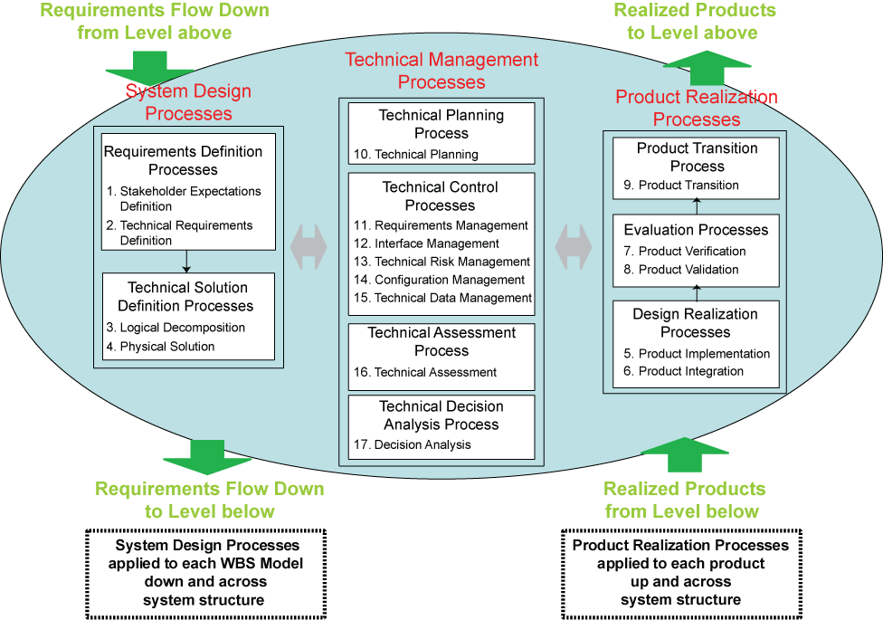
Figure 3-1 – SE Engine

The context in which the common technical processes are used is provided below.

The common technical processes are applied to a product-based Work Breakdown Structure (WBS) model to concurrently develop the products that will satisfy the operational or mission functions of the system (end products) and that will satisfy the life-cycle support functions of the system (enabling products). The enabling products facilitate the activities of system design, product realization, operations and mission support, sustainment, and end-of-product life disposal or recycling by having the needed products and services available when needed. (From IEEE 1220, ANSI/EIA 632, ISO/IEC 15288, or ISO/IEC 19760; see Figure 1-1 tools and methods element.)

The common technical processes are applied to design a system solution definition for each WBS model down and across each level of the system structure and to realize the WBS model end products up and across the system structure. Figure 3-2 illustrates how the three major sets of processes of the SE Engine (system design processes, product realization processes, and technical management processes) are applied to a WBS model within a system structure (a hierarchy of product-based WBS models). (From IEEE 1220, ANSI/EIA 632, ISO/IEC 15288, or ISO/IEC 19760; see Figure 1-1 tool and methods element.)
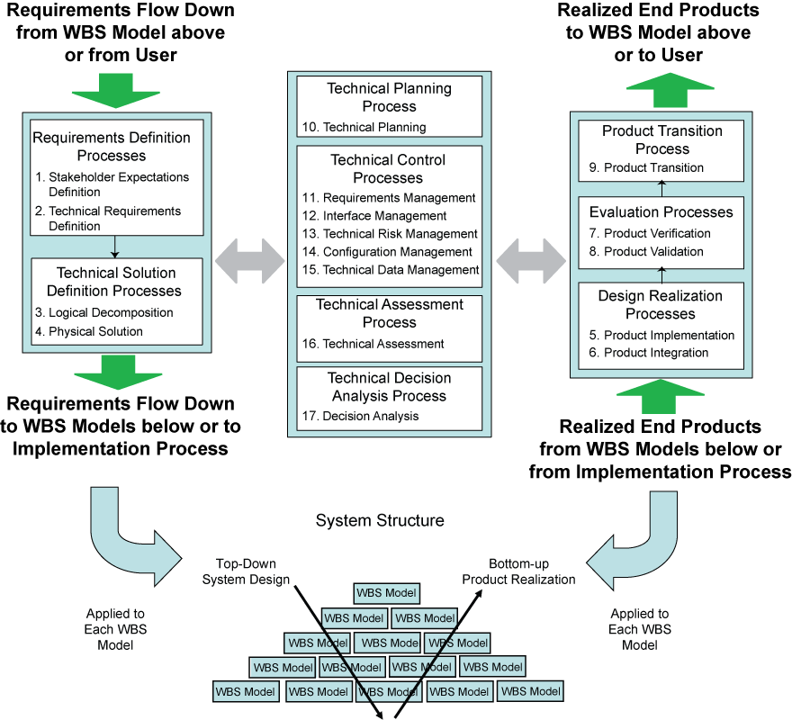
Figure 3-2 – Application of SE Engine Processes within System Structure

The common technical processes are used to define the WBS models of the system structure in each applicable phase of the relevant product-line life cycle (see Figure 5-1) to generate work products and system products needed to satisfy the exit criteria of the applicable phase. System engineering continues well into the operations and maintenance phase of a project, i.e., after the system products are delivered. For example, in the course of operating, maintaining, and disposing of an existing system, all upgrades, enhancements, supporting or enabling developments, and reconfigurations must apply the common SE technical processes. (From ISO/IEC 15288 and ANSI/EIA 632.)

The common technical processes are applied by assigned technical teams and individuals of the NASA workforce trained in the requirements of this SE NPR.

The assigned technical teams and individuals should use the appropriate and available sets of tools and methods to accomplish required common technical process activities. This would include the use of modeling and simulation as applicable to the product-line phase, location of the WBS model in the system structure, and the applicable phase exit criteria.

The assigned technical teams shall define in the project SEMP how the required 17 common technical processes, as implemented by Center documentation, will be applied to the various levels of project WBS model system structure during each applicable life-cycle phase and have their approach approved by the DGA.

Process Requirements

Stakeholder Expectations Definition Process
For the statements below “establish” means developing policy, work instructions, or procedures to implement process activities. “Maintain” includes planning the process, providing resources, assigning responsibilities, training people, managing configurations, identifying and involving stakeholders, and monitoring and controlling the process.

The Center Directors or designees shall establish and maintain a process, to include activities, requirements, guidelines, and documentation, for the definition of stakeholder expectations for the applicable WBS model.

The stakeholder expectations definition process is used to elicit and define use cases, scenarios, operational concepts, and stakeholder expectations for the applicable product-line life-cycle phases and WBS model. This includes requirements for: (a) operational end products and life-cycle-enabling products of the WBS model; (b) expected skills and capabilities of operators or users; (c) expected number of simultaneous users, (d) system and human performance criteria, (e) technical authority, standards, regulations, and laws; (f) factors such as safety, quality, security, context of use by humans, reliability, availability, maintainability, electromagnetic compatibility, interoperability, testability, transportability, supportability, usability, and disposability; and (g) local management constraints on how work will be done (e.g., operating procedures). The baselined stakeholder expectations are used for validation of the WBS model end product during product realization.

Typical practices of this process are defined in Appendix C.1.1.

Technical Requirements Definition Process

The Center Directors or designees shall establish and maintain a process, to include activities, requirements, guidelines, and documentation, for definition of the technical requirements from the set of agreed to stakeholder expectations for the applicable WBS model.

The technical requirements definition process is used to transform the baselined stakeholder expectations into unique, quantitative, and measurable technical requirements expressed as “shall” statements that can be used for defining a design solution definition for the WBS model end product and related enabling products.

Typical practices of this process are defined in Appendix C.1.2.

Logical Decomposition Process

The Center Directors or designees shall establish and maintain a process, to include activities, requirements, guidelines, and documentation, for logical decomposition of the validated technical requirements of the applicable WBS model.

The logical decomposition process is used to improve understanding of the defined technical requirements and the relationships among the requirements (e.g., functional, behavioral, and temporal) and to transform the defined set of technical requirements into a set of logical decomposition models and their associated set of derived technical requirements for input to the design solution definition process.

Typical practices of this process are defined in Appendix C.1.3.

Design Solution Definition Process

The Center Directors or designees shall establish and maintain a process, to include activities, requirements, guidelines and documentation, for designing product solution definitions within the applicable WBS model that satisfy the derived technical requirements.

The design solution definition process is used to translate the outputs of the logical decomposition process into a design solution definition that is in a form consistent with the product-line life-cycle phase and WBS model location in the system structure and that will satisfy phase exit criteria. This includes transforming the defined logical decomposition models and their associated sets of derived technical requirements into alternative solutions, then analyzing each alternative to be able to select a preferred alternative, and fully defining that alternative into a final design solution definition that will satisfy the technical requirements. These design solution definitions will be used for generating end products either by using the product implementation process or product integration process as a function of the position of the WBS model in the system structure and whether there are additional subsystems of the end product that need to be defined. The output definitions from the design solution (end product specifications) will be used for conducting product verification.

Typical practices of this process are defined in Appendix C.1.4.

Product Implementation Process

The Center Directors or designees shall establish and maintain a process, to include activities, requirements, guidelines, and documentation, for implementation of a design solution definition by making, buying, or reusing an end product of the applicable WBS model.

The product implementation process is used to generate a specified product of a WBS model through buying, making, or reusing in a form consistent with the product-line life-cycle phase exit criteria and that satisfies the design solution definition specified requirements (e.g., drawings, specifications).

Typical practices of this process are defined in Appendix C.2.1

Product Integration Process

The Center Directors or designees shall establish and maintain a process to include activities, requirements, guidelines, and documentation for the integration of lower-level products into an end product of the applicable WBS model in accordance with its design solution definition.

The product integration process is used to transform the design solution definition into the desired end product of the WBS model through assembly and integration of lower-level validated end products in a form consistent with the product-line life-cycle phase exit criteria and that satisfies the design solution definition requirements (e.g., drawings, specifications).

Typical practices of this process are defined in Appendix C.2.2.

Product Verification Process

The Center Directors or designees shall establish and maintain a process, to include activities, requirements, guidelines, and documentation, for verification of end products generated by the product implementation process or product integration process against their design solution definitions.

The product verification process is used to demonstrate that an end product generated from product implementation or product integration conforms to its design solution definition requirements as a function of the product-line life-cycle phase and the location of the WBS model end product in the system structure. Special attention is given to demonstrating satisfaction of the measures of performance (MOPs) defined for each measure of effectiveness (MOE) during conduct of the technical requirements definition process.

Typical practices of this process are defined in Appendix C.2.3.

Product Validation Process

The Center Directors or designees shall establish and maintain a process, to include activities, requirements, guidelines, and documentation, for validation of end products generated by the product implementation process or product integration process against their stakeholder expectations.

The product validation process is used to confirm that a verified end product generated by product implementation or product integration fulfills (satisfies) its intended use when placed in its intended environment and ensure that any anomalies discovered during validation are appropriately resolved prior to delivery of the product (if validation is done by the supplier of the product) or prior to integration with other products into a higher-level assembled product (if validation is done by the receiver of the product). The validation is done against the set of baselined stakeholder expectations. Special attention should be given to demonstrating satisfaction of the MOEs identified during conduct of the stakeholder expectations definition process. The type of product validation is a function of the form of the product, product-line life-cycle phase, and in accordance with an applicable customer agreement.

Typical practices of this process are defined in Appendix C.2.4.

Product Transition Process

The Center Directors or designees shall establish and maintain a process, to include activities, requirements, guidelines and documentation, for transitioning end products to the next level up WBS model customer or user.

The product transition process is used to transition a verified and validated end product that has been generated by product implementation or product integration to the customer at the next level in the system structure for integration into an end product or, for the top level end product, transitioned to the intended end user. The form of the product transitioned will be a function of the product-line life-cycle phase exit criteria and the location within the system structure of the WBS model in which the end product exits.

Typical practices of this process are defined in Appendix C.2.5.

Technical Planning Process

The Center Directors or designees shall establish and maintain a process, to include activities, requirements, guidelines, and documentation, for planning the technical effort.

The technical planning process is used to plan for the application and management of each common technical process and to identify, define, and plan the technical effort applicable to the product-line life-cycle phase, for WBS model location within the system structure, and to meet project objectives and product-line life-cycle phase exit criteria. A key document generated by this process is the SEMP. (See Chapter 6.)

Typical practices of this process are defined in Appendix C.3.1.

Requirements Management Process

The Center Directors or designees shall establish and maintain a process, to include activities, requirements, guidelines, and documentation, for management of requirements defined and baselined during the application of the system design processes.

The requirements management process is used to: (a) manage the product requirements identified, baselined, and used in the definition of the WBS model products during system design; (b) provide bidirectional traceability back to the top WBS model requirements; and (c) manage the changes to established requirement baselines over the life cycle of the system products.

Typical practices of this process are defined in Appendix C.3.2.

Interface Management Process

The Center Directors or designees shall establish and maintain a process, to include activities, requirements, guidelines, and documentation, for management of the interfaces defined and generated during the application of the system design processes.

The interface management process is used to (a) establish and use formal interface management to assist in controlling system product development efforts when the efforts are divided between Government programs, contractors, and/or geographically diverse technical teams within the same program or project and (b) maintain interface definition and compliance among the end products and enabling products that compose the system, as well as with other systems with which the end products and enabling products must interoperate.

Typical practices of this process are defined in Appendix C.3.3.

Technical Risk Management Process

The Center Directors or designees shall establish and maintain a process, to include activities, requirements, guidelines, and documentation for management of the technical risk identified during the technical effort. (NPR 8000.4, Risk Management Procedural Requirements, is to be used as a source document for defining this process, and NPR 8705.5, Probabilistic Risk Assessment (PRA) Procedures for NASA Programs and Projects, provides one means of identifying and assessing technical risk.)

The technical risk management process is used to examine on a continuing basis the risks of technical deviations from the project plan and identify potential technical problems before they occur so that risk-handling activities can be planned and invoked as needed across the life of the product or project to mitigate impacts on achieving product-line life-cycle phase exit criteria and meeting technical objectives.

Typical practices of this process are defined in Appendix C.3.4.

Configuration Management Process

The Center Directors or designees shall establish and maintain a process, to include activities, requirements, guidelines, and documentation, for configuration management.

The configuration management process for end products, enabling products, and other work products placed under configuration control is used to (a) identify the configuration of the product or work product at various points in time; (b) systematically control changes to the configuration of the product or work product; (c) maintain the integrity and traceability of the configuration of the product or work product throughout its life; and (d) preserve the records of the product or end product configuration throughout its life cycle, dispositioning them in accordance with NPR 1441.1, NASA Records Retention Schedules.

Typical practices of this process are defined in Appendix C.3.5.

Technical Data Management Process

The Center Directors or designees shall establish and maintain a process, to include activities, requirements, guidelines, and documentation, for management of the technical data generated and used in the technical effort.

The technical data management process is used to (a) provide the basis for identifying and controlling data requirements; (b) responsively and economically acquire, access, and distribute data needed to develop, manage, operate, and support system products over their product-line life; (c) manage and disposition data as records; (d) analyze data use; (e) if any of the technical effort is performed by an external contractor, obtain technical data feedback for managing the contracted technical effort; and (f) assess the collection of appropriate technical data and information.

Typical practices of this process are defined in Appendix C.3.6.

Technical Assessment Process

The Center Directors or designees shall establish and maintain a process, to include activities, requirements, guidelines, and documentation, for making assessments of the progress of planned technical effort and progress toward requirements satisfaction.

The technical assessment process is used to help monitor progress of the technical effort and provide status information for support of the system design, product realization, and technical management processes.

Typical practices of this process are defined in Appendix C.3.7.

Decision Analysis Process

The Center Directors or designees shall establish and maintain a process, to include activities, requirements, guidelines and documentation, for making technical decisions.

The decision analysis process, including data collection (e.g., engineering performance, quality, and reliability data), is used to help evaluate technical decision issues, technical alternatives, and their uncertainties to support decisionmaking. This process is used throughout technical management, system design, and product realization processes to evaluate the impact of decisions on performance, cost, schedule, and technical risk.

Typical practices of this process are defined in Appendix C.3.8.

NASA Oversight Activities on Contracted Projects

Introduction

Oversight/insight of projects where prime or external contractors do the majority of the development effort has always been an important part of NASA programs and projects. With the new focus on Exploration and Space missions such projects will not only increase but it will become more critical that NASA projects provide increased systems engineering on these projects before, during, and after contract performance.

This chapter defines a minimum set of technical activities and requirements for a NASA project technical team to perform on projects where prime or external contractors do the majority of the development effort before contract award, during contract performance, and upon completion of the contract. These activities and requirements are intended to supplement the common technical process activities and requirements of Chapter 3 and thus enhance the outcome of the contracted effort.

Activities Prior to Contract Award

The assigned NASA technical team shall prepare a SEMP that covers the periods before contract award, during contract performance, and upon contract completion in accordance with content contained in the annotated outline in Appendix D.

The assigned technical team shall use common technical processes, as implemented by the Center's documentation, to establish the technical inputs, which include product requirements and Statement of Work tasks, to the Request for Proposal (RFP) appropriate for the product to be developed.

The technical team shall determine the technical work products to be delivered by the offeror or contractor to include a contractor SEMP that specifies their systems engineering approach for requirements development, technical solution definition, design realization, product evaluation, product transition, and technical planning, control, assessment, and decision analysis.

The technical team shall provide to the contracting officer, for inclusion in the RFP, the requirements for technical oversight activities planned in the NASA SEMP. (Care should be taken that no requirements or solicitation information is divulged prior to the release of the solicitation by the cognizant contracting officer.)

The technical team shall participate in the evaluation of offeror proposals following applicable NASA and Center source selection procedures.

During Contract Performance

The assigned technical team, under the authority of the cognizant contracting officer, shall perform the technical oversight activities established in the NASA SEMP.

Contract Completion

The assigned technical team shall participate in scheduled milestone reviews to finalize Government acceptance of the deliverables.

The assigned technical team shall participate in product transition to the customer and/or disposal as defined in the NASA SEMP.

Systems Engineering Technical Reviews

Life Cycle

NASA has four interrelated product lines as defined by 7120.5: Basic and Applied Research (BAR); Advanced Technology Development (ATD); Flight System and Ground Support (FS&GS) projects; and Institutional Projects (IP). As shown in Figure 5-1, each product line has its own unique product-line life cycle. Figure 5-1 shows the product-line life cycles and technical reviews mapped into the management life cycle.

The product-line life cycle for a typical BAR project begins in the “Preparation of Portfolio” phase and eventually ends with a “Monitor Performance Metrics” phase.

The ATD management life cycle for a typical ATD project begins in the “Concept Study” phase and eventually ends with “Technology Readiness Level Maturation” and “Key Performance Parameters (KPP) Enhancements” phases.

The FS&GS project management life cycle starts with “Concept Studies,” progresses into a “Concept Development” phase, and eventually ends after its “Operations and Sustainment” phase with a “Disposal” phase.

The IP management life cycle proceeds through their capital assets life cycle in five well-defined phases. An IP project starts with a “Pre-Formulation and Proposal” phase, progresses into a “Preliminary Design” phase, and eventually ends after “Operations and Maintenance” with a “Disposal” phase. For non-capital asset projects, the last three phases are replaced by an “Execute Project Plan” phase. Typically, these projects enable all of the other NASA investment areas and product lines.

The two major common phases for all of the product lines are Formulation and Implementation. Within each product line, the specific phases are appropriate to their product lines. FS&GS projects have two variations—traditional flight systems development and Announcement of Opportunity (AO) projects.

The life-cycle phases in which the SE engine is applied and the technical reviews of this chapter are closely linked to the management life-cycle phases of NPR 7120.5. The application of the common technical processes within each life-cycle phase produce technical results that provide inputs to technical reviews and support informed management decisions for progressing to the next product-line life-cycle phase.

At each management decision gate, one of the key questions is whether the project is ready to proceed to the next product-line phase (i.e., from Phase B to Phase C). At each decision gate, management examines the maturity of the technical aspects of the project; for example, whether the resources (staffing, funding) are sufficient for the planned technical effort, whether the technical maturity has evolved, what the technical and non-technical internal issues and risks are; or whether the stakeholder expectations have changed. If the technical and management aspects of the project are satisfactory and corrective actions are implementable, then the project can be approved to proceed to the next phase.
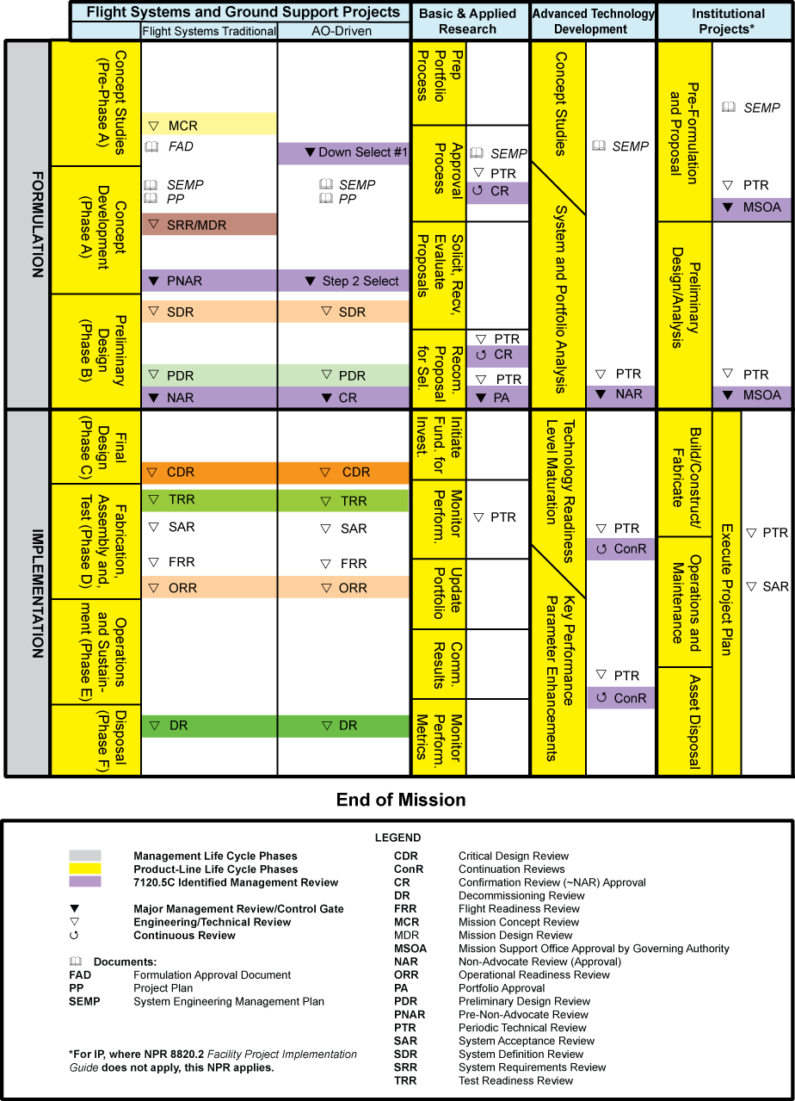
Figure 5-2 – Product Line Life Cycle

Three points are important: (1) Management reviews and the technical reviews support one another. (2) Technical reviews are completed before a management decision gate. (3) Technical reviews should occur relative to the maturity of the relevant technical baseline as opposed to calendar milestones (e.g., the quarterly progress review, the yearly summary, etc.).

Technical Review Requirements

Review Process and Practices

For each product line (BAR, ATD, IP, and FS&GS), technical efforts are monitored throughout the life cycle to ensure that the technical goals of the project are being achieved and that the technical direction of the project is appropriate.

Technical teams shall monitor technical effort through periodic technical reviews. (See Technical Assessment Process Appendix C.3.7.4.d.)

A technical review is an evaluation of the project, or element thereof, by a knowledgeable group for the purposes of:
- Assessing the status of and progress toward accomplishing the planned activities.
- Validating the technical tradeoffs explored and design solutions proposed.
- Identifying technical weaknesses or marginal design and potential problems (risks) and recommending improvements and corrective actions.
- Making judgments on the activities’ readiness for the follow-on events, including additional future evaluation milestones to improve the likelihood of a successful outcome.
- Making assessments and recommendations to the project team, Center, and Agency management.
- Providing a historical record that can be referenced of decisions that were made during these formal reviews.

See NPR 7120.5 for a description of independent reviews, major reviews, project milestone reviews, and engineering peer reviews.

The set of minimum reviews is used to evaluate the status of the technical progress and is supported by other equivalent technical discipline activities to include safety reviews.

The technical team shall ensure that system aspects represented or implemented in software are included in all technical reviews to demonstrate that project technical goals and progress are being achieved and that all NPR 7150.2 software review requirements are implemented.

Planning and Conduct
The technical team shall develop and document plans for technical reviews for use in the project planning process. The technical review schedule will be reflected in the overall project plan described in NPR 7120.5. The results of each technical review will be used to update the technical review plan as part of the SEMP update process. The review plans, data, and results should be maintained and dispositioned as Federal records.

Minimum Set of Technical Reviews

Definition of Minimum Set

Figure 5-1 maps specific reviews and their time sequence for each product line. These reviews are event based, held prior to management reviews when progressing from one life-cycle phase to the next. A description and representative entrance and success criteria for each of these reviews are contained in Appendix G. Additional description of technical reviews is provided in NASA Systems Engineering Handbook (SP-6105).

The monitoring function for traditional FS&GS projects shall be accomplished using the following required minimum set of technical reviews: Mission Concept Review (MCR), System Requirements Review (SRR) and/or Mission Definition Review (MDR), System Definition Review (SDR), Preliminary Design Review (PDR), Critical Design Review (CDR), Test Readiness Review (TRR), System Acceptance Review (SAR), Flight Readiness Review (FRR), Operational Readiness Review (ORR), and Decommissioning Review (DR). Programs would typically hold FRR, ORR, and DRs with support as required from the projects.

The assigned technical team shall accomplish the monitoring function for flight-related ATD projects using appropriately defined and conducted periodic technical reviews (PTR).

The assigned technical team shall accomplish the monitoring function for IPs using PTR and SAR.

SP 6105, NASA Systems Engineering Handbook, provides a complete description of additional common technical progress reviews (interim reviews) with entrance and success criteria, as well as timing, key products, success criteria, etc.

Reviews are considered complete when the following is accomplished:
- Agreement exists for the disposition of all Review Item Discrepancies (RID) and Request for Actions (RFA).
- The review board report and minutes are complete and distributed.
- Agreement exists on a plan to address the issues and concerns in the review board’s report.
- Agreement exists on a plan for addressing the actions identified out of the review.
- Liens against the review results are closed, or an adequate and timely plan exists for their closure.
- Differences of opinion between the project under review and the review board(s) have been resolved, or a timely plan exists to resolve the issues.
- A report is given by the review board chairperson to the appropriate management and governing program management committees (GPMCs) charged with oversight of the project.
- Appropriate procedures and controls are instituted to ensure that all actions from reviews are followed and verified through implementation to closure.

Systems Engineering Management Plan

Systems Engineering Management Plan Function

The primary function of the SEMP is to provide the basis for implementing the technical effort and communicating what will be done, by whom, when, where, cost drivers, and why it is being done. In addition, the SEMP identifies the roles and responsibility interfaces of the technical effort and how those interfaces will be managed.

The SEMP is the vehicle that documents and communicates the technical approach including the application of the common technical processes; resources to be used; and key technical tasks, activities, and events along with their metrics and success criteria. The SEMP communicates the technical effort that will be performed by the assigned technical team to the team itself, managers, customers, and other stakeholders. Whereas the primary focus is on the applicable phase in which the technical effort will be done, the planning extends to a summary of the technical efforts that are planned for future applicable phases.

The SEMP is a “living” and tailorable document that captures a project’s current and evolving systems engineering strategy and its relationship with the overall project management effort throughout the life cycle of the system. The SEMP’s purpose is to guide all technical aspects of the project.

The SEMP is consistent with higher level SEMPs and the project plan in accordance with NPR 7120.5.

The content of a SEMP for an in-house technical effort may differ from an external technical effort. For an external technical effort, the SEMP should include details on developing requirements for source selection, monitoring performance, and transferring and integrating externally produced products to NASA. (See Appendix D for further details.)

The SEMP provides the basis for generating the contractor engineering plan.

Roles and Responsibilities

Working with the program/project manager, the technical team shall determine the appropriate level within the system structure at which SEMPs are developed, taking into account factors such as number and complexity of interfaces, operating environments, and risk factors.

The technical team shall baseline the SEMP per the Center's Implementation Plan incorporating the content contained in Appendix D Systems Engineering Management Plan, prior to completion of Phase A in the program life cycle or the equivalent milestone. At the discretion of the PM and the DGA, for a small project the material in the SEMP can be placed in the project plan’s technical summary and the annotated outline in Appendix D used as a topic guide. As changes occur, the SEMP will be updated by the technical team, reviewed and concurred with by the PM, and presented at subsequent milestone reviews or their equivalent.

The DGA shall review and approve or disapprove the SEMP at each major milestone review or its equivalent.

The assigned technical team shall establish the initial SEMP early in the Formulation Phase and update as necessary to reflect changes in scope or improved technical development.

The technical team shall ensure that any technical plans and discipline plans describe how the technical activities covered in the plans are consistent with the SEMP and are accomplished as fully integrated parts of the technical effort.

The technical team shall ensure that the project's software development/management plan describes how the software activities are consistent with the SEMP and are accomplished as fully integrated parts of the technical effort. The required content of the project’s software development/management plan is provided in NPR 7150.2, dependent upon the classification of software items.
Appendix A. Definitions
A.1 Activity: (1) Any of the project components or research functions that are executed to deliver a product or service or provide support or insight to mature technologies. (2) A set of tasks that describe the technical effort to accomplish a process and help generate expected outcomes.
A.2 Advanced Technology Development: ATD is one of four interrelated NASA product lines. ATD programs and projects are investments that produce entirely new capabilities or that help overcome technical limitations of existing systems. ATD is seen as a bridge between BAR and actual application in NASA, such as FS&GS projects or elsewhere. ATD projects typically fall within a Technology Readiness Level (TRL) range of 4 to 6.
A.3 Baseline: An agreed-to set of requirements, designs, or documents that will have changes controlled through a formal approval and monitoring process.
A.4 Basic and Applied Research: Research whose results expand the knowledge base, provide scientific and technological breakthroughs that are immediately applicable, or evolve into an advanced technology development (ATD). Basic research addresses the need for knowledge, while applied research directs this new knowledge toward a practical application.

A.5 Component Facilities: Complexes that are geographically separated from the NASA Center or institution to which they are assigned.
A.6 Contractor: For the purposes of this NPR, a “contractor” is an individual, partnership, company, corporation, association, or other service having a contract with the Agency for the design, development, manufacture, maintenance, modification, operation, or supply of items or services under the terms of a contract to a program or project within the scope of this NPR. Research grantees, research contractors, and research subcontractors are excluded from this definition.
A.7 Critical Event (also referred to as a Key Event in this NPR): An event that requires monitoring in the projected life cycle of a product that will generate critical requirements that would affect system design, development, manufacture, test, and operations (such as with an MOE, MOP, TPM, or KPP).
A.8 Customer: The organization or individual that has requested a product and will receive the product to be delivered. The customer may be an end user of the product, the acquiring agent for the end user, or the requestor of the work products from a technical effort. Each product within the system hierarchy has a customer.
A.9 Designated Governing Authority: The management entity above the program, project, or activity level with technical oversight responsibility.
A.10 Enabling Products: The life-cycle support products and services (e.g., production, test, deployment, training, maintenance, and disposal) that facilitate the progression and use of the operational end product through its life cycle. Since the end product and its enabling products are interdependent, they are viewed as a system. Project responsibility thus extends to responsibility for acquiring services from the relevant enabling products in each life-cycle phase. When a suitable enabling product does not already exist, the project that is responsible for the end product can also be responsible for creating and using the enabling product.
A.11 Engine: The SE model shown in Figure 3-1 provides the 17 technical processes and their relationship with each other. The model is called an “SE engine” in that the appropriate set of processes are applied to the products being engineered to drive the technical effort.
A.12 Entry Criteria: Minimum accomplishments each project needs to fulfill to enter into the next life-cycle phase or level of technical maturity.
A.13 Establish (with respect to each process in Chapter 3): The act of developing policy, work instructions or procedures to implement process activities.
A.14 Exit Criteria: Specific accomplishments that should be satisfactorily demonstrated before a project can progress to the next product-line life-cycle phase.
A.15 Expectation: Statements of needs, desires, capabilities and wants that are not expressed as a requirement (not expressed as a “shall” statement) is to be referred to as an “expectation.” Once the set of expectations from applicable stakeholders is collected, analyzed, and converted into a “shall” statement, the “expectation” becomes a “requirement.” Expectations can be stated in either qualitative (non-measurable) or quantitative (measurable) terms. Requirements are always stated in quantitative terms. Expectations can be stated in terms of functions, behaviors, or constraints with respect to the product being engineered or the process used to engineer the product.
A.16 Flight Systems and Ground Support: FS&GS is one of four interrelated NASA product lines. FS&GS projects result in the most complex and visible of NASA investments. To manage these systems, the Formulation and Implementation phases for FS&GS projects follow the NASA project life-cycle model consisting of phases A (Concept Development) through F (Disposal). Primary drivers for FS&GS projects are safety and mission success.
A.17 Formulation Phase: The first part of the NASA management life cycle defined in NPR 7120.5 where system requirements are baselined, feasible concepts are determined, a system definition is baselined for the selected concept(s), and preparation is made for progressing to the Implementation Phase.
A.18 Implementation Phase: The part of the NASA management life cycle defined in NPR 7120.5 where the detailed design of system products is completed and the products to be deployed are fabricated, assembled, integrated and tested; and the products are deployed to their customers or users for their assigned use or mission.
A.19 Institutional Projects: Projects that build or maintain the institutional infrastructure to support other NASA product lines.
A.20 Information Systems and Technology Projects: All NASA projects for or including the development, modernization, enhancement, or steady-state operations of information systems and technologies. This includes projects for or containing computer and/or communications systems, ancillary equipment, hardware, software applications, firmware, or networks for the generation, processing, storage, access, manipulation, exchange or safeguarding of information.
A.21 Iterative: Application of a process to the same product or set of products to correct a discovered discrepancy or other variation from requirements. (See “recursive” and “repeatable.”)
A.22 Key Event: See Critical Event.
A.23 Key Performance Parameters: Those capabilities or characteristics (typically engineering-based or related to safety or operational performance) considered most essential for successful mission accomplishment. Failure to meet a KPP threshold can be cause for the project, system, or advanced technology development to be reevaluated or terminated or for the system concept or the contributions of the individual systems to be reassessed. A project’s KPPs are identified and quantified in the project baseline. (See Technical Performance Parameter.)
A.24 Logical Decomposition: The decomposition of the defined technical requirements by functions, time, and behaviors to determine the appropriate set of logical models and related derived technical requirements. Models may include functional flow block diagrams, timelines, data control flow, states and modes, behavior diagrams, operator tasks, and functional failure modes.
A.25 Maintain (with respect to establishment of processes in Chapter 3): The act of planning the process, providing resources, assigning responsibilities, training people, managing configurations, identifying and involving stakeholders, and monitoring process effectiveness.
A.26 Measure of Effectiveness: A measure by which a stakeholder’s expectations will be judged in assessing satisfaction with products or systems produced and delivered in accordance with the associated technical effort. The MOE is deemed to be critical to not only the acceptability of the product by the stakeholder but also critical to operational/mission usage. An MOE is typically qualitative in nature or not able to be used directly as a “design-to” requirement.
A.27 Measure of Performance: A quantitative measure that, when met by the design solution, will help ensure that an MOE for a product or system will be satisfied. These MOPs are given special attention during design to ensure that the MOEs to which they are associated are met. There are generally two or more measures of performance for each MOE.
A.28 Non-Advocate Review: The analysis of a proposed project by a non-advocate team composed of management, technical, and budget experts from outside the advocacy chain of the proposed project. The NAR provides Agency management with an independent assessment of the readiness of the project to proceed into implementation.
A.29 Other Interested Parties: A subset of “stakeholders,” other interested parties are groups or individuals that are not customers of a planned technical effort but may be affected by the resulting product, the manner in which the product is realized or used, or have a responsibility for providing life-cycle support services. A subset of “stakeholders.” (See Stakeholder.)
A.30 Peer Review: Independent evaluation by internal or external subject matter experts who do not have a vested interest in the work product under review. Peer reviews can be planned, focused reviews conducted on selected work products by the producer’s peers to identify defects and issues prior to that work product moving into a milestone review or approval cycle.
A.31 Process: A set of activities used to convert inputs into desired outputs to generate expected outcomes and satisfy a purpose.
A.32 Product: A part of a system consisting of end products that perform operational functions and enabling products that perform life-cycle services related to the end product or a result of the technical efforts in the form of a work product (e.g., plan, baseline, or test result).
A.33 Product-Based WBS Model: See WBS model.
A.34 Product Realization: The act of making, buying, or reusing a product, or the assembly and integration of lower level realized products into a new product, as well as the verification and validation that the product satisfies its appropriate set of requirements and the transition of the product to its customer.
A.35 Program: A strategic investment by a mission directorate (or mission support office) that has defined goals, objectives, architecture, funding level, and a management structure that supports one or more projects.
A.36 Program Commitment Agreement: The contract between the Administrator and the cognizant Mission Directorate Associate Administrator (MDAA) or Mission Support Office Director (MSOD) for implementation of a program.
A.37 Project: (1) A specific investment having defined goals, objectives, requirements, life-cycle cost, a beginning, and an end. A project yields new or revised products or services that directly address NASA’s strategic needs. They may be performed wholly in-house; by Government, industry, academia partnerships; or through contracts with private industry. (2) A unit of work performed in programs, projects, and activities.
A.38 Realized Product: The desired output from the application of the four Product Realization Processes. The form of this product is dependent on the phase of the product-line life cycle and the phase exit criteria.
A.39 Recursive: Value is added to the system by the repeated application of processes to design next lower layer system products or to realize next upper layer end products within the system structure. This also applies to repeating application of the same processes to the system structure in the next life-cycle phase to mature the system definition and satisfy phase exit criteria.
A.40 Relevant Stakeholder: See Stakeholder.
A.41 Repeatable: A characteristic of a process that can be applied to products at any level of the system structure or within any life-cycle phase.
A.42 Requirement: The agreed upon need, desire, want, capability, capacity, or demand for personnel, equipment, facilities, or other resources or services by specified quantities for specific periods of time or at a specified time expressed as a “shall” statement. Acceptable form for a requirement statement is individually clear, correct, feasible to obtain, unambiguous in meaning, and can be validated at the level of the system structure at which stated. In pairs of requirement statements or as a set, collectively, they are not redundant, are adequately related with respect to terms used, and are not in conflict with one another.
A.43 Risk. The combination of the probability that a program or project will experience an undesired event (some examples include a cost overrun, schedule slippage, safety mishap, health problem, malicious activities, environmental impact, failure to achieve a needed scientific or technological breakthrough or mission success criteria) and the consequences, impact, or severity of the undesired event, were it to occur. Both the probability and consequences may have associated uncertainties. (Reference 7120.5.)
A.44 Software: As defined in NPD 2820.1, NASA Software Policy.
A.45 Specification: A document that prescribes, in a complete, precise, verifiable manner, the requirements, design, behavior, or characteristics of a system or system component.
A.46 Stakeholder: A group or individual who is affected by or is in some way accountable for the outcome of an undertaking. The term “relevant stakeholder” is a subset of the term “stakeholder” and describes people or roles that are designated in a plan for stakeholder involvement. Since “stakeholder” may describe a very large number of people, a lot of time and effort would be consumed by attempting to deal with all of them. For this reason, “relevant stakeholder” is used in most practice statements to describe the people identified to contribute to a specific task. There are two main classes of stakeholders. See “customers” and “other interested parties.”
A.47 Success Criteria: Specific accomplishments that must be satisfactorily demonstrated to meet the objectives of a technical review so that a technical effort can progress further in the life cycle. Success criteria are documented in the corresponding technical review plan.
A.48 Surveillance-Type Projects: A project where prime or external contractors do the majority of the development effort that requires NASA oversight.
A.49 System: A system is: (a) The combination of elements that function together to produce the capability to meet a need. The elements include all hardware, software, equipment, facilities, personnel, processes, and procedures needed for this purpose. (reference NPR 7120.5) (b) The end product (performs operational functions) and enabling products (provide life-cycle support services to the operational end products) that make up a system. (See WBS definition.)
A.50 Systems Approach: The application of a systematic, disciplined engineering approach that is quantifiable, recursive, iterative, and repeatable for the development, operation, and maintenance of systems integrated into a whole throughout the life cycle of a project or program.
A.51 Systems Engineering Management Plan: The SEMP identifies the roles and responsibility interfaces of the technical effort and how those interfaces will be managed. The SEMP is the vehicle that documents and communicates the technical approach, including the application of the common technical processes; resources to be used; and key technical tasks, activities, and events along with their metrics and success criteria.
A.52 System Safety Engineering: The application of engineering and management principles, criteria, and techniques to achieve acceptable mishap risk, within the constraints of operational effectiveness and suitability, time, and cost, throughout all phases of the system life cycle.
A.53 System Structure: A system structure is made up of a layered structure of product-based WBS models. (See WBS definition.)
A.54 Tailoring: The documentation and approval of the adaptation of the process and approach to complying with requirements underlying the specific program or projects. (Adapted from NPR 7120.5.) Tailoring considerations include system size and complexity, level of system definition detail, scenarios and missions, constraints and requirements, technology base, major risk factors, and organizational best practices and strengths. (From Systems Engineering Fundamentals, Defense Acquisition University, January 2001.)
A.55 Technical Performance Measures: The set of critical or key performance parameters that are monitored by comparing the current actual achievement of the parameters with that anticipated at the current time and on future dates. Used to confirm progress and identify deficiencies that might jeopardize meeting a system requirement. Assessed parameter values that fall outside an expected range around the anticipated values indicate a need for evaluation and corrective action. Technical performance measures are typically selected from the defined set of Measures of Performance (MOPs).
A.56 Technical Team: A group of multidisciplinary individuals with appropriate domain knowledge, experience, competencies, and skills assigned to a specific technical task.
A.57 Technology Readiness Level: Provides a scale against which to measure the maturity of a technology. TRLs range from 1, Basic Technology Research, to 9, Systems Test, Launch and Operations. Typically, a TRL of 6 (i.e., technology demonstrated in a relevant environment) is required for a technology to be integrated into an SE process. (As defined in NPR 7120.5 Appendix F.)
A.58 Technical Risk: Risk associated with the achievement of a technical goal, criterion, or objective. It applies to undesired consequences related to technical performance, human safety, mission assets, or environment.
A.59 Transition: The act of delivery or moving of a product from the location where the product has been implemented or integrated, as well as verified and validated, to a customer. This act can include packaging, handling, storing, moving, transporting, installing, and sustainment activities.
A.60 Transition Process: In the context of this SE NPR, the Transition Process transfers a product to a customer higher in the system structure for assembly and integration into a higher level product or to the intended end use customer.
A.61 Validation (of a product): Proof that the product accomplishes the intended purpose. Validation may be determined by a combination of test, analysis, and demonstration.
A.62 Validated Requirements: A set of requirements that are well-formed (clear and un-ambiguous), complete (agrees with customer and stakeholder needs and expectations), consistent (conflict free), and individually verifiable and traceable to a higher-level requirement or goal.
A.63 Verification (of a product): Proof of compliance with specifications. Verification may be determined by test, analysis, demonstration, and inspection.
A.64 Waiver: A documented agreement intentionally releasing a program or project from meeting a requirement. (Some Centers use deviations prior to Implementation and waivers during Implementation).
A.65 WBS Model: Model that describes a system that consists of end products and their subsystems (perform the operational functions of the system), the supporting or enabling products (for development; fabrication, assembly, integration, and test; operations; sustainment; and end-of-life product disposal or recycling), and any other work products (plans, baselines) required for the development of the system. See the example product-based WBS for an aircraft system and one of its subsystems (navigation subsystem) below:
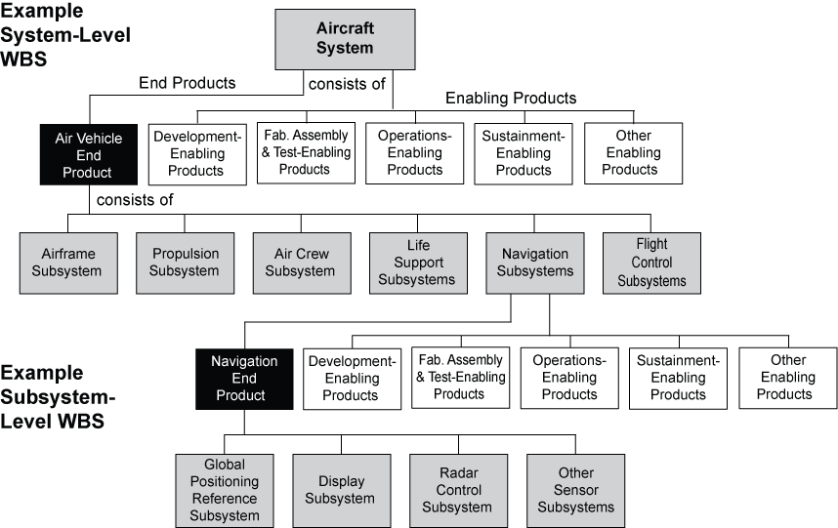
Figure A-3 – Product-Based WBS Model Example
Appendix B. Acronyms
AO Announcement of Opportunity
ATD Advanced Technology Development
BAR Basic and Applied Research
CDR Critical Design Review
CM Configuration Management
CMM Capability Maturity Model®
CMMI Capability Maturity Model® IntegrationSM
CoF Construction of Facilities
ConR Continuation Reviews
CR Confirmation Review
DAU Defense Acquisition University
DGA Designated Governing Authority
DR Decommissioning Review
ECP Engineering Change Proposal
ECR Environmental Compliance and Restoration
EEE Electrical, Electronic, and Electromechanical
EMC Electromagnetic Compatibility
EMI Electromagnetic Interference
EPR Engineering Peer Reviews
FAD Formulation Approval Document
FMEA Failure Modes and Effects Analysis
FRR Flight Readiness Review
FS&GS Flight Systems and Ground Support
GPMC Governing Program Management Committee
ICD Interface Control Document
ICWG Interface Control Working Group
INCOSE International Council on Systems Engineering
IP Institutional Projects
IPD Integrated Product Development
IPPD Integrated Product and Process Development
KPP Key Performance Parameter
LLIL Limited Life Items List
MCR Mission Concept Review
MD Mission Directorates
MDAA Mission Directorate Associate Administrator
MDR Mission Design Review
MOE Measures of Effectiveness
MOP Measures of Performance
MSOA Mission Support Office Approval
MSOD Mission Support Office Director
NAR Non-Advocate Review
NODIS NASA On-Line Directives Information System
NPD NASA Policy Directive
NPR NASA Procedural Requirements
OCE Office of the Chief Engineer
ORR Operational Readiness Review
PA Portfolio Approval
PDR Preliminary Design Review
PHA Preliminary Hazard Analysis
PM Program or Project Manager
PMP Program Management Plan
PNAR Pre-Non-Advocate Review
PP Project Plan
PR Procedural Requirements
PTR Periodic Technical Reviews
RFA Requests for Action
RFP Request for Proposal
RID Review Item Discrepancy
SAR Systems Acceptance Review
SDP Software Development Plan
SDR System Definition Review/System Design Review
SE Systems Engineering
SEMP Systems Engineering Management Plan
SE NPR Systems Engineering NASA Procedural Requirements
SEWG Systems Engineering Working Group
S&MA Safety and Mission Assurance
SRR System Requirements Review
TPM Technical Performance Measures
TRL Technology Readiness Level
TRR Test Readiness Review
WBS Work Breakdown Structure
xPR (Center) Procedural Requirements

Appendix C. Practices for Common Technical Processes
- This appendix contains best typical practices as extracted from industry and national and international standards and as found within the Agency. The practices may be used by Centers in preparing directives, policies, rules, work instructions, and other documents implementing SE processes. The practices of this appendix may also be used in the future assessments of those plans and processes to provide feedback to the OCE and Centers on the strengths and weaknesses in the Center’s implementation of this SE NPR. These practices can be expanded and updated as necessary.
- Each process is described in terms of purpose, inputs, outputs, and activities. Notes are provided to further explain a process and to help understand the best practices included. A descriptive figure is also provided for each process to illustrate notional relationships between activities within a process and the sources of inputs and destinations of outputs. Figures in this appendix are not intended to include all possible inputs, outputs, or intermediate work products.
C.1 System Design Processes
- There are four system design processes applied to each product-based WBS model from the top to the bottom of the system structure: (1) Stakeholder Expectation Definition, (2) Technical Requirements Definition, (3) Logical Decomposition, and (4) Design Solution Definition. (See Figure 3-2.)
- During the application of these four processes to a WBS model it is expected that there will be a need to apply activities from other processes yet to be completed in this set of processes and to repeat process activities already performed in order to arrive at an acceptable set of requirements and solutions. There will also be a need to interact with the technical management processes to aid in identifying and resolving issues and making decisions between alternatives.
- For software products, the technical team should refer to NPR 7150.2 software design requirements. The technical team should also ensure that the process implementations comply with NPR 7150.2 software product realization requirements for software aspects of the system.
C.1.1 Stakeholder Expectations Definition Process
C.1.1.1 Purpose
The stakeholder expectations definition process is used to elicit and define use cases, scenarios, operational concepts, and stakeholder expectations for the applicable product-line life-cycle phases and WBS model. This includes requirements for:
- operational end products and life-cycle-enabling products of the WBS model;
- expected skills and capabilities of operators or users;
- expected number of simultaneous users,
- system and human performance criteria,
- technical authority, standards, regulations, and laws;
- factors such as safety, quality, security, context of use by humans, reliability, availability, maintainability, electromagnetic compatibility, interoperability, testability, transportability, supportability, usability, and disposability; and
- local management constraints on how work will be done (e.g., operating procedures).
The baselined stakeholder expectations are used for validation of the WBS model end product during product realization.
C.1.1.2 Inputs and Sources:
- Customer expectations (from users and program and/or project).
- Other stakeholder expectations (from project and/or other interested parties of the WBS model products – recursive loop).
- Customer flow-down requirements from previous level WBS model products (from Design Solution Definition Process – recursive loop – and Requirements Management and Interface Management Processes).
Note: This would include requirements for initiating enabling product development to provide appropriate life-cycle support products and services to the mission, operational or research end product of the WBS model.
C.1.1.3 Outputs and Destinations:
- Set of validated stakeholder expectations, including interface requirements (to Technical Requirements Definition, Requirements Management, and Interface Management Processes).
- Baseline operational concepts (to Technical Requirements Definition Process and Configuration Management Processes).
- Baseline set of enabling product support strategies (to Technical Requirements Definition Process and Configuration Management Processes).
- Measures of Effectiveness (MOEs) (to Technical Requirements Definition Process and Technical Data Management Process).
C.1.1.4 Activities
For the WBS model in the system structure, the following activities are typically performed:
- Establish a list that identifies customers and other stakeholders that have an interest in the system and its products.
- Elicit customer and other stakeholder expectations (needs, wants, desires, capabilities, external interfaces, and constraints) from the identified stakeholders.
- Establish operational concepts and support strategies based on stakeholder expected use of the system products over the system’s life.
Note: Defined scenarios and operational concepts include functionality and performance of intended uses and relevant boundaries, constraints, and environments in which the product(s) will operate. Support strategies include provisions for fabrication, test, deployment, operations, sustainment, and disposal as appropriate.
- Define stakeholder expectations in acceptable statements that are complete sentences and have the following characteristics: (1) individually clear, correct, and feasible to satisfy; not stated as to how it is to be satisfied; implementable; only one interpretation of meaning; one actor-verb-object expectation; and can be validated at the level of the system structure at which it is stated; and (2) in pairs or as a set there is an absence of redundancy, consistency with respect to terms used, not in conflict with one another, and do not contain stakeholder expectations of questionable utility or which have an unacceptable risk of satisfaction.
- Analyze stakeholder expectation statements to establish a set of measures (measures of effectiveness) by which overall system or product effectiveness will be judged and customer satisfaction will be determined.
Note: A set of measures of effectiveness (MOE) is selected from the set of defined stakeholder expectation statements. It represents a expectation that is critical to the success of the system and failure to satisfy this measure will cause the stakeholder to deem the system unacceptable. Examples of typical MOEs are weight, availability, mobility, user/operator comfort, CPU capacity, and parameters associated with critical events during operations. Whereas weight is generally stated in quantitative terms and can be easily allocated to lower level system products, other MOEs may be qualitative or not easily allocated and thus will need measures of performance (MOPs) derived that can be used as design to requirements. MOPs are derived during technical requirements definition process activities.
- Validate that the resulting set of stakeholder expectation statements are upward and downward traceable to reflect the elicited set of stakeholder expectations and that any anomalies identified are resolved.
- Obtain commitments from customer and other stakeholders that the resultant set of stakeholder expectation statements is acceptable.
Note: This can be done through the equivalent of a systems requirement review with appropriate formality as a function of the location of the product in the system structure, the agreement affecting the development effort, and the type of NASA product—ranging from applied research to FS&GS.
- Baseline the agreed to set of stakeholder expectation statements.
Note 1: Products generated by the product implementation process or product integration process will be validated against this set of baselined stakeholder expectations.
Note 2: The baselines are generated and placed under change control using the requirements and interface management processes and configuration management process, as applicable to the formality required and the location of the WBS model in the system structure. Initiate bidirectional traceability or expectations and requirements at this point for tracking changes from initial stakeholder inputs through design solution definition outputs.
Note 3: The baseline information should include rationale for decisions made, assumptions with respect to the decisions made, and other information that will provide an understanding of the stakeholder expectations baseline.
C.1.1.5 Process Flow Diagram
- A typical process flow diagram for the stakeholder expectations definition process is provided in Figure C-1 with inputs and their sources and the outputs and their destinations. The activities of the stakeholder expectations definition process are truncated to indicate the action and object of the action.
- The customer flow-down requirements from the design solution definition process are applicable at levels of the system structure below the top level. The other stakeholder expectations are applicable at each level of the system structure to reflect the local management policies, applicable standards and regulations, and enabling product support needs for the lower level WBS model products.
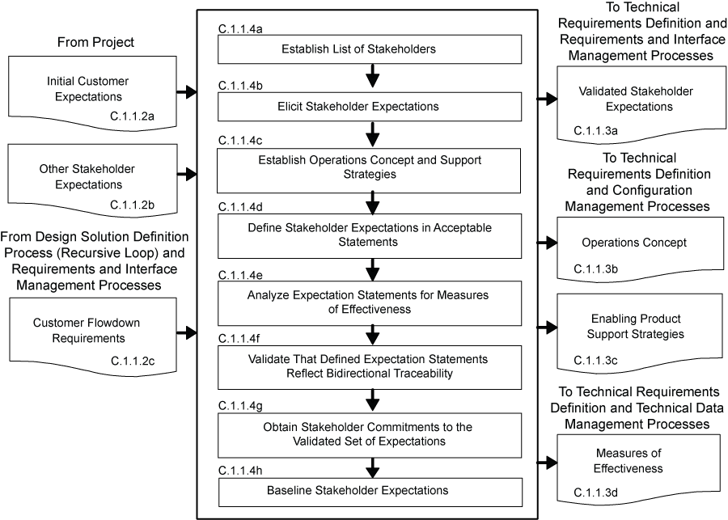
Figure C-1 – Stakeholder Expectation Definition Process
C.1.2 Technical Requirements Definition Process
C.1.2.1 Purpose
The technical requirements definition process is used to transform the baselined stakeholder expectations into unique, quantitative, and measurable technical requirements expressed as “shall” statements that can be used for defining a design solution definition for the WBS model end product and related enabling products.
C.1.2.2 Inputs and Sources:
- Baselined set of stakeholder expectations, including interface requirements (from Stakeholder Expectations Definition and Configuration Management Processes).
- Baselined Concept of Operation (from Stakeholder Expectations Definition and Configuration Management Processes).
- Baselined Enabling Product Support Strategies (from Stakeholder Expectations Definition and Configuration Management Processes).
- Measures of Effectiveness (from Stakeholder Expectations Definition and Technical Data Management Processes).
C.1.2.3 Outputs and Destinations:
- Set of validated technical requirements that represents a reasonably complete description of the problem to be solved, including interface requirements (to Logical Decomposition and Requirements and Interface Management Processes).
- Sets of MOPs that when met will satisfy the MOE to which a set is related (to Logical Decomposition and Technical Data Management Processes).
- A set of critical technical performance measures (TPMs) that if not met will put the project in cost, schedule or performance risk (to Technical Assessment Process).
C.1.2.4 Activities
For the WBS model in the system structure, the following activities are typically performed:
- Analyze the scope of the technical problem to be solved to identify and resolve the design boundary that identifies: (1) which system functions are under design control and which are not; (2) expected interaction among system functions (data flows, human responses, and behaviors); (3) external physical and functional interfaces (mechanical, electrical, thermal, data, procedural) with other systems; (4) required capacities of system products; (5) timing of events, states, modes, and functions related to operational scenarios; and (6) emerging or maturing technologies necessary to make requirements.
- Define constraints affecting the design of the system or products or how the system or products will be able to be used.
Note: Constraints that affect the design include physical product constraints (e.g., color, texture, size, weight, buoyancy, use environment, rate of use, life-cycle services) and human constraints (e.g., operator physical and performance capabilities, operator work environment, and interfaces). Constraints are typically not able to be changed based on tradeoff analyses. Applicable industry standards should be referenced for possible constraints.
- Define functional and behavioral expectations for the system or product in acceptable technical terms for the range of anticipated uses of system products as identified in the concept of operations. This permits separation of defined stakeholder expectation functions and behaviors that belong to a lower level in the system structure and to allocate them to the appropriate level.
- Define the performance requirements associated with each defined functional and behavioral expectation.
Note: The performance requirements are expressed as the quantitative part of a requirement to indicate how well each product function is expected to be accomplished. Any qualitative performance expectations should be analyzed and quantified; and the performance requirements that can be changed by tradeoff analysis should be identified.
- Define technical requirements in acceptable “shall” statements that are complete sentences with a single “shall” per numbered statement and have the following characteristics: (1) individually clear, correct, and feasible to satisfy; not stated as to how it is to be satisfied; implementable; only one interpretation of meaning; one actor-verb-object requirement; and can be validated at the level of the system structure at which it is stated; and (2) in pairs or as a set there is an absence of redundancy, consistent with respect to terms used, not in conflict with one another, and form a set of “design-to” requirements.
- Validate that the resulting technical requirement statements (1) have bidirectional traceability to the baselined stakeholder expectations; (2) were formed using valid assumptions; and (3) are essential to and consistent with designing and realizing the appropriate product solution form that will satisfy the applicable product-line life-cycle phase exit criteria.
- Define MOPs for each identified measure of effectiveness (MOE) that cannot be directly used as a design-to technical requirement.
Note: Typically each qualitative MOE will have two or more MOPs made up of functional and performance requirement combinations. These quantitative MOPs, appropriately determined and defined, when designed in the design solution definition and met by a product generated by the product implementation process or product integration process, should help ensure that the qualitative MOEs (e.g., the seat shall be comfortable, the separation of the booster engines shall not cause damage to the mission vehicle) will be satisfied.
- Define appropriate TPMs by which technical progress will be assessed.
Note: TPMs are used for progress measurement and need to meet certain criteria to be a valid TPM: (1) be a significant qualifier of the system (e.g., weight, range, capacity, response time, safety parameter) that will be monitored at key events (e.g., inspections, planned tests); (2) can be measured; and (3) projected progress profiles can be established (e.g., from historical data or based on test planning). TPMs provide an early warning method to flag potential technical problems in that the project will be put at technical performance, cost, or schedule risk if the requirement is not met. TPMs are typically selected from the MOPs.
- Establish the technical requirements baseline.
Note: The work products generated during the definition of the technical requirements should be captured along with key decision made, supporting decision rationale and assumptions, and lessons learned in performing the technical requirements process activities to provide an understanding of the technical requirements baseline. The baselines would be established and placed under change control by invoking the activities of the requirements management, interface management and configuration management processes, as appropriate.
C.1.2.5 Process Flow Diagram
A typical process flow diagram for the technical requirements definition process is provided in Figure C-2 with inputs and their sources and the outputs and their destinations. The activities of the technical requirements definition process are truncated to indicate the action and object of the action.
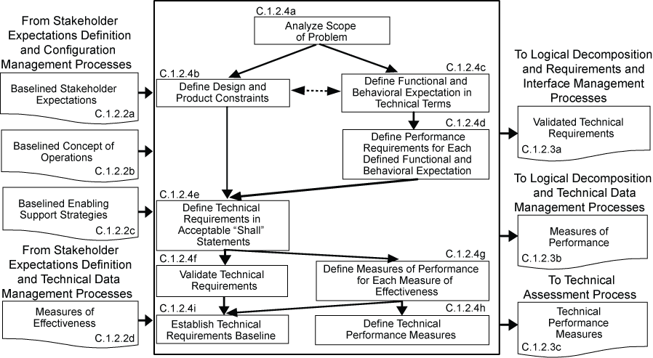
Figure C-2 – Technical Requirements Definition Process
C.1.3 Logical Decomposition Process
C.1.3.1 Purpose
The logical decomposition process is used to improve understanding of the defined technical requirements and the relationships among the requirements (e.g., functional, behavioral, and temporal) and to transform the defined set of technical requirements into a set of logical decomposition models and their associated set of derived technical requirements for input to the design solution definition process.
C.1.3.2 Inputs and Sources:
- The baseline set of validated technical requirements, including interface requirements (from Technical Requirements Definition and Configuration Management Processes).
- The defined MOPs (from Technical Requirements Definition and Technical Data Management Processes).
C.1.3.3 Outputs and Destinations:
- Set of validated derived technical requirements, including interface requirements (to Design Solution Definition and Requirements and Interface Management Processes).
- The set of logical decomposition models (to Design Solution Definition and Configuration Management Processes).
- Logical decomposition work products (to Technical Data Management Processes).
C.1.3.4 Activities: For the WBS model in the system structure, the following activities are typically performed:
- Define one or more logical decomposition models based on the defined technical requirements to gain a more detailed understanding and definition of the design problem to be solved.
Note 1: The defined technical requirements can be decomposed and analyzed by functions, time, behaviors, data flow, objects, states and modes, and failure modes and effects, as appropriate, to define sets of logical decomposition models. The models may include functional flow block diagrams, timelines, data control flow, states and modes, behavior diagrams, operator tasks, or functional failure modes and should be based on performance, cost, schedule, safety, and risk analyses.
Note 2: Use of existing products, which helps reduce development time and cost, may be considered in establishing logical decomposition models. New interfaces may appear with the introduction of existing products. These interfaces need to be included in the technical requirements, thus requiring an iteration of the technical requirements definition process.
Note 3: New technology insertion is considered at this point. The use of new technologies can provide a competitive edge but needs to be balanced against the risks of their insertion.
- Allocate the technical requirements to the logical decomposition models to form a set of derived technical requirement statements that have the following characteristics:
- Describe functional and performance, service and attribute, time, and data flow requirements, etc., as appropriate for the selected set of logical decomposition models.
- Individually are complete sentences and are clear, correct, and feasible to satisfy; not stated as to how to be satisfied; implementable; only have one interpretation of meaning, one actor-verb-object expectation; and can be validated at the level of the system structure at which it is stated.
- In pairs or as a set, have an absence of redundancy, are adequately related with respect to terms used, and are not in conflict with one another.
- Form a set of detailed “design-to” requirements.
Note: Traceability for the allocated MOPs should be maintained throughout the logical decomposition process. This is essential in that particular attention should be paid to demonstrating satisfaction of the MOPs during verification of a product generated by the product implementation process or product integration process.
- Resolve derived technical requirement conflicts.
Note 1: The logical decomposition models and derived technical requirements should be analyzed to identify possible conflicts. The established set of performance criteria, cost, schedule and risks should be used in conducting tradeoff analyses for conflict resolution.
Note 2: Conflicts among derived technical requirements are always a problem. This logical decomposition process activity is designed to discover such conflicts early and resolve them before the design solution definition is too far underway. Understanding the problem to be solved in more detail is helpful for obtaining a better and more cost-effective design solution definition.
- Validate that the resulting set of derived technical requirements have: (1) bidirectional traceability with the set of validated technical requirements and (2) assumptions and decision rationale consistent with the source set of technical requirements.
Note 1: There may be some technical requirements that cannot be allocated to the logical decomposition models. If so, then these should be allocated directly to the physical entities that will make up the alternatives for design solution definition.
Note 2: Bidirectional requirements traceability is used for tracking changes to the technical requirements based on the logical decomposition models and their allocated derived technical requirements.
- Establish the derived technical requirements baseline.
Note 1: The baselines would be established and placed under change control by invoking the activities of the requirements management, interface management and configuration management processes, as appropriate.
Note 2: The work products generated during the definition of the derived technical requirements should be captured along with key decision made, supporting decision rationale and assumptions, and lessons learned in performing the logical decomposition process activities to provide an understanding of the derived technical requirements baseline and the logical decomposition models and to permit traceability to technical requirements, stakeholder expectations and logical decomposition models.
C.1.3.5 Process Flow Diagram
A typical process flow diagram for logical decomposition is provided in Figure C-3 with inputs and their sources and the outputs and their destinations. The activities of the logical decomposition process are truncated to indicate the action and object of the action.
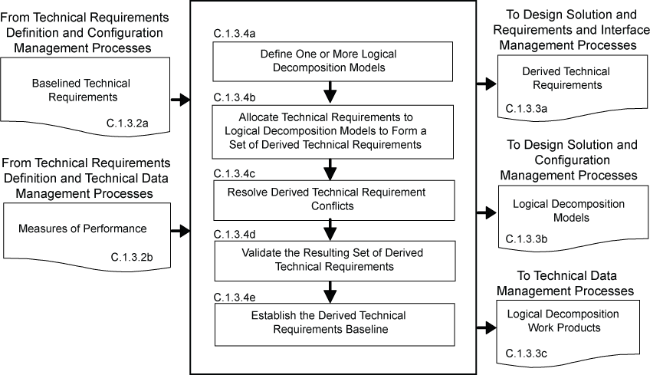
Figure C-3 – Logical Decomposition Process
C.1.4 Design Solution Definition Process
C.1.4.1 Purpose
The design solution definition process is used to translate the outputs of the logical decomposition process into a design solution definition that is in a form consistent with the product-line life-cycle phase and WBS model location in the system structure and that will satisfy phase exit criteria. This includes transforming the defined logical decomposition models and their associated sets of derived technical requirements into alternative solutions, then analyzing each alternative to be able to select a preferred alternative and fully define that alternative into a final design solution definition that will satisfy the technical requirements. These design solution definitions will be used for generating end products either by using the product implementation process or product integration process as a function of the position of the WBS model in the system structure and whether there are additional subsystems of the end product that need to be defined. The output definitions from the design solution (end product specifications) will be used for conducting product verification.
C.1.4.2 Inputs and Sources:
- A baselined set of logical decomposition models (from Logical Decomposition and Configuration Management Processes).
- A baseline set of derived technical requirements including interface requirements (from Logical Decomposition and Configuration Management Processes).
Note: If there were unallocated technical requirements these requirements would also be input to the design solution definition process.
C.1.4.3 Outputs and Destinations:
The specified requirements that describe the system design solution definition for the products of the WBS model under development include:
- A WBS model design solution definition set of requirements for the system (see WBS definition in Appendix A), including specification configuration documentation and external interface specification (to Requirements and Interface Management Process).
- A baseline set of “make-to,” “buy-to,” “reuse-to,” or set of “assemble and integrate-to” specified requirements (specifications and configuration documents) for the desired end product of the WBS model, including interface specifications (to Requirements and Interface Management Process).
Note: The specifications should include not only the product characteristics and functional and performance requirements but also how each requirement will be evaluated during verification and/or acceptance tests.
- The initial specifications for WBS model subsystems for flow down to the next applicable lower level WBS models, including interface specifications (to Stakeholder Expectations Definition, and Requirements and Interface Management Processes).
Note: If there is not a need for further development of end product subsystems, the product implementation process is the applicable destination of the end product specified requirements. (See 2 above.)
- The requirements for enabling products that will be needed to provide life-cycle support to the end products, including interface requirements (to Stakeholder Expectations Definition Process for development of enabling products or to Product Implementation Process for acquisition of existing enabling products, and Requirements and Interface Management Processes).
- A product verification plan that will be used to demonstrate that the product generated from the design solution definition conforms to the design solution definition specified requirements (to Product Verification Process).
Note: The technical planning process should be used to develop this plan based on the product design solution definition process activities and the product verification process activities.
- A product validation plan that will be used to demonstrate that the product generated from the design solution definition conforms to its set of stakeholder expectations (to Product Validation Process).
Note: The technical planning process should be used to develop this plan based on the product design solution definition process activities and the product validation process activities.
- Baseline operate-to and logistics procedures (to Technical Data Management Process).
C.1.4.4 Activities
For the WBS model in the system structure, the following activities are typically performed:
- Define alternative solutions for the system end product being developed or improved that are consistent with derived technical requirements and non-allocated technical requirements, if any.
Note 1: The derived technical requirements should be partitioned based on their associated logical decomposition model to potential physical elements that will make up the end product (e.g., hardware, software, human/manual operations, data, processes and/or composites of these).
Note 2: Alternative solutions can be formed by packaging the physical elements in such a way that the derived technical requirements will be satisfied.
Note 3: Criteria should be established by which alternative solutions can be evaluated.
- Analyze each alternative solution against defined criteria such as: satisfaction of external interface requirements; technology requirements; off-the-shelf availability of products; physical failure modes, effects and criticality; life-cycle cost and support considerations; capacity to evolve; make vs. buy; standardization of products; integration concerns; and context of use issues of operators considering tasks, location, workplace equipment, and ambient conditions.
- Select the best solution alternative based on the analysis results of each alternative solution and technical decision analysis recommendations.
Note: The decision analysis process is used to make an evaluated recommendation of the best or favored solution.
- Generate the full design description of the selected alternative solution in a form appropriate to the product-line life-cycle phase, location of the WBS model in the system structure, and phase exit criteria to include: (1) system specification and external interface specifications; (2) end product specifications, configuration description documents, and interface specifications; (3) end product subsystem initial specifications, if subsystems are required; (4) requirements for associated supporting enabling products; (5) end product verification plan; (6) end product validation plan; and (7) applicable logistics and operate-to procedures.
Note 1: The first application of the system design processes to develop a system structure typically results in a set of top-level requirements and one or more concepts. The form of design solution definition output could be, for example, a simulation model or paper study report.
Note 2: The output of the design solution definition process is typically called a technical data package. This package evolves from phase to phase starting with conceptual sketches or models and ending before fabrication, assembly and integration of the product with complete drawings, parts list and other details needed for product implementation or product integration.
Note 3: Branches of the system structure tree end when there are no subsystems needed to make up an end product within a WBS model. At that point the end product can be made, bought or reused using the product implementation process. Any end product that consists of lower level subsystem products will be realized by the product integration process. The form of the product will be dependent on the product-line life-cycle phase, the location of the WBS model in the system structure, and the phase exit criteria.
Note 4: The operational concept for the end product should be updated to reflect the design solution definition selected.
- Verify that the design solution definition: (1) is realizable within constraints imposed on the technical effort; (2) has specified requirements that are stated in acceptable statements and have bidirectional traceability with the derived technical requirements, technical requirements, and stakeholder expectations; (3) has decisions and assumptions made in forming the solution consistent with its set of derived technical requirements, separately allocated technical requirements, and identified system product and service constraints.
Note 1: The use of peer reviews is recommended to evaluate the resulting design solution definition documentation against a set of established criteria consistent with the product-line life-cycle phase exit criteria and the WBS model’s location in the system structure.
Note 2: Identified anomalies should be resolved during the verification of the design solution definition.
- Baseline the design solution definition specified requirements including the specifications and configuration descriptions.
Note: The baselines would be established and placed under change and/or configuration control by invoking the activities of the requirements management, interface management and configuration management processes, as appropriate.
- Initiate development or acquisition of the life cycle supporting enabling products needed, as applicable, for research, development, fabrication, integration, test, deployment, operations, sustainment, and disposal.
Note 1: Schedules should be such that the enabling products will be available when needed to support the product-line life-cycle phase activities.
Note 2: Development of enabling products and services rely on the same processes used to develop their associated operational products in the WBS model.
- Initiate development of the system products of the next lower level WBS model, if any.
Note 1: Development of the next lower level of system products using the same design processes is an example of the recursive application of the repeatable system design processes.
Note 2: If this activity is not applicable then the end product should be reviewed for making, buying or reuse using the product implementation process.
C.1.4.5 Process Flow Diagram
A typical process flow diagram for design solution definition is provided in Figure C-4 with inputs and their sources and the outputs and their destinations. The activities of the design solution definition process are truncated to indicate the action and object of the action.
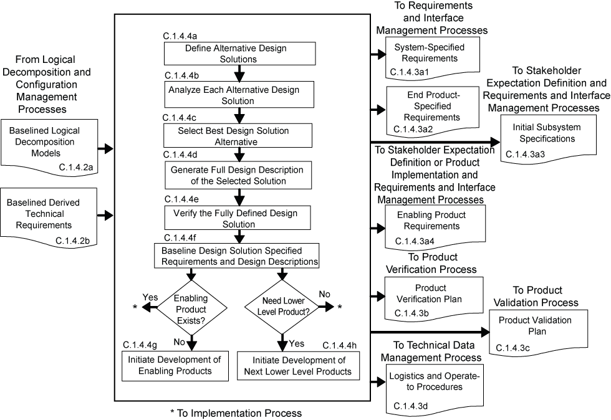
Figure C-4 – Design Solution Definition Process
C.2 Product Realization Processes
There are five product realization processes. Four of the product realization processes are applied to each end product of a WBS model from the bottom to the top of the system structure: (1) either product implementation or product integration, (2) product verification, (3) product validation, and (4) product transition. (See Figure 3-2.) The form of the end product realized will be dependent on the applicable product-line life-cycle phase, location within the system structure of the WBS model containing the end product, and the exit criteria of the phase. Typical early phase products are in the form of reports, models, simulations, mockups, prototypes, or demonstrators. Later phase product forms include the final mission products, including payloads and experiment equipment. For software products, the technical team should refer to NPR 7150.2 for software product realization requirements. The technical team should also ensure that the process implementations comply with NPR 7150.2, NASA Software Engineering Requirements for software aspects of the system. The product realization process descriptions that follow assume that each lowest level product goes through the sequencing shown in Figure C-5a. Exceptions will need to be planned according to what has and has not been already performed.
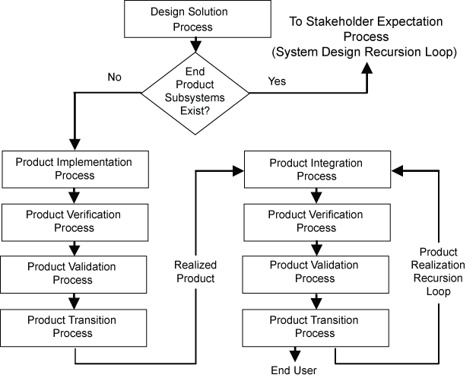
Figure C-5a –Sequencing of Design Realization Processes
C.2.1 Product Implementation Process
C.2.1.1 Purpose
The product implementation process is used to generate a specified product of a WBS model through buying, making, or reusing in a form consistent with the product-line life-cycle phase exit criteria and that satisfies the design solution definition specified requirements (e.g., drawings, specifications).
C.2.1.2 Inputs and Sources:
- Raw materials needed to make the end product (from existing resources or external sources).
- End product design solution definition specified requirements (specifications) and configuration documentation for the end product of the applicable WBS model, including interface specifications, in the form appropriate to satisfying the product-line life-cycle phase exit criteria (from Configuration Management Process).
- Product implementation enabling products (from existing resources or Product Transition Process for enabling product realization).
C.2.1.3 Outputs and Destinations:
- Made, bought, or reused end product in the form appropriate to the product-line life-cycle phase and to satisfy exit criteria (to Product Verification Process).
Note: For early life-cycle phases products generated by the product implementation process can be in the form or reports, models, simulations, mockups, prototypes, and demonstrators. In later phases the form may be in mission ready products including payloads and experiment equipment.
- Documentation and manuals in a form appropriate for satisfying the life-cycle phase exit criteria, including “as-built” product descriptions and “operate-to” and maintenance manuals (to Technical Data Management Process).
Note: “As-built” descriptions include descriptive materials for made, bought or reuse products. For early life-cycle phases documents can be in draft form. In later phases the documents/manuals should be in mission or experiment ready procedural form.
- Product implementation work products needed to provide reports, records, and non-deliverable outcomes of process activities (to Technical Data Management Process).
C.2.1.4 Activities
For the WBS model in the system structure, the following activities are typically performed:
- Prepare to conduct product implementation to include (1) preparing a product implementation strategy and detailed planning and procedures; and (2) determining whether the product configuration documentation is adequately complete to conduct the type of product implementation as applicable for the product-line life-cycle phase, location of the product in the system structure, and phase exit criteria.
- If the strategy is for buying an existing product, participate in the buy of the product including (1) review of the technical information made available by vendors; (2) assisting in the preparation of requests for acquiring the product from a vendor; (3) assisting in the inspection of the delivered product and the accompanying documentation; (4) determination of whether the vendor conducted product validation or if it will need to be done by a project technical team; and (5) determination of the availability of enabling products to provide test, operations, and maintenance support and disposal services for the product.
- If the strategy is to reuse a product that exists in the Government inventory, participate in the acquiring of the reuse product including: (1) review of the technical information made available for the specified product to be reused; (2) determination of supporting documentation and user manuals availability; (3) determination of the availability of enabling products to provide test, operations, and maintenance support and disposal services for the product; (5) assisting in the requests for acquiring the product from Government sources; and (4) assisting in the inspection of the delivered product and the accompanying documentation.
- If the strategy is to make the product,
- Evaluate the readiness of the product implementation enabling products to conduct the making of the product.
- Make the specified product in accordance with the specified requirements, configuration documentation, and applicable standards.
- Prepare appropriate product support documentation such as integration constraints and/or special procedures for performing product verification and product validation.
- Capture work products and related information generated while performing the product implementation process activities.
Note: Work products include procedures used, rationale for decisions made, assumptions made in product implementation and decisions made, corrective actions taken to correct identified anomalies, lessons learned in performing the product implementation activities, and update product configuration and support documentation.
C.2.1.5 Process Flow Diagram
C.2.1.5.1 A typical process flow diagram for product implementation is provided in Figure C-5b with inputs and their sources and the outputs and their destinations. The activities of the product implementation process are truncated to indicate the action and object of the action.
C.2.1.5.2 The path that products from the three sources in Figure C-5b take with respect to product verification, product validation, and product transition vary based on:
- Whether the products bought have been verified and/or validated by the vendor.
- Whether reuse products that come from within the organization have been verified and/or validated.
- Whether the customer for the product desires to do the product validation or have the developer perform the product validation.
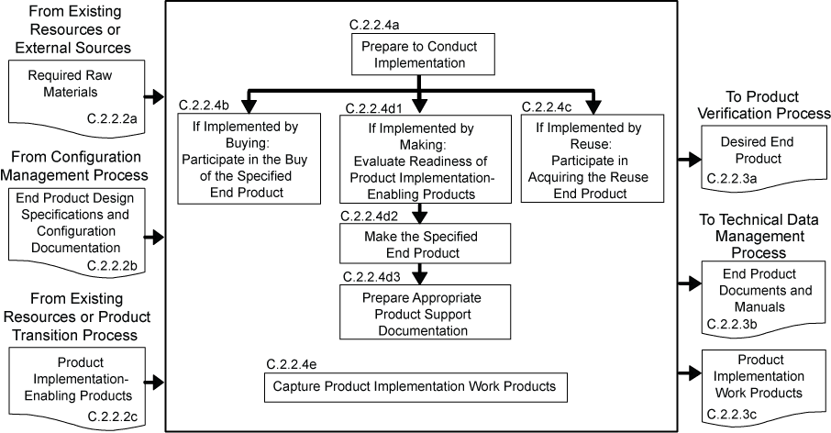
Figure C-5b – Product Implementation Process
C.2.2 Product Integration Process
C.2.2.1 Purpose
The product integration process is used to transform the design solution definition into the desired end product of the WBS model through assembly and integration of lower-level validated end products in a form consistent with the product-line life-cycle phase exit criteria and that satisfies the design solution definition requirements (e.g., drawings, specifications).
C.2.2.2 Inputs and Sources:
- Lower-level products to be assembled and integrated (from Product Transition Process).
- End product design definition specified requirements (specifications) and configuration documentation for the applicable WBS model, including interface specifications, in the form appropriate to satisfying the product-line life-cycle phase exit criteria (from Configuration Management Process).
- Product integration enabling products (from existing resources or Product Transition Process for enabling product realization).
C.2.2.3 Outputs and Destinations:
- Integrated product(s) in the form appropriate to the product-line life-cycle phase and to satisfy phase exit criteria (to Product Verification Process).
Note: For early life-cycle phases products generated by the product integration process can be in the form or reports, models, simulations, mockups, prototypes, and demonstrators. In later phases the form may be in mission ready products including payloads and experiment equipment.
- Documentation and manuals in a form appropriate for satisfying the life-cycle phase exit criteria, including “as-integrated” product descriptions and “operate-to” and maintenance manuals (to Technical Data Management Process).
Note: “As-integrated” descriptions include descriptive materials for integrated products. For early life-cycle phases documents can be in draft form. In later phases the documents/manuals should be in mission or experiment ready procedural form.
- Product integration work products needed to provide reports, records, and non-deliverable outcomes of process activities (to Technical Data Management Process).
C.2.2.4 Activities
For the WBS model in the system structure, the following activities are typically performed:
- Prepare to conduct product integration to include (1) preparing a product integration strategy, detailed planning for the integration, and integration sequences and procedures; and (2) determining whether the product configuration documentation is adequately complete to conduct the type of product integration applicable for the product-line life-cycle phase, location of the product in the system structure, and management phase exit criteria.
- Obtain lower level products required to assemble and integrate into the desired product.
- Confirm that the received products that are to be assembled and integrated have been validated to demonstrate that the individual products satisfy the agreed to set of stakeholder expectations, including interfaces requirements.
Note: Documented evidence that the correct products are provided for this activity as necessary. This validation can be completed by the providing organization or by an assigned technical team within the project.
- Prepare the integration environment in which assembly and integration will take place to include evaluating the readiness of the product integration enabling products and the assigned workforce.
Note: The product integration enabling products include, as a function of the product-line life-cycle phase, facilities, equipments, jigs, tooling, and assembly areas/lines and the integration environment includes test equipment, simulators (for products not available), storage areas, and recording devices.
- Assemble and integrate the received products into the desired end product in accordance with the specified requirements, configuration documentation, interface requirements, applicable standards, and integration sequencing and procedures.
Note: This activity includes managing, evaluating, and controlling physical, functional, and data interfaces among the products being integrated.
- Prepare appropriate product support documentation such as special procedures for performing product verification and product validation.
- Capture work products and related information generated while performing the product integration process activities.
Note: Work products include procedures used, rationale for decisions made, assumptions made in product integration and decisions made, corrective actions taken to correct identified anomalies, lessons learned in performing the product integration process activities, and updated product configuration and support documentation.
C.2.2.5 Process Flow Diagram
A typical process flow diagram for product integration is provided in Figure C-6 with inputs and their sources and the outputs and their destinations. The activities of the product integration process are truncated to indicate the action and object of the action.
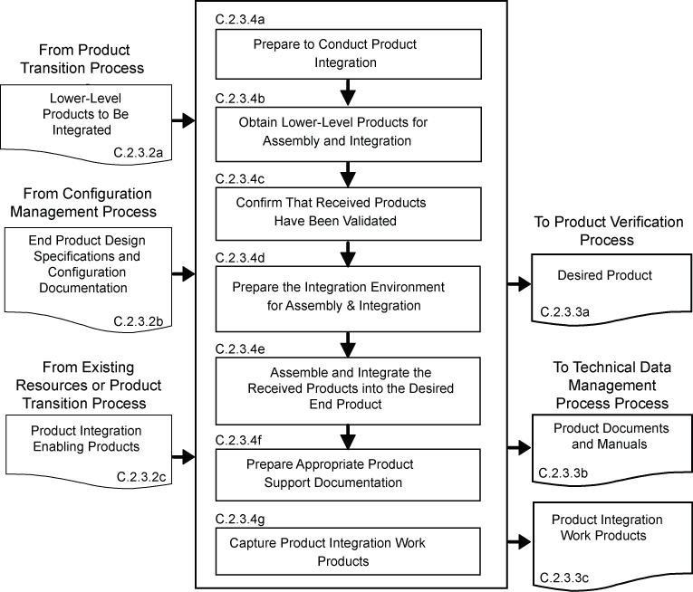
Figure C-6 – Product Integration Process
C.2.3 Product Verification Process
C.2.3.1 Purpose
The product verification process is used to demonstrate that an end product generated from product implementation or product integration conforms to its design solution definition requirements as a function of the product-line life-cycle phase and the location of the WBS model end product in the system structure. Special attention is given to demonstrating satisfaction of the MOPs defined for each MOE during conduct of the technical requirements definition process.
Note: Product verification can be accomplished by inspections, analyses, demonstrations, or test in accordance with the verification plan and as a function of the product-line life-cycle phase.
C.2.3.2 Inputs and Sources:
- End product to be verified (from Product Implementation Process or Product Integration Process).
- End product specification and configuration baselines, including interface specifications, to which the product being verified was generated (from Technical Data Management Process).
Note: The baselines would be updated design solution definition specifications and configuration documents based on corrections made during product implementation or product integration.
- Product verification plan (from Design Solution Definition Process and Technical Planning Process)
- Product verification enabling products (from existing resources or Product Transition Process for enabling product realization).
C.2.3.3 Outputs and Destinations:
- A verified end product (to Product Validation Process).
- Product verification results (to Technical Assessment Process).
- Completed verification report to include for each specified requirement: (1) the source paragraph references from the baseline documents for derived technical requirements, technical requirements and stakeholder expectations; (2) bidirectional traceability among these sources; (3) verification type(s) to be used in performing verification of the specified requirement; (4) reference to any special equipment, conditions, or procedures for performing the verification; (5) results of verification conducted; (6) variations, anomalies, or out-of-compliance results; (7) corrective actions taken; and (8) results of corrective actions (to Technical Data Management Process).
Note: The information in this report is captured in what is often referred to as a verification matrix. This matrix is typically established and maintained once requirements traceability is initiated after obtaining stakeholder commitment to the set of stakeholder expectations.
- Product verification work products needed to provide reports, records, and non-deliverable outcomes of process activities (to Technical Data Management Process).
C.2.3.4 Activities
For the WBS model in the system structure, the following activities are typically performed:
- Prepare to conduct product verification to include as applicable to the product-line life-cycle phase and WBS model location in the system structure: (1) reviewing the product verification plan for specific procedures, constraints, conditions under which verification will take place, pre and post verification actions, and criteria for determining the success or failure of verification methods and procedures; (2) arranging the needed product verification enabling products and support resources; (3) obtaining the end product to be verified; (4) obtaining the specification and configuration baseline against which the verification is to be made; and (5) establishing and checking the verification environment to ensure readiness for performing the verification.
- Perform the product verification in accordance with the product verification plan and defined procedures to collect data on each specified requirement with specific attention given to MOPs.
Note: Perform again any product verification steps that were not in compliance with planned product verification procedures or the planned environment including equipment, measurement, or data capture failures.
- Analyze the outcomes of the product verification to include identification of verification anomalies, establishing recommended corrective actions, and/or establishing conformance to each specified requirement under controlled conditions.
Note: Corrective actions should be assessed using the technical assessment process and decision analysis process with recommendations made and executed by re-planning the technical effort, repeating the system design processes, and/or repeating the product verification.
- Prepare a product verification report providing the evidence of product conformance with the applicable design solution definition specified requirements baseline to which the product was generated, including bidirectional requirements traceability and corrective actions taken to correct anomalies of verification results.
Note: The recommended content of this report is provided in the report output description in C.2.3.3.c.
- Capture the work products from the product verification.
Note: Work products include verification outcomes; records of procedural steps taken against planned procedures; any failures or anomalies in the planned verification procedures, equipment, or environment; and records citing satisfaction or non-satisfaction of verification criteria. Also records should document:
- Version of the set of specification and configuration documentation used.
- Version of the end product verified.
- Version or standard for tools and equipment used, together with applicable calibration data.
- Results of each verification including pass or fail declarations.
- Discrepancy between expected and actual results.
C.2.3.5 Process Flow Diagram
A typical process flow diagram for product verification is provided in Figure C-7 with inputs and their sources and the outputs and their destinations. The activities of the product verification process are truncated to indicate the action and object of the action.
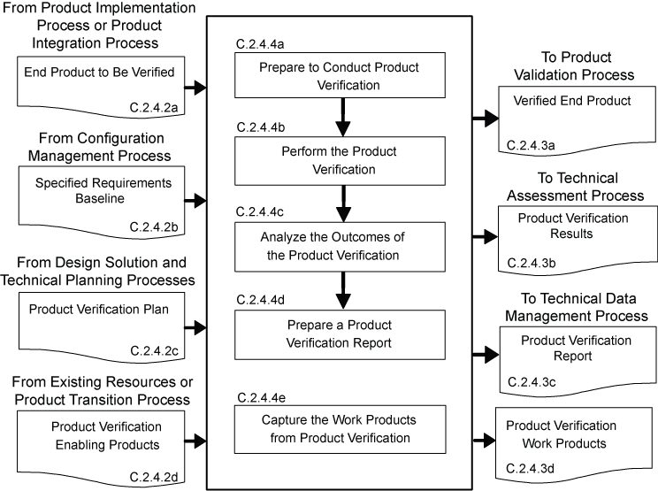
Figure C-7 – Product Verification Process
C.2.4 Product Validation Process
C.2.4.1 Purpose
The product validation process is used to confirm that a verified end product generated by product implementation or product integration fulfills (satisfies) its intended use when placed in its intended environment and assure that any anomalies discovered during validation are appropriately resolved prior to delivery of the product (if validation is done by the supplier of the product) or prior to integration with other products into a higher-level assembled product (if validation is done by the receiver of the product). The validation is done against the set of baselined stakeholder expectations. Special attention should be given to demonstrating satisfaction of the MOEs identified during conduct of the stakeholder expectations definition process. The type of product validation is a function of the form of the product, product-line life-cycle phase, and in accordance with an applicable customer agreement.
Note 1: Product should be validated against its stakeholders’ expectations before being integrated into a higher level product.
Note 2: Early in the life cycle, product validation is conducted through simulation, inspection, analysis or test, as appropriate.
Note 3: Later in the life cycle, product validation can be done through certification tests against established certification requirements or acceptance tests using operational processes and personnel in an operational environment, where possible and as applicable.
C.2.4.2 Inputs and Sources:
- End product to be validated (from Product Verification Process).
- Stakeholder requirements baseline (from Configuration Management Process).
Note: The baselines would be updated based on corrections made during product implementation or product integration or as a result of correcting verification anomalies.
- Product validation plan (from Design Solution Definition Process and Technical Planning Process)
- Product validation enabling products (from existing resources or Product Transition Process for enabling product realization).
C.2.4.3 Outputs and Destinations:
- A validated end product (to Transition Process).
- Product validation results (to Technical Assessment Process).
- Completed validation report to include for each stakeholder expectation or subset of stakeholder expectations involved with the validation, for example: (1) the source requirement paragraph reference from the stakeholder expectations baseline; (2) validation type(s) to be used in establishing compliance with selected set of stakeholder expectations and match with each source expectation referenced; (3) identification of any special equipment, conditions or procedures for performing the validation that includes referenced expectation; (4) results of validation conducted with respect to the referenced expectation; (5) deficiency findings (variations, anomalies or out-of-compliance results); (6) corrective actions taken; and (7) results of corrective actions (to Technical Data Management Process).
Note: The information in this report is captured in what is often referred to as a validation cross-reference matrix. This matrix is typically established and maintained once requirements traceability is initiated after obtaining stakeholder commitment to the set of stakeholder expectations and the establishment of the stakeholder expectations baseline.
- Product validation work products needed to provide reports, records, and non-deliverable outcomes of process activities (to Technical Data Management Process).
C.2.4.4 Activities
For the WBS model in the system structure, the following activities are typically performed:
- Prepare to conduct product validation to include as applicable to the product-line life-cycle phase and product location in the system structure: (1) reviewing the product validation plan for specific procedures, constraints, conditions under which validation will take place, pre and post validation actions, and criteria for determining the success or failure of validation methods and procedures; (2) arranging the needed product validation enabling products and support resources; (3) obtaining the end product to be validated; (4) obtaining the stakeholder expectations baseline against which the validation is to be made; and (5) establishing and checking out the validation environment to ensure readiness for performing the validation.
Note: Product validation environmental considerations include: measurement tools (scopes, electronic devices, probes); temporary embedded test software; recording equipment (capture test results); simulated subsystems in the loop (by software, electronics, or mechanics); simulated external interfacing products of other systems/products (representations of external threats or constraints); actual external interfacing products of other systems (aircraft, vehicles, boosters, humans); facilities; and skilled operators.
- Perform the product validation in accordance with the product validation plan and defined procedures to collect data on performance of the product against stakeholder expectations with specific attention given to MOEs.
Note 1: Perform again any validation steps that were not in compliance with planned validation procedures or the planned environment including equipment, measurement, or data capture failures.
Note 2: The validation environment may be a representative or simulated environment when it is not possible or cost prohibitive to use the operational environment.
- Analyze the outcomes of the product validation to include identification of validation anomalies, establishing recommended corrective actions, and/or establishing conformance to stakeholder expectations under operational conditions (actual, analyzed or simulated).
Note: Corrective actions should be assessed using the technical assessment process and decision analysis process with recommendations made and executed by re-planning the technical effort, repeating the system design processes, and/or repeating the product validation.
- A product validation report providing the evidence of product conformance with the stakeholder expectations baseline including corrective actions taken to correct anomalies of validation results
Note: The recommended content of this report is provided in the report output description in C.2.4.3.c.
- Capture the work products from the product validation.
Note: Work products include validation outcomes; records of procedural steps taken against planned procedures; any failures or anomalies in the planned validation procedures, equipment, or environment; and records citing satisfaction or non-satisfaction of validation criteria. Also records should document:
- Version of the stakeholder expectations baseline used.
- Version of the end product validated.
- Version or standard for tools and equipment used, together with applicable calibration data.
- Results of the product validation including pass or fail declarations.
- Discrepancy between expected and actual results.
C.2.4.5 Process Flow Diagram
A typical process flow diagram for product validation is provided in Figure C-8 with inputs and their sources and the outputs and their destinations. The activities of the product validation process are truncated to indicate the action and object of the action.
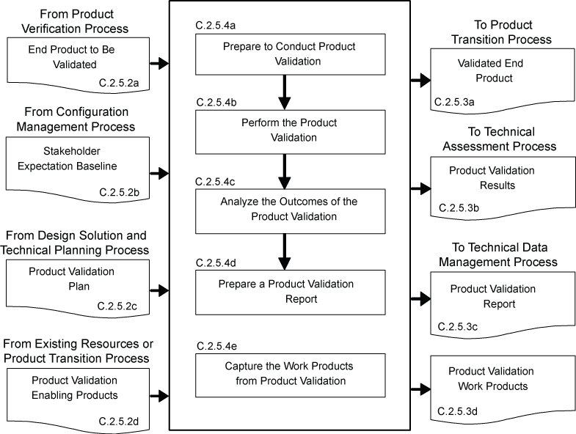
Figure C-8 – Product Validation Process
C.2.5 Product Transition Process
C.2.5.1 Purpose
The product transition process is used to transition a verified and validated end product that has been generated by product implementation or product integration to the customer at the next level in the system structure for integration into an end product or, for the top level end product, transitioned to the intended end user. The form of the product transitioned will be a function of the product-line life-cycle phase exit criteria and the location within the system structure of the WBS model in which the end product exits.
Note 1: Planning for transition includes preparation of packaging, handling, transporting, storing, training or certification activities and operations, users, or installation manuals as appropriate for the product-line life-cycle phase and the location of the end product in the system structure.
Note 2: Depending on the agreement and the product-line life-cycle phase, the product transition process may include installation, training and sustainment tasks.
Note 3: For transitions during early life-cycle phases, products may be in paper form, electronic form, physical models, or technology demonstration prototypes. During later life-cycle phases, products may be a one-of-a-kind operational/mission product or one of many to be produced and delivered in a single package or container.
C.2.5.2 Inputs and Sources:
- End product or products to be transitioned (from Product Validation Process).
- Documentation including manuals, procedures and processes that are to accompany the end product (from Technical Data Management Process).
Note: In early product-line life-cycle phases these manuals and documents would be in draft. In later phases the manuals and documents should be in a form ready for use and have been verified and/or validated that they meet end product and user support needs.
- Product transition enabling products to include packaging materials, containers, handling equipment, and storage, receiving and shipping facilities (from existing resources or Product Transition Process for enabling product realization).
C.2.5.3 Outputs and Destinations:
- Delivered end product with applicable documentation including manuals, procedures, and processes in a form consistent with the product-line life-cycle phase and location of the product in the system structure (to end user or Product Integration Process – recursive loop).
Note 1: If a physical form of the product is delivered, the product should have been transitioned in protective packaging by appropriate handling and transporting mechanisms and/or stored in appropriate protective environments.
Note 2: If the end product is an enabling product providing life-cycle support (e.g., for product implementation, product integration, product verification, product validation or product transition for the end product), the development or acquisition of the enabling product is needed to be initiated early so that it will be available when needed.
Note 3: The manuals and documents to be considered for delivery with the end product are the training modules, installation manuals and operations and sustaining engineering processes to prepare users, installers, or maintainers to do their functions with respect to the transitioned product.
- Product transition work products needed to provide reports, records, and non-deliverable outcomes of process activities (to Technical Data Management Process).
- Realized enabling products from existing enabling products and services or from applying the common technical processes to develop and realize (to Product Implementation, Integration, Verification, Validation and Transition Processes, as appropriate)
C.2.5.4 Activities
For the WBS model in the system structure, the following activities are typically performed:
- Prepare to conduct product transition to include (1) preparing a product implementation strategy to establish the type of product transition to be made (to the next higher level customer for product integration or to an end user); and (2) reviewing related end product stakeholder expectations and design solution definition specified requirements to identify special transition procedures and enabling product needs for the type of product transition, if any, for packaging, storage, handling, shipping/transporting, site preparation, installation, and/or sustainment.
Note 1: The product-line life-cycle phase and the location of the end product in the system structure will influence the form of the end product and the packaging, storage, handling, and shipping/transporting required.
Note 2: The requirements for readying the product for being transitioned is typically addressed in stakeholder expectations and end product design solution definition specified requirements. Included are packaging requirements protection, security and prevention of deterioration for products placed in storage or when it is necessary to transport or ship between and within organizational facilities or between organizations by land, air and/or water vehicles. The end product specified should state the spectrum of environmental and stress conditions specified for the package. Particular emphasis needs to be on protecting surfaces from physical damage; preventing corrosion, rodent damage to electronic wiring or cabling, shock or stress damage, heat warping or cold fractures, and moisture and other particulate intrusion that would damage moving parts. Other packaging considerations include: economy and ease of handling or transporting (e.g., containerization); accountability (e.g., shrink wrapping); and ease and safety of unpacking (e.g., sharp edges, strength of binding materials, environmental hazards of packing materials, weight).
Note 3: The requirements for transporting the end product is typically addressed in enabling product requirements. Factors to consider include: safety to the product, property and humans during moving; cost of transport options in terms of acquisition, installation, and maintenance; distances involved; environments through which the product will move; volume, space and weight restrictions on transport options; and handling to/from locations/transporters.
- Evaluate the end product, personnel, and enabling product readiness for product transition including: (1) availability and appropriateness of the documentation that will be packaged and shipped with the end product; (2) adequacy of procedures for conducting product transition; (3) availability and skills of personnel to conduct product transition; and (4) availability of packaging materials/containers, handling equipment, storage facilities, and shipping/transporter services.
Note: Evaluations should include, as applicable: (1) packaging, handling, shipping, and storage procedures; (2) installation procedures; (3) use instructions; and (4) other relevant documentation such as manuals and processes for developers, users, operators, trainers, installers, and support personnel.
- Prepare the end product for transition to include the packaging and moving the product to the shipping/transporting location and any intermediate storage.
- Transition the end product with required documentation to the customer based on the type of transition required, e.g., to the next higher level WBS model for product integration or to the end user.
- Prepare sites, as required, where the end product will be stored, assembled, integrated, installed, used, and/or maintained, as appropriate for the life-cycle phase, position of the end product in the system structure, and customer agreement.
Note: This may include making the end product ready for assembly and integration into an upper level product; bringing the product to operational/mission readiness (with appropriate acceptance and certification tests having been completed); placing the product into operation/use; training personnel such as users, operators, and maintainers; or providing in-service support (sustainment) of the end product for operations/use, monitoring, and maintenance.
- Capture work products from product transition process activities.
Note: Work products include procedures used, rationale for decisions made, assumptions made in product transition and decisions made, corrective actions taken to correct identified anomalies, lessons learned in performing the product transition process activities, and updated support documentation.
C.2.5.5 Process Flow Diagram
A typical process flow diagram for product transition is provided in Figure C-9 with inputs and their sources and the outputs and their destinations. The activities of the product transition process are truncated to indicate the action and object of the action.
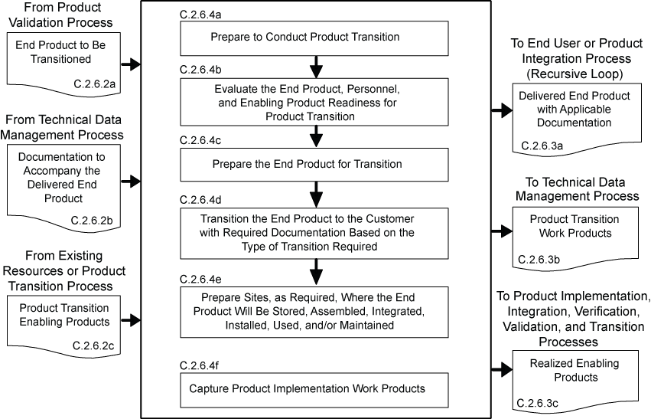
Figure C-9 – Product Transition Process
C.3 Technical Management Processes
There are eight technical management processes—Planning, Requirements Management, Interface Management, Risk Management, Configuration Management, Technical Data Management, Assessment, and Decision Analysis. (See Figure 3-2.) These technical management processes are intended to supplement the management requirements defined in NPR 7120.5. NPR 7120.5 provides program and project managers with the technical activities that they are required to be cognizant of and are responsible for. On the other hand, the technical management process in this SE NPR: (1) provide the technical team their requirements for planning, monitoring and controlling the technical effort as well as the technical decision analysis requirements for performing tradeoff and effectiveness analyses to support decisionmaking throughout the technical effort; (2) focus on (a) completion of technical process planning (preparation of the SEMP and other technical plans), (b) technical progress assessment (using technical measures and conducting technical reviews to assess progress against the SEMP and defined technical requirements), and (c) control of product requirements, product interfaces, technical risks, configurations, technical data and include ensuring that common technical process implementations comply with NPR 7150.2 software product realization requirements for software aspects of the system. Documentation produced through each technical management process should be managed and dispositioned as Federal records.
C.3.1 Technical Planning Process
C.3.1.1 Purpose
The technical planning process is used to plan for the application and management of each common technical process and to identify, define, and plan the technical effort applicable to the product-line life-cycle phase, for WBS model location within the system structure, and to meet project objectives and product-line life-cycle phase exit criteria. A key document generated by this process is the SEMP. (See Chapter 6.)
Note: The results of this technical planning effort should be summarized and provided to the project manager as input to the Technical Summary section of the Project Plan required by 7120.5.
C.3.1.2 Inputs and Sources:
- Project technical effort requirements and project resource constraints (from the project).
- Agreements, capability needs and applicable product-line life-cycle phase(s) (from the project).
- Applicable policies, procedures, standards, and organizational processes (from the project).
- Prior product-line life-cycle phase or baseline plans (from Technical Data Management Process).
- Re-planning needs (from Technical Assessment and Technical Risk Management Processes).
C.3.1.3 Outputs and Destinations:
- Technical work cost estimates, schedules, and resource needs, e.g., funds, workforce, facilities, and equipment (to project).
- Product and process measures needed to assess progress of the technical effort and the effectiveness of processes (to Technical Assessment Process).
- The SEMP and other technical plans that support implementation of the technical effort (to all processes; applicable plans to Technical Processes).
- Technical work directives, e.g., work packages or task orders with work authorization (to applicable technical teams).
- Technical planning work products needed to provide reports, records, and nondeliverable outcomes of process activities (to Technical Data Management Process).
C.3.1.4 Activities
For the WBS model in the system structure, the following activities are typically performed:
- Prepare to conduct technical planning to include:

- Preparing or updating a planning strategy for each of the common technical processes of this SE NPR.
- Determining:
- deliverable work products from technical efforts.
- technical reporting requirements.
- other technical information needs for reviews or satisfying product-line life-cycle management phase entry or exit criteria.
- product and process measures to be used in measuring technical performance, cost, and schedule progress.
- key or critical technical events with entry and success criteria.
- data management approach for data collection and storage and how measurement data will be analyzed, reported, and dispositioned as Federal records.
- technical risks that need to be addressed in the planning effort.
- tools and engineering methods to be employed in the technical effort.
- approach to acquiring and maintaining the technical expertise needed (training and skills development plan).
- Define the technical work to be done to include associated technical, support, and management tasks needed to generate the deliverable products and satisfy entry and success criteria of key technical events and the applicable product-line life-cycle management phase.
Note: Accurate identification of tasks is needed to help (1) create viable schedules, (2) identify staffing needs, (3) determine resource loading and (4) make acceptable cost estimations.
- Schedule, organize, and cost the technical effort.
Note: Based on the defined technical work and identified key events (1) event-based and calendar-based schedules are prepared, (2) resource needs are established, (3) costs estimate are established, and (4) workforce, staff, and skill/training needs are identified and requested.
- Prepare the SEMP and other technical plans needed to support the technical effort and perform the technical processes.
Note 1: The SEMP is described in Chapter 6 and an annotated outline is provided in Appendix D.
Note 2: Other technical plans include the product verification plan and product validation plan developed to support the product verification process and product validation process, respectively, and based on the design solution definition specified requirements to which the product to be evaluated will be generated.
Note 3: Larger projects can find descriptions of other technical plans that may be applicable to the project in ANSI/EIA 632. Smaller projects may include the provisions of applicable plans in the project plan. The key is to ensure that necessary technical activities and considerations are included in the technical effort.
- Obtain stakeholder commitments to the technical plans.
Note: Review SEMP and other technical plans and reconcile to reflect work and resource levels.
- Issue authorized technical work directives to implement the technical work.
Note: Work packages or task orders that implement planned technical efforts are prepared and appropriate work authorizations requested. Authorized work directives are issued to technical teams assigned to perform the technical, support and management activities of the planned technical effort.
- Capture work products from technical planning activities
Note: Work products include the planning strategy for developing any needed technical plans, procedures used for technical planning, rationale for decisions made, assumptions made during technical planning and with respect to decisions made, corrective actions taken to correct identified anomalies, lessons learned in performing the technical planning activities, and updated support documentation.
C.3.1.5 Process Flow Diagram
A typical process flow diagram for technical planning is provided in Figure C-10 with inputs and their sources and the outputs and their destinations. The activities of the technical planning process are truncated to indicate the action and object of the action.
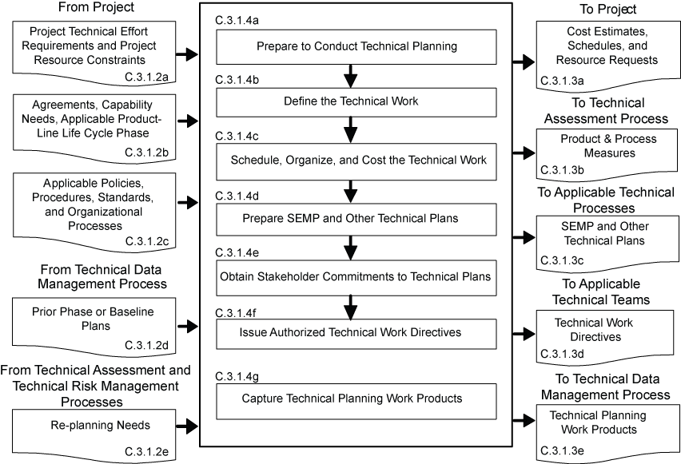
Figure C-10 – Technical Planning Process
C.3.2 Requirements Management Process
C.3.2.1 Purpose
The requirements management process is used to:
- manage the product requirements identified, baselined, and used in the definition of the WBS model products during system design;
- provide bidirectional traceability back to the top WBS model requirements; and
- manage the changes to established requirement baselines over the life cycle of the system products.
C.3.2.2 Inputs and Sources:
- Expectations and requirements to be managed (from System Design Processes).
- Requirement change requests (the project and Technical Assessment Process).
- TPM estimation/evaluation results (from Technical Assessment Process)
- Product verification and product validation results (from Product Verification and Validation Processes)
C.3.2.3 Outputs and Destinations:
- Requirement documents (to Configuration Management Process).
- Approved changes to requirement baselines (to Configuration Management Process).
- Requirements management work products needed to provide reports, records, and non-deliverable outcomes of process activities (to Technical Data Management Process).
Note: The bidirectional traceability status would be included as one of the work products and used in product verification and product validation reports.
C.3.2.4 Activities
For the WBS model in the system structure, the following activities are typically performed:
- Prepare to conduct requirements management to include:
- Preparing or updating a strategy and procedures for:

- establishing that expectation and requirement statements, singularly and as a whole, are prepared in accordance with established formats and rules.
- identifying expectations and requirements to be managed, expectation and requirement sources, allocation and traceability of requirements, and linking product expectations and requirements with costs, weight, and power allocations as applicable
- formal initiation, assessment, review, approval and disposition of engineering change proposals and changes to expectation and requirements baseline.
- Selecting or updating an appropriate requirements management tool.
- Training technical team members in the established requirements management procedures and in the use of the selected/updated requirements management tool.
- Conduct requirements management to include: (1) capturing, storing and documenting the expectations and requirements; (2) establishing that expectation and requirement statements are compliant with format and other established rules; (3) confirming that each established requirements baseline has been validated; and (4) identifying and analyzing out-of-tolerance system-critical technical parameters and unacceptable validation and verification results and proposing requirement appropriate changes to correct out-of-tolerance requirements.
- Conduct expectation and requirements traceability to include: (1) tracking expectations and requirements between baselines, especially MOEs, MOPs, and TPMs, and (2) establishing and maintaining appropriate requirements compliance matrixes that contain the requirements, bidirectional traceability, compliance status, and any actions to complete compliance.
- Manage expectation and requirement changes to include: (1) reviewing engineering change proposals (ECPs) to determine any changes to established requirement baselines, (2) implementing formal change procedures for proposed and identified expectation or requirement changes, and (3) disseminating the approved change information.
- Capture work products from requirements management process activities to include maintaining and reporting information on the rationale for and disposition and implementation of change actions, current requirement compliance status, and expectation and requirement baselines.
C.3.2.5 Process Flow Diagram
A typical process flow diagram for requirements management is provided in Figure C-11 with inputs and their sources and the outputs and their destinations. The activities of the requirements management process are truncated to indicate the action and object of the action.
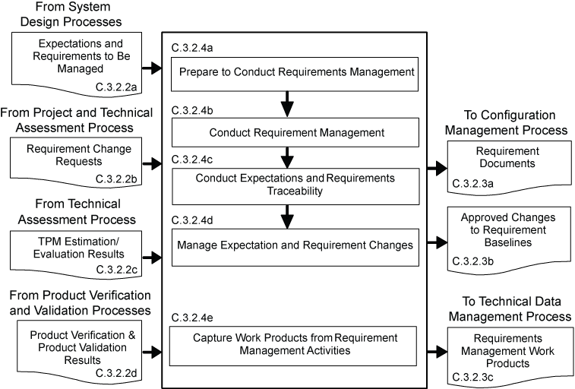
Figure C-11 – Requirements Management Process
C.3.3 Interface Management Process
C.3.3.1 Purpose
The interface management process is used to:
- establish and use formal interface management to assist in controlling system product development efforts when the efforts are divided between Government programs, contractors, and/or geographically diverse technical teams within the same program or project and
- maintain interface definition and compliance among the end products and enabling products that compose the system as well as with other systems with which the end products and enabling products must interoperate.
Note: A less formal interface management approach can be used in conjunction with requirements management and/or configuration management process activities when the technical effort is co-located in the same project.
C.3.3.2 Inputs and Sources:
- Internal and external functional and physical interface requirements for the products of a WBS model (from user or program and System Design Processes).
- Interface change requests (from project, and Technical Assessment Processes).
C.3.3.3 Outputs and Destinations:
- Interface Control Documents (to Configuration Management Processes).
- Approved interface requirement changes (to Configuration Management Process)
- Interface management work products needed to provide reports, records, and non-deliverable outcomes of process activities (to Technical Data Management Process)
C.3.3.4 Activities
For the WBS model in the system structure, the following activities are typically performed:
- Prepare or update interface management procedures for (1) establishing interface management responsibilities for those interfaces that are part of agreement boundaries, (2) maintaining and controlling identified internal and external physical and functional interfaces, (3) preparing and maintaining appropriate physical and functional interface specifications or interface control documents and drawings to describe and control interfaces external to the system end product, (4) identifying interfaces between system products (including humans) and among configuration management items, (5) establishing and implementing formal change procedures for interface evolution, (6) disseminating the needed interface information for integration into technical effort activities and for external interface control, and (7) training technical teams and other applicable support and management personnel in the established interface management procedures.
Note: During application of the system design processes several kinds of interface requirements are baselined and thus need to be managed for each WBS model:
  - System (External). This external interface specifies the vertical functional, physical, electro-magnetic, human and interoperability requirements and characteristics in a system-to-system environment e.g., end products with parent platform and external end products.
  - End Product (Internal). This interface specification has horizontal internal interfaces with other end products and with the enabling products of the WBS model.
  - Enabling Product (Internal and External). This interface specification encompasses the horizontal interfaces with other enabling products and the end products of the same WBS model and possibly vertical interfaces to other system end products and enabling products.
  - Subsystem (Internal). This interface specification specifies the horizontal internal interfaces with the subsystem end products of same parent within the WBS model to ensure effective product integration with respect to form and fit, and, when the subsystem products are not physically mated together except by cabling or electronics, with respect to function.
- Conduct interface management during system design activities for each WBS model in the system structure to include: (1) integrating the interface management activities with requirements management activities; (2) analyzing the concept of operations to identify critical interfaces not included in the stakeholder set of expectations; (3) documenting interfaces both external and internal to each WBS model as the development of the system structure emerges and interfaces are added and existing interfaces are changed; (4) documenting origin, destination, stimulus, and special characteristics of interfaces; (5) maintaining the design solution definition for internal horizontal and vertical interfaces between WBS models in the system structure; (6) maintaining horizontal traceability of interface requirements across interfaces and capturing status in the established requirements compliance matrix; and (7) confirming that each interface control document or drawing that is established has been validated with parties on both sides of the interface.
- Conduct interface management during product integration activities to include: (1) reviewing product integration procedures to ensure that interfaces are marked to ensure easy and correct assembly/connection with other products, (2) identifying product integration planning to identify interface discrepancies, if any, and report to the proper technical team or technical manager, (3) confirming that a pre-check is completed on all physical interfaces before connecting products together, (4) evaluating assembled products for interface compatibility, (5) confirming that product verification and product validation plans/procedures include confirming internal and external interfaces, and (6) preparing an interface evaluation report upon completion of integration and product verification and product validation.
- Conduct interface control to include: (1) managing interface changes within the system structure, (2) identifying and tracking proposed and directed changes to interface specifications and interface control documents and drawings, (3) confirming that the vertical and horizontal interface issues are analyzed and resolved when a change affects products on both sides of the interface, (4) controlling traceability of interface changes including source of the change, processing methods, and approvals, and (5) disseminating the approved interface change information for integration into technical efforts at every level of the project.
Note 1: Typically an interface control working group (ICWG) establishes communication links between those responsible for design of interfacing systems, end products, enabling products and subsystems. The ICWG has the responsibility to ensure accomplishment of the planning, scheduling and execution of all interface activities. ICWGs are typically a technical team with appropriate technical membership from the project, each contractor, significant vendor, and program.
Note 2: An interface control document or drawing (ICD) is a document that establishes and defines the detailed interface definition between two or more systems, end products, system elements, or configuration items. It is used to control the defined interface early in the product-line life cycle and thus reduce design changes due to poorly identified, managed and controlled interfaces.
- Capture work products from interface management activities.
Note: Work products include the strategy and procedures for conducting interface management, rationale for interface decisions made, assumptions made in approving or denying an interface change, corrective actions taken to correct identified interface anomalies, lessons learned in performing the interface management activities, and updated support and interface agreement documentation.
C.3.3.5 Process Flow Diagram
A typical process flow diagram for interface management is provided in Figure C-12 with inputs and their sources and the outputs and their destinations. The activities of the interface management process are truncated to indicate the action and object of the action.
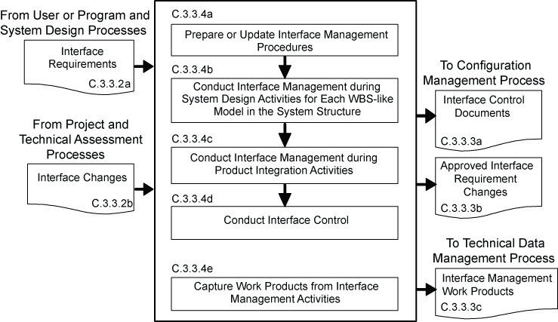
Figure C-12 – Interface Management Process
C.3.4 Technical Risk Management Process
C.3.4.1 Purpose
The technical risk management process is used to examine on a continuing basis the risks of technical deviations from the project plan and identify potential technical problems before they occur so that risk-handling activities can be planned and invoked as needed across the life of the product or project to mitigate impacts on achieving product-line life-cycle phase exit criteria and meeting technical objectives.
C.3.4.2 Inputs and Sources:
- Project Risk Management Plan (from project)
- Technical risk issues (from project and other common technical processes).
- Technical risk status measurements (from Technical Assessment and Decision Analysis Processes).
- Technical risk reporting requirements (from project and Technical Planning Process).
C.3.4.3 Outputs and Destinations:
- Technical risk mitigation and/or contingency actions (to Technical Planning Process for re-planning and/or re-direction).
- Technical risk reports (to project and Technical Data Management Process).
- Work products from technical risk management activities (to Technical Data Management Process).
C.3.4.4 Activities
For the WBS model in the system structure, the following activities are typically performed: (NPR 8000.4, Risk Management Procedural Requirements, is to be used as a source document for defining this process and implementing procedures.)
- Prepare a strategy to conduct technical risk management to include: (1) documenting how the project risk management plan will be implemented in the technical effort; (2) planning identification of technical risk sources and categories; (3) identification of potential technical risks; (4) characterizing and prioritizing technical risks; (5) planning informed technical management (mitigation) actions should the risk event occur; (6) tracking technical risk status against established trigger; (7) resolving technical risk by taking planned action if established trigger is tripped; and (8) communicating technical risk status and mitigation actions taken, when appropriate.
- Identify technical risks to include: (1) identifying sources of risk issues related to the technical effort; (2) anticipate what can go wrong in each of the source areas to create technical risk issues; (3) analyzing identified technical risks for cause and importance; (4) preparing clear, understandable, and standard form risk statements; and (5) coordinating with relevant stakeholders associated with each identified technical risk.
Note 1: Typical technical risk areas include: poorly defined technical tasks, cost estimations, calendar-driven scheduling, poor definition of requirements and interfaces, new technology, environmental conditions, planning assumptions, procedures used in performing technical processes, resource availability and skills of workforce.
Note 2: Whereas there many ways to identify risks, two potential approaches is by data mining and trending.
Note 3: Technical risks are typically defined by relative time frame of risk occurrence, concerns or doubts about risk circumstances, limits or boundary of risk applicability, and potential consequences.
- Conduct technical risk assessment to include: (1) categorizing the severity of consequences for each identified technical risk in terms of performance, cost, and schedule impacts to the technical effort and project; (2) analyze the likelihood and uncertainties of events associated with each technical risk and quantify (for example by probabilities) or qualify (for example by high, moderate, or low) the probability of occurrence in accordance with project risk management plan rules; and (3) prioritize risks for mitigation.
Note: Typically the prioritization of the technical risk is based on: whether the risk is a near or far term concern, possible risk mitigation options and how long the options are viable, the coupling between various sources and characteristics of risk (e.g., technologies, requirements, interfaces, test approaches, manufacturing capacity, logistics, workforce capability, schedules and costs), how the occurrence of risk can be detected, influences of other factors (e.g., quality, safety, security, and interoperability).
- Prepare for technical risk mitigation to include: (1) selecting risks for risk mitigation and monitoring, (2) selecting an appropriate risk handling approach, (3) establishing the risk level or threshold when risk occurrence becomes unacceptable and triggers execution of a risk mitigation action plan, (4) selecting contingency actions and triggers should risk mitigation not work to prevent a problem occurrence, (5) preparing risk mitigation and contingency action plans with identification of responsibilities and authorities.
- Monitor the status of each technical risk periodically to include: (1) tracking risk status to determine whether conditions or situations have changed so that a risk monitoring is no longer needed or new risks have been discovered, (2) comparing risk status and risk thresholds, (3) reporting risk status to decision authorities when a threshold has been triggered and an action plan implemented, (4) preparing technical risk status reports as required by the project risk management plan, (5) communicating risk status during technical reviews in the form specified by the project risk management plan.
- Implement technical risk mitigation and contingency action plans when the applicable thresholds have been triggered to include: (1) monitoring the results of the action plan implemented, (2) modifying the action plan as appropriate to the results of the actions, (3) continuing actions until the residual risk and/or consequences impacts are acceptable or become a problem to be solved, (4) communicate to the project when risks are beyond the scope of the technical effort to control, will affect a product higher in the system structure, or represent a significant threat to the technical effort or project success, (5) preparing action plan effectiveness reports as required by the project risk management plan, (6) communicating action plan effectiveness during technical reviews in the form specified by the project risk management plan.
- Capture work products from technical risk management activities.
Note: Work products include the strategy and procedures for conducting technical risk management; rationale for technical risk management decisions made; assumptions made in prioritizing, handling and reporting technical risks and action plan effectiveness; corrective actions taken to correct action plan implementation anomalies; and lessons learned in performing the technical risk management activities.
C.3.4.5 Process Flow Diagram
A typical process flow diagram for technical risk management is provided in Figure C-13 with inputs and their sources and the outputs and their destinations. The activities of the technical risk management process are truncated to indicate the action and object of the action.
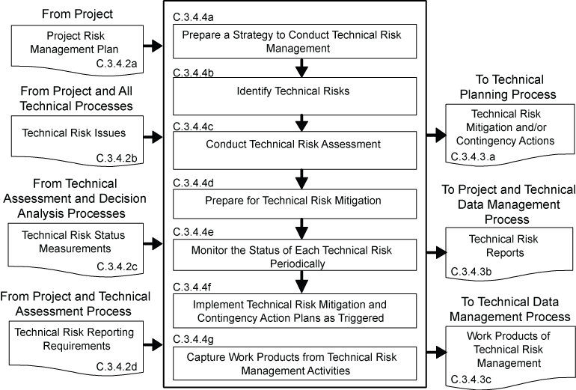
Figure C-13 – Technical Risk Management Process
C.3.5 Configuration Management Process
C.3.5.1 Purpose
The configuration management process for end products, enabling products, and other work products placed under configuration control is used to:
- identify the configuration of the product or work product at various points in time;
- systematically control changes to the configuration of the product or work product;
- maintain the integrity and traceability of the configuration of the product or work product throughout its life; and
- preserve the records of the product or end product configuration throughout its life cycle, dispositioning them in accordance with NPR 1441.1 NASA Records Retention Schedules.
C.3.5.2 Inputs and Sources:
- Project configuration management plan, if any (from project).
- ECPs (from contractors, if any, and technical teams).
- Expectations and requirement outputs to include stakeholder expectations, technical requirements, derived technical requirements, system and end product specifications, requirement documents, and interface control documents/drawings (from Requirements and Interface Management Processes).
- Approved requirement baseline changes, including interface requirement changes (from Requirements Management and Interface Management Processes).
- Concepts of operations, enabling product strategies, logical decomposition models, SEMP, technical plans, and other configuration items identified in the list of CIs to be controlled (from Stakeholder Expectation Definition, Logical Decomposition, Technical Planning, and other technical processes as appropriate).
C.3.5.3 Outputs and Destinations:
- List of configuration items to be placed under control (to applicable technical processes).
- Current baselines (to Technical Requirements Definition, Logical Decomposition, Design Solution Definition, and Product Implementation, Integration, Verification, and Validation Processes.)
Note: A configuration management baseline identifies an agreed-to description of the attributes of a work product or set of work products at a point in time and provides a known configuration to which changes are addressed. Three example baselines for flight systems and ground support systems that are often referenced are the Functional Baseline, Allocated Baseline and Product Baseline. Functional Baselines are established for each WBS model system element prior to the start of Preliminary Design. Allocated Baselines are established for each WBS model end product with the successful completion of a Preliminary Design Review (PDR) at each level of the system structure. The product baseline represents the configuration of each end product.
- Configuration management reports (to project and Technical Data Management Process).
- Work products from configuration management activities (to Technical Data Management Process).
C.3.5.4 Activities
For the WBS model in the system structure, the following activities are typically performed:
- Prepare a strategy to conduct configuration management for the system products and designated work products to include: (1) documenting how the project configuration management plan, if any, will be implemented; (2) identifying configuration items to be put under configuration control; (3) identifying schema of identifiers to accurately describe a configuration item and its revisions or versions; (4) controlling changes to configuration items; (5) maintaining and reporting disposition and implementation of change actions to appropriate stakeholders including technical teams within the project; (6) ensuring that products are in compliance with specifications and configuration documentation during reviews and audits; (7) providing the appropriate reference configuration at the start of each product-line life-cycle phase; (8) obtaining appropriate tools for configuration management; and (9) training appropriate technical team members and other technical support and management personnel in the established configuration management strategy and any configuration management procedures and tools.
- Identify baselines to be under configuration control to include: (1) listing of the configuration items to control; (2) providing each configuration item with a unique identifier; (3) identifying acceptance requirements for each baseline identified for control; (4) identifying the owner of each configuration item; and (5) establishing a baseline configuration for each configuration item.
Note: Typical acceptance requirements for a baseline includes: product-line life-cycle management phase and entry or exit criteria to be satisfied; when the baseline will be approved; when work products will be ready for evaluation; degree of control desired; cost and schedule limitations; and customer requirements.
- Manage configuration change control to include: (1) establishing change criteria, procedures, and responsibilities; (2) receive, record, and evaluate change requests; (3) tracking change requests to closure; (4) obtaining appropriate approvals before implementing a change; (5) incorporating approved changes in appropriate configuration items; (6) releasing changed configuration items for use; and (7) monitoring implementation to determine whether changes resulted in unintended effects (e.g., have not compromised safety or security of baseline product).
Note: A configuration management change board is typically established to receive, review and approve change requests such as an engineering change proposal submitted by a contractor.
- Maintain the status of configuration documentation to include: (1) maintaining configuration item description records and records that verify readiness of configuration items for testing, delivery, or other related technical efforts; (2) maintaining change requests, disposition action taken, and history of change status; (3) maintaining differences between successive baselines; and (4) controlling access to and release of configuration baselines.
- Conduct configuration audits to include: (1) auditing baselines under control to confirm that the actual work product configuration matches the documented configuration, the configuration is in conformance with product requirements, and records of all change actions are complete and up to date; (2) identifying risks to the technical effort based on incorrect documentation, implementation, or tracking of changes; (3) assessing the integrity of the baselines; (4) confirming the completeness and correctness of the content of configuration items with applicable requirements; (5) confirming compliance of configuration items with applicable configuration management standards and procedures; and (6) tracking action items to correct anomalies from audit to closure.
- Capture work products from configuration management activities to include a list of identified configuration items; description of configuration items placed under control; change requests and disposition of the request and rationale for the disposition; documented changes with reason for change and change action; archive of old baselines; and required reports on configuration management outcomes.
C.3.5.5 Process Flow Diagram
A typical process flow diagram for configuration management is provided in Figure C-14 with inputs and their sources and the outputs and their destinations. The activities of the configuration management process are truncated to indicate the action and object of the action.
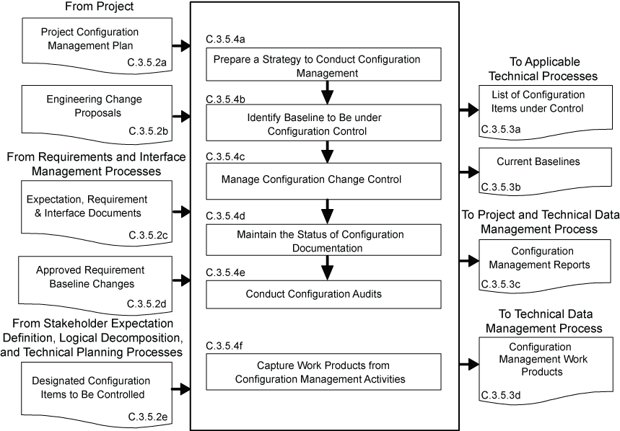
Figure C-14 – Configuration Management Process
C.3.6 Technical Data Management Process
C.3.6.1 Purpose
The technical data management process is used to
- provide the basis for identifying and controlling data requirements;
- responsively and economically acquire, access, and distribute data needed to develop, manage, operate and support system products over their product-line life;
- manage and disposition data as records;
- analyze data use;
- if any of the technical effort is performed by an external contractor, obtain technical data feedback for managing the contracted technical effort; and
- assess the collection of appropriate technical data and information.
C.3.6.2 Inputs and Sources:
- Technical data and work products to be managed (from all technical processes and contractors).
- Requests for technical data (from all technical processes and project).
C.3.6.3 Outputs and Destinations:
- Form of technical data products (to all technical processes and contractors).
- Technical data electronic exchange formats (to all technical processes and contractors).
- Delivered technical data (to project and all technical processes).
C.3.6.4 Activities
For the WBS model in the system structure, the following activities are typically performed:
- Prepare a strategy for the conduct of technical data management to include: (1) determining required data content and form and electronic data exchange interfaces in accordance with international standards or agreements; (2) establishing a framework for technical data flow within the project technical processes and to/from contractors; (3) designating technical data management responsibilities and authorities regarding origination, generation, capture, archiving, security, privacy and disposal of technical data work products; (4) establishing the rights, obligations, and commitments regarding the retention of, transmission of, and access to technical data items; (5) establishing relevant data storage, transformation, transmission, and presentation standards and conventions to be used, project or program policy, and agreements or legislative constraints; (6) describing the methods, tools, and metrics used during the technical effort and for technical data management; and (7) training appropriate technical team members and support and management personnel in the established technical data management strategy and related procedures and tools.
- Collect and store required technical data to include: (1) identifying existing sources of technical data that are designated as outputs of the common technical processes; (2) collecting and storing technical data in accordance with the technical data management strategy and procedures; (3) recording and distributing lessons learned; (4) performing technical data integrity checks on collected data to confirm compliance with content and format requirements and identifying errors in specifying or recording data; and (5) prioritizing, reviewing, and updating technical data collection and storage procedures.
- Maintain stored technical data to include: (1) managing the databases to maintain proper quality and integrity of the collected and stored technical data and to confirm that the technical data is secure and is available to those with authority to have access; (2) performing technical data maintenance as required; (3) preventing the stored data from being used or accessed inappropriately; (4) maintaining the stored technical data in a manner that protects it against foreseeable hazards such as fire, flood, earthquake, and riots; and (5) maintaining periodic back-ups of each technical database.
- Provide technical data to authorized parties to include: (1) maintaining an information library or reference index to provide data available and access instructions; (2) receiving and evaluating requests for technical data and delivery instructions; (3) confirming that required and requested technical data is appropriately distributed to satisfy the needs of the requesting party and in accordance with established procedures, directives, and agreements; (4) confirming that electronic access rules are followed before allowing access to the database and before any data is electronically released/transferred to the requester; and (5) provide proof of correctness, reliability, and security of technical data provided to internal and external recipients.
C.3.6.5 Process Flow Diagram
A typical process flow diagram for technical data management is provided in Figure C-15 with inputs and their sources and the outputs and their destinations. The activities of the technical data management process are truncated to indicate the action and object of the action.
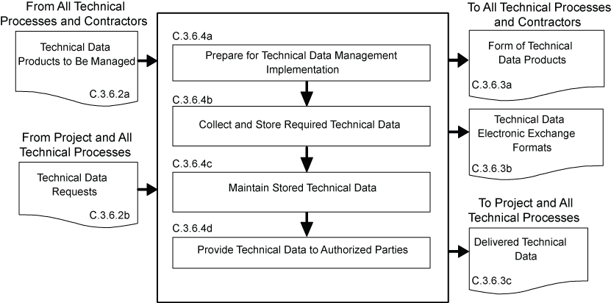
Figure C-15 – Technical Data Management Process
C.3.7 Technical Assessment Process
C.3.7.1 Purpose
The technical assessment process is used to help monitor progress of the technical effort and provide status information for support of the system design, product realization, and technical management processes.
C.3.7.2 Inputs and Sources:
- Process and product measures (from Technical Planning Process).
- Technical plans including the SEMP (from Technical Planning Process).
- Risk reporting requirements during technical reviews (from project).
- Technical cost and schedule status reports (from project).
- Product measurements (from Product Verification and Product Validation Processes).
- Decision support recommendations and impacts (from Decision Analysis Process).
C.3.7.3 Outputs and Destinations:
- Assessment results and findings including technical performance measurement estimates of measures (to Technical Planning, Technical Risk Management and Requirements Management Processes).
- Analysis support requests (to Decision Analysis Process).
- Technical review reports (to project and Technical Data Management Process).
- Corrective action and requirement change recommendations including corrective actions to correct out-of-tolerance TPMs (to Technical Planning, Requirements Management, and Interface Management Processes).
- Work products from technical assessment activities (to Technical Data Management Process).
C.3.7.4 Activities
For the WBS model in the system structure, the following activities are typically performed:
- Prepare a strategy for conducting technical assessments to include: (1) identifying the plans against which progress and achievements of the technical effort are to be assessed; (2) establishing procedures for obtaining cost expenditures against work planned and task completions against schedule; (3) identifying and obtaining technical requirements against which product development progress and achievement will be assessed and establishing the procedures for conducting the assessments; (4) establishing events when TPMs, estimation or measurement techniques, and rules for taking action when out-of-tolerance conditions exist will be assessed; (5) identifying and planning for phase-to-phase technical reviews and WBS model-to-model vertical progress reviews, as well as establishing review entry and success criteria, review board members, and close out procedures; (6) establishing which technical effort work products will undergo peer review, the team members who will perform the peer reviews, and reporting requirements; and (7) training team members, support staff, and managers involved in conducting technical assessment activities.
- Assess technical work productivity (progress and achievement against plans) to include: (1) identifying, collecting, and analyzing process measures (e.g., earned value measurements for measuring progress against planned cost, schedule, resource use, and technical effort tasks) and identifying and reporting cost-effective changes to correct variances; (2) monitoring stakeholder involvement according to the SEMP; and (3) monitoring technical data management against plans.
- Assess product quality (progress and achievements against technical requirements) to include: (1) identifying, collecting, and analyzing the degree of technical requirement and TPM satisfaction; (2) assessing the maturity of the WBS model products and services as applicable to the applicable product-line life-cycle phases; (3) determining any variances from expected values of product performance and identifying and defining cost-effective changes to correct variances.
Note: Product measures tell the degree of satisfaction of stakeholder expectations and deliver an ever-improving value to the customers of system products and services. Product measures also indicate that the design process is continuing in the direction of an acceptable solution. An example of an input product measure is the quality of materials and skills of assigned project personnel. An example of an output metric is a TPM. A TPM provides an early warning of the adequacy of a design in satisfying selected critical technical parameter requirements. A “critical technical parameter” is one that characterizes a significant total system qualifier (e.g., one or more of the MOPs). TPM also examines marginal cost benefit of performance in excess of requirements. In addition, it should be possible to project the evolution of the parameter as a function of time toward the desired value at the completion of development. The projection can be based on test, planning, or historical data.
- Conduct technical reviews to include: (1) identifying the type of technical reviews and each review’s purpose and objectives (see Chapter 5 for specific technical reviews that apply); (2) determining progress toward satisfying entry criteria; (3) establishing the makeup of the review team; (4) preparing the review presentation materials; and (5) identifying and resolving action items resulting from the review.
Note 1: Reviews are typically closed out when the minutes have been prepared, approved, and distributed; action items have been resolved; and the review completion documented and signed off by the review chairperson.
Note 2: This activity includes peer reviews, which are a planned, focused review by technical team peers on a single work product with the intent of identifying issues prior to that work product moving on to the next step. A peer review includes planning, preparing, conducting, analyzing outcomes, and identifying and implementing corrective actions.
- Capture work products from the conduct of technical assessment activities to include: (1) identifying variances resulting from technical assessments; (2) identifying and reporting changes to correct variances; (3) recording methods used in doing assessment activities; (4) documenting assumptions made in arriving at the process and product measure outcomes; and (5) reporting corrective action recommendations.
C.3.7.5 Process Flow Diagram
A typical process flow diagram for technical assessment is provided in Figure C-16 with inputs and their sources and the outputs and their destinations. The activities of the technical assessment process are truncated to indicate the action and object of the action.
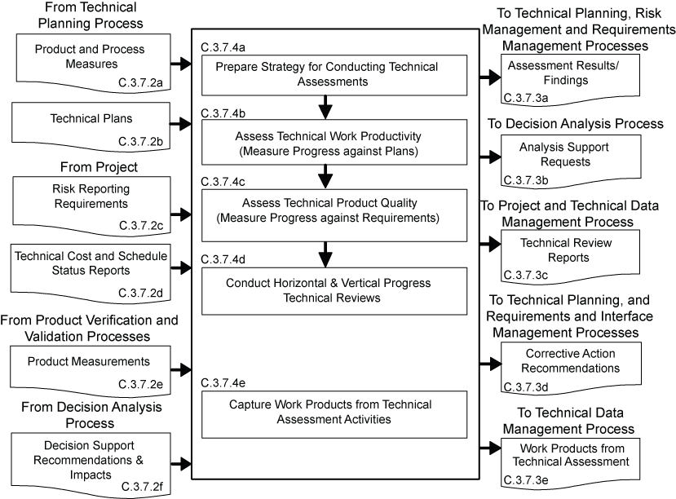
Figure C-16 – Technical Assessment Process
C.3.8 Decision Analysis Process
C.3.8.1 Purpose
The decision analysis process including data collection (e.g., engineering performance, quality, and reliability data) is used to help evaluate technical decision issues, technical alternatives, and their uncertainties to support decisionmaking. This process is used throughout technical management, system design, and product realization processes to evaluate the impact of decisions on performance, cost, schedule, and technical risk.
C.3.8.2 Inputs and Sources:
- Decision need, alternatives, issues, or problems and supporting data (from all Technical Processes).
- Analysis support requests (from Technical Assessment Process).
C.3.8.3 Outputs and Destinations:
- Alternative selection recommendations and impacts (to all Technical Processes)
- Decision support recommendations and impacts (to Technical Assessment Process)
- Work products of decision analysis activities (to Technical Data Management Process).
C.3.8.4 Activities
For the WBS model in the system structure, the following activities are typically performed:
- Establish guidelines to determine which technical issues are subject to a formal analysis/evaluation process to include: (1) when to use a formal decisionmaking procedure, for example, as a result of an effectiveness assessment, a technical trade off, a problem needing to be solved, action needed as a response to risk exceeding the acceptable threshold, verification or validation failure, make-buy choice, evaluating a solution alternative, or resolving a requirements conflict; (2) what needs to be documented; (3) who will be the decision makers and their responsibilities and decision authorities; (4) how decisions will be handled that do not require a formal evaluation procedure.
- Define the criteria for evaluating alternative solutions to include: (1) the types of criteria to consider, including the following: technology limitations, environmental impact, safety, risks, total ownership and life-cycle costs, and schedule impact; (2) the acceptable range and scale of the criteria; and (3) the rank of each criterion by its importance.
- Identify alternative solutions to address decision issues to include alternatives for consideration in addition to those that may be provided with the issue.
- Select evaluation methods and tools/techniques based on the purpose for analyzing a decision and on the availability of the information used to support the method and/or tool.
Note: Typical evaluation methods include the following: simulations; weighted trade-off matrices;   engineering,   manufacturing, cost, and technical opportunity studies; surveys  ; extrapolations based on field experience and prototypes; user review and comment; and testing.
- Evaluate alternative solutions with the established criteria and selected methods to include: (1) evaluation of assumptions related to evaluation criteria and of the evidence that supports the assumptions; and (2) evaluation of whether uncertainty in the values for alternative solutions affects the evaluation.
- Select recommended solutions from the alternatives based on the evaluation criteria to include documenting the information that justifies the recommendations and gives the impacts of taking the recommended course of action.
- Report the analysis/evaluation results/findings with recommendations, impacts, and corrective actions.
- Capture work products from decision analysis activities to include: (1) decision analysis guideline generated and strategy and procedures used; (2) analysis/ evaluation approach, criteria, and methods and tools used; (3) analysis/evaluation results, assumptions made in arriving at recommendations, uncertainties, and sensitivities of the recommended actions or corrective actions; and (4) lessons learned and recommendations for improving future decision analyses.
C.3.8.5 Process Flow Diagram
A typical process flow diagram for technical decision analyses is provided in Figure C-17 with inputs and their sources and the outputs and their destinations. The activities of the decision analysis process are truncated to indicate the action and object of the action.
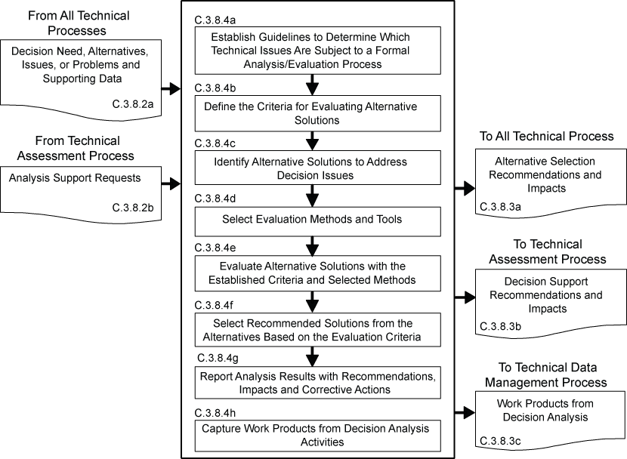
Figure C-17 – Decision Analysis Process

Appendix D. Systems Engineering Management Plan
D.1 Purpose and Use
The purpose of this appendix is to provide an annotated outline for a SEMP for use by NASA in planning the technical effort required for in-house and contracted projects. The SEMP is the technical planning document for systems engineering. The SEMP is designed to be a single, integrated technical planning document for the conduct and management of the required technical effort that is the responsibility of an in-house NASA project. The resulting technical plan is to represent the agreed-to and approved tailoring of the requirements of the SE NPR to satisfy project technical requirements. The plan is to be used by the technical team responsible for generating technical work products to integrate and manage the full spectrum of technical activities required to engineer the system covered by the SEMP. The SEMP needs to be coordinated with the project plan for integration of the technical planning and modifications related to the allocated resources, including cost, schedule, personnel, facilities, and deliverables required. The plan will also be used to evaluate the team’s technical approach, to make technical risk assessments, and to measure progress.
D.2 Terms Used
Terminology is a key factor in ensuring a common understanding of the technical effort to be accomplished. Terms used in the SEMP need to have the same meaning as the terms used in the SE NPR.
D.3 SEMP Preparation
D.3.1 Outline Use
The SEMP outline in this appendix is to be used in preparing a project SEMP. For a small project the material in the SEMP can be placed in the project plan’s technical summary and this annotated outline used as a topic guide.
D.3.2 Tailoring and Waivers
D.3.2.1 SEMP tailoring is to be consistent with the SE NPR tailoring requirements and guidelines. (See Appendix F.) The SEMP is to include documentation of any tailoring to the SE NPR requirements and SEMP sections or subsections. Tailoring is an adaptation of a process or approach to meet a requirement, whereas a waiver is a documented agreement intentionally releasing a program or project from meeting a requirement. Tailored requirements will be documented directly following the heading of each affected SEMP section or subsection. Tailored SE NPR requirements that are not directly related to a SEMP section or subsection will be documented in the waiver section.
D.3.2.2 Approved waivers will be documented and incorporated into the waiver section of the SEMP.
D.3.3 Surveillance-Type Projects
For projects with significant portions of the engineering work contracted out, the SEMP should scope and plan the NASA project’s implementation of the common technical processes before, during, and at the completion of the contracted effort. This should include planning the technical team’s involvement in RFP preparation, in source selection activities, and in acceptance of deliverables. The interface activities with the contractor, including NASA technical team involvement with and monitoring of contracted work, should be a focus of the SEMP.
D.4 SEMP Annotated Outline
D.4.1 General Structure
The SEMP contains the following sections, unless they have been tailored out. Cross references to detailed information in related technical plans are included in each pertinent SEMP section.
- Purpose and Scope.
- Applicable Documents and Designated Governing Authority.
- Technical Summary.
- Technical Effort Integration.
- Common Technical Processes Implementation.
- Technology Insertion.
- Additional SE Functions and Activities.
- Integration with the Project Plan Resource Allocation.
- Waivers.
- Appendices.
D.4.2 Purpose and Scope
This section provides a brief description of the purpose, scope, and content of the SEMP. The scope encompasses the SE technical effort required to generate the work products necessary to meet the exit criteria for the product-line life-cycle phases.
D.4.3 Applicable Documents
This section of the SEMP lists the documents applicable to SEMP implementation and describes major standards and procedures that the technical effort needs to follow. Specific implementation of standardization tasking is incorporated into pertinent sections of the SEMP.
D.4.4 Technical Summary
This section contains an executive summary describing the problem to be solved by this technical effort.
D.4.4.1 System Description
This subsection contains a definition of the purpose of the system being developed and a brief description of the purpose of the products of the WBS models of the system structure for which this SEMP applies. Each WBS model includes the system end products and their subsystems and the supporting or enabling products and any other work products (plans, baselines) required for the development of the system. The description should include any interfacing systems and system products, including humans, with which the WBS model system products will interact physically, functionally, or electronically.
D.4.4.2 System Structure
This subsection contains an explanation of how the WBS models will be developed; how the resulting WBS model will be integrated into the project WBS; and how the overall system structure will be developed. This subsection contains a description of the relationship of the specification tree and the drawing tree with the products of the system structure and how the relationship and interfaces of the system end products and their life-cycle-enabling products will be managed throughout the planned technical effort.
D.4.4.3 Product Integration
This subsection contains an explanation of how the product will be integrated and will describe clear organizational responsibilities and interdependencies whether the organizations are geographically dispersed or managed across Centers.
D.4.4.4 Planning Context
This section contains the product-line life-cycle model constraints (e.g., NPR 7120.5) that affect the planning and implementation of the common technical processes to be applied in performing the technical effort. The constraints provide a linkage of the technical effort with the applicable product-line life-cycle phases covered by the SEMP including, as applicable, milestone decision gates, major technical reviews, key intermediate events leading to project completion, life-cycle phase, event entry and exit criteria, and major baseline and other work products to be delivered to the sponsor or customer of the technical effort.
D.4.4.5 Boundary of Technical Effort
This subsection contains a description of the boundary of the general problem to be solved by the technical effort. Specifically, it identifies what can be controlled by the technical team (inside the boundary) and what influences the technical effort and is influenced by the technical effort but not controlled by the technical team (outside the boundary). Specific attention should be given to physical, functional, and electronic interfaces across the boundary.
D.4.4.6 Cross References
This subsection contains cross references to appropriate nontechnical plans that interface with the technical effort. This section contains a summary description of how the technical activities covered in other plans are accomplished as fully integrated parts of the technical effort.
D.4.5 Technical Effort Integration
This section contains a description of how the various inputs to the technical effort will be integrated into a coordinated effort that meets cost, schedule, and performance objectives.
D.4.5.1 Responsibility and Authority
This subsection contains a description of the organizing structure for the technical teams assigned to this technical effort and includes how the teams will be staffed and managed, including (a) what organization/panel will serve as the DGA for this project and, therefore, will have final signature authority for this SEMP; (b) how multidisciplinary teamwork will be achieved; (c) identification and definition of roles, responsibilities, and authorities required to perform the activities of each planned common technical process; (d) planned technical staffing by discipline and expertise level, with human resource loading; (e) required technical staff training; and (f) assignment of roles, responsibilities, and authorities to appropriate project stakeholders or technical teams to assure planned activities are accomplished.
D.4.5.2 Contractor Integration
This subsection contains a description of how the technical effort of in-house and external contractors is to be integrated with the NASA technical team efforts. This includes establishing technical agreements, monitoring contractor progress against the agreement, handling technical work or product requirements change requests, and acceptance of deliverables. The section will specifically address how interfaces between the NASA technical team and the contractor will be implemented for each of the 17 common technical processes. For example, it addresses how the NASA technical team will be involved with reviewing or controlling contractor-generated design solution definition documentation or how the technical team will be involved with product verification and product validation activities.
D.4.5.3 Support Integration
This subsection contains a description of the methods (such as integrated computer-aided tool sets, integrated work product databases, and technical management information systems) that will be used to support technical effort integration.
D.4.6 Common Technical Processes Implementation
Each of the 17 common technical processes will have a separate subsection that contains the plan for performing the required process activities as appropriately tailored. (See Chapter 3 for the process activities required and Appendix F for tailoring.) Implementation of the 17 common technical processes includes (1) the generation of the outcomes needed to satisfy the entry and exit criteria of the applicable product-line life-cycle phase or phases identified in D.4.4.4 and (2) the necessary inputs for other technical processes. These sections contain a description of the approach, methods, and tools for:
- Identifying and obtaining adequate human and non-human resources for performing the planned process, developing the work products, and providing the services of the process.
- Assigning responsibility and authority for performing the planned process, developing the work products, and providing the services of the process.
- Training the technical staff performing or supporting the process, where training is identified as needed.
- Designating and placing designated work products of the process under appropriate levels of configuration management.
- Identifying and involving stakeholders of the process.
- Monitoring and controlling the process.
- Objectively evaluating adherence of the process and the work products and services of the process to the applicable requirements, objectives, and standards and addressing noncompliance.
- Reviewing activities, status, and results of the process with appropriate levels of management and resolving issues.
D.4.7 Technology Insertion
This section contains a description of the approach and methods for identifying key technologies and their associated risks and criteria for assessing and inserting technologies, including those for inserting critical technologies from technology development projects.
D.4.8 Additional SE Functions and Activities
This section contains a description of other areas not specifically included in previous sections but that are essential for proper planning and conduct of the overall technical effort.
D.4.8.1 System Safety
This subsection contains a description of the approach and methods for conducting safety analysis and assessing the risk to operators, the system, the environment, or the public.
D.4.8.2 Engineering Methods and Tools
This subsection contains a description of the methods and tools not included in D.4.7 that are needed to support the overall technical effort and identifies those tools to be acquired and tool training requirements.
D.4.8.3 Specialty Engineering
This subsection contains a description of engineering discipline and specialty requirements that apply across projects and the WBS models of the system structure. Examples of these requirement areas would include planning for safety, reliability, human factors, logistics, maintainability, quality, operability, and supportability.
D.4.9 Integration with the Project Plan and Technical Resource Allocation
This section contains how the technical effort will integrate with project management and defines roles and responsibilities. This section addresses how technical requirements will be integrated with the project plan to determinate the allocation of resources, including cost, schedule, and personnel, and how changes to the allocations will be coordinated.
D.4.10 Waivers
This section contains all approved waivers to the Center Directors SE NPR Implementation Plan requirement for the SEMP. This section also contains a separate subsection that includes any tailored SE NPR requirements that are not related and able to be documented in a specific SEMP section or subsection.
D.4.11 Appendices
Appendices are included, as necessary, to provide a glossary, acronyms and abbreviations, and information published separately for convenience in document maintenance. Included would be: (a) information that may be pertinent to multiple topic areas (e.g., description of methods or procedures); (b) charts and proprietary data applicable to the technical efforts required in the SEMP; and (c) a summary of technical plans associated with the project. Each appendix should be referenced in one of the sections of the engineering plan where data would normally have been provided.

Appendix E. Hierarchy of Related NASA Documents
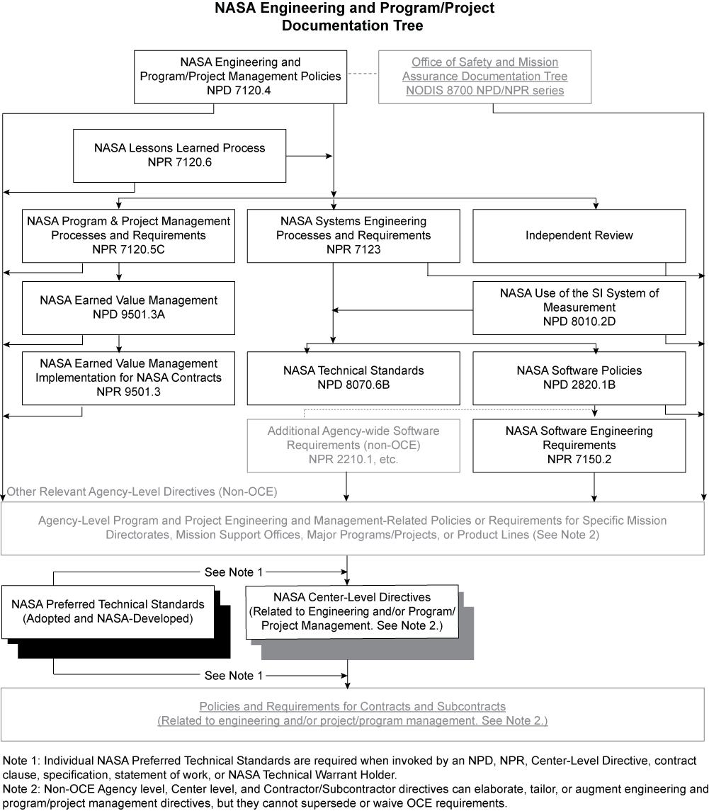

Appendix F. Tailoring
F.1 Tailoring is the documentation and approval of the adaptation of the processes and approach to complying with requirements according to the purpose, complexity, and scope of a NASA program or project. Tailoring, including rationale for modifications, additions, or deletions should be approved by the DGA.
F.2 Each project following this SE NPR needs to tailor to the specific needs of a particular project, phase, or acquisition structure. Tasks that add unnecessary costs, data, and any factors that do not add value to the project need to be eliminated. Tailoring takes the form of modification or addition.
F.3 Tailoring specific tasks requires definition of the depth of detail, level of effort, and the data expected. Tailoring is performed to both breadth and depth based on the project and specific phase of the life cycle. “Tailoring in breadth” deals with factors that can include types and numbers of systems impacted by the development of a new subsystem, the numbers and types of assessments, and numbers and types of reviews. “Tailoring in depth” involves decisions concerning the level of detail needed to generate and substantiate the requirements. The depth of the SE effort varies from project to project in relation to complexity, uncertainty, urgency, and the willingness to accept risk.
F.4 The objectives of the effort, the scope of the SE process, and the breadth and depth of application need to be considered. To assist in defining the depth of application and level of effort, the following should be evaluated as part of the tailoring process of this SE NPR:
- The level of detail in system definition required from the in-house Government or contracted effort.
- The directions and limitations of tasks including willingness to accept risk.
- The scenarios and missions to be examined for each primary system function.
- A set of measures of effectiveness.
- Known constraints in areas where they exist but quantitative data is not available.
- The technology database including identification of key technologies, performance, maturity, cost, risks, schedule, and any limiting criteria on the use of technologies.
- The factors essential to system success, including those factors related to major risk areas (e.g., budget, resources, and schedule).
- Technical demonstration and confirmation events that need to be conducted (including technical reviews).
- The goals and constraints of the project.
- The organizational and contractual requirements for SE processes.
- The baseline SE process for the organization and tailoring guidelines.
- Any cost targets and the acceptable level of risk.
F.5 The basic SE tailoring process can be applied to any development effort (including new developments, modifications, and product improvements) regardless of size or complexity. Attention to scope of the effort and level of output expected is essential. A revolutionary new system development, for example, in Formulation will not usually require formal configuration management audits or formal change control mechanisms. However, conceptual exploration investigation of modifications to an existing developed system may need this type of activity.
F.6 The level of detail expected from the system products of the technical effort needs to be identified. This will scope the depth to which the SE process is executed. For example, functional analysis and synthesis are conducted to a sufficiently detailed depth to identify areas of technical risk based on the life-cycle phase or effort.
F.7 The term “sufficiently detailed” is determined based on the objectives of the project and can be characterized by the information content expected from the physical architecture. Throughout the life cycle, the level of detail may vary since the baseline system may be at one level of detail and product improvements or other modifications may be at a different level of detail. Note that level of detail needed from the technical effort to ensure adequacy of technical definition, design, and development is not synonymous with the level of detail expected for management control and reporting (e.g., cost performance reports).
F.8 The primary output of the SE tailoring process for a project is documented in the SEMP. The form of the SEMP will vary depending on the size, complexity and acceptable cost or risk level of the project.
References
The following documents were used as reference materials in the development of this appendix:
- Defense Acquisition University Systems Engineering Fundamentals, Defense Acquisition University Press, Ft. Belvoir, VA 22060, December 2000.
- International Council on Systems Engineering (INCOSE) Systems Engineering Guide.
Appendix G. Technical Review Entrance and Success Criteria
This appendix describes the recommended best practices for technical reviews.
G.1 Mission Concept Review (MCR)
- The MCR will affirm the mission need and examine the proposed mission's objectives and the concept for meeting those objectives. It is an internal review that usually occurs at the cognizant organization for system development.
- The MCR should be completed prior to entering the concept development phase.
- Entrance Criteria. The MCR should include, for hardware and software system elements, availability of the products in Table G-1 to the cognizant participants prior to the review.
- Success Criteria. The review board was able to conclude that the success criteria in Table G-1 was accomplished to complete the objectives of the MCR.
Table G-1 – MCR Entrance and Success Criteria
Mission Concept Review
Entrance Criteria | Success Criteria
- Mission goals and objectives.  - Analysis of Alternative Concepts to show at least one is feasible.  - Concept of Operations.  - Preliminary mission descope options  - Preliminary risk assessment including technologies and associated risk management/mitigation strategies and options.  - Conceptual test and evaluation strategy.  - Preliminary technical plans to achieve next phase (preliminary SEMP).  - Defined MOEs and MOPs.  - Conceptual life-cycle support strategies (logistics, manufacturing, operation, etc.). | - Mission objectives are clearly defined and stated and are unambiguous and internally consistent.  - The preliminary set of requirements satisfactorily provides a system which will meet the mission objectives.  - The mission is feasible. A solution has been identified which is technically feasible. A rough cost estimate is within an acceptable cost range.  - The concept evaluation criteria to be used in candidate systems evaluation have been identified and prioritized.  - The need for the mission has been clearly identified.  - The cost and schedule estimates are credible.  - A technical search was done to identify existing assets or products that could satisfy the mission or parts of the mission.  - Technical planning is sufficient to proceed to the next phase.  - Risk and mitigation strategies have been identified and are acceptable.

G.2 System Requirements Review (SRR) and/or Mission Definition Review (MDR)

- The SRR and/or MDR examines the functional and performance requirements defined for the system and the preliminary program or project plan and ensures that the requirements and the selected concept will satisfy the mission.
- SRR and/or MDR is typically conducted during the concept development phase following completion of the concept studies phase, following baselining of the Systems Engineering Management Plan (SEMP) and before the preliminary design phase, the Agency Pre-Non-Advocate Review (PNAR), and System Definition Review (SDR).
- Entrance Criteria. Prior to the execution of the SRR and/or MDR the activities and products identified in Table G-2 should be completed and documentation provided to all participants prior to the review. Also, precursor reviews should be completed.
- Success Criteria. The review board was able to conclude that the success criteria in Table G-2 was accomplished to complete the objectives of the SRR and/or MDR.
Table G-2 – SRR and/or MDR Entrance and Success Criteria
System Requirements Review and/or Mission Definition Review
Entrance Criteria | Success Criteria
- Successful completion of the MCR and responses made to all MCR Requests for Actions (RFAs).  - A preliminary SRR and/or MDR agenda, success criteria, and charge to the board have been agreed to by the technical team, project manager, and review chair prior to the SRR and/or MDR.  - The following technical products for hardware and software system elements are available to the cognizant participants prior to the review:  - System Architecture.  - System requirements document.  - System software functionality description.  - Updated concept of operations.  - Updated mission requirements, if applicable.  - Baselined SEMP.  - Preliminary system requirements allocation to the next lower level system.  - Updated cost estimate.  - Technology Development Maturity Assessment Plan.  - Preferred system solution definition including major trades and options.  - Updated risk assessment and mitigations.  - Updated cost and schedule data.  - Logistics documentation (preliminary maintenance plan, etc.).  - Preliminary human rating plan, if applicable.  - Software Development Plan (SDP).  - System safety and mission assurance plan.  - Configuration management plan.  - Project management plan.  - Initial document tree.  - Verification and validation approach.  - Preliminary hazard analysis (PHA).  - Other specialty disciplines as required. | - The resulting overall concept is reasonable, feasible, complete, responsive to the mission requirements, and is consistent with system requirements and available resources (cost, schedule, mass power, etc.).  - The project utilizes a sound process for the allocation and control of requirements throughout all levels, and a plan has been defined to complete the definition activity within schedule constraints.  - Requirements definition is complete with respect to top level mission and science requirements, and interfaces with external entities and between major internal elements have been defined.  - Requirements allocation and flow down of key driving requirements have been defined down to subsystems.  - System and subsystem design approaches and operational concepts exist and are consistent with the requirements set.  - The requirements, design approaches, and conceptual design will fulfill the mission needs within the estimated costs.  - Preliminary approaches have been determined for how requirements will be verified and validated down to the subsystem level  - Major risks have been identified, and viable mitigation strategies have been defined.

G.3 System Definition Review (SDR)

- The SDR examines the proposed system architecture/design and the flow down to all functional elements of the system.
- SDR is conducted early in the preliminary design phase, after the Pre-Non-Advocate Review (PNAR) and before the Preliminary Design Review (PDR).
- Entrance Criteria. Prior to the execution of the SDR, the activities and products identified in Table G-3 should be completed and documentation provided to all participants prior to the review. Also, precursor reviews should be completed.
- Success Criteria. The review board was able to conclude that the success criteria in Table G-3 was accomplished to complete the objectives of the SDR.
Table G-3 – SDR Entrance and Success Criteria
System Definition Review
Entrance Criteria | Success Criteria
- Successful completion of the SRR/MDR and responses has been made to all SRR/MDR RFAs.  - A preliminary SDR agenda, success criteria, and charge to the board have been agreed to by the technical team, project manager and review chair prior to the SDR.  - SDR technical products listed below for both hardware and software system elements have been made available to the cognizant participants prior to the review:  - Updated baselined documentation, as required.  - Preliminary functional baseline (with supporting trade-off analyses and data).  - Preliminary system software functional requirements.  - SEMP changes, if any.  - Updated risk assessment and mitigations.  - Updated technology development, maturity, and assessment plan.  - Updated cost and schedule data.  - Updated logistics documentation.  - Based on system complexity, updated human rating plan.  - Software test plan.  - Software requirements document(s).  - Interface requirements documents (including software).  - Technical resource utilization estimates and margins.  - Updated safety and mission assurance (S&MA) plan.  - Updated PHA. | - Systems requirements including mission success criteria and any sponsor imposed constraints are defined, and form the basis for the proposed conceptual design.  - All technical requirements are allocated, and the flow down to subsystems is adequate. The design definition is sufficient to support initial parametric and bottoms-up cost estimating.  - The requirements process is sound and can reasonably be expected to continue to identify and flow detailed requirements in a manner timely for development.  - The technical approach is credible and responsive to the identified requirements.  - Technical plans have been updated, as necessary.  - The trade-offs are completed, and those planned for phase B adequately address the option space.  - Significant development, mission, and safety risks are identified, and a risk process and resources exist to manage the risks.  - Adequate planning exists for the development of any enabling new technology.  - The operations concept is consistent with proposed design concept(s) ad is in alignment with the mission requirements.

G.4 Preliminary Design Review (PDR)
- The Preliminary Design Review (PDR) demonstrates that the preliminary design meets all system requirements with acceptable risk and within the cost and schedule constraints and establishes the basis for proceeding with detailed design. It will show that the correct design option has been selected, interfaces have been identified, and verification methods have been described.
- PDR occurs near the completion of the preliminary design phase as the last review in the Formulation Phase and before the Agency Non-Advocate Review (NAR).
- Entrance Criteria. Prior to the execution of the PDR, the activities and products identified in Table G-4 should be completed and documentation provided to all participants prior to the review. Also, precursor reviews should be completed.
- Success Criteria. The review board was able to conclude that the success criteria in Table G-4 was accomplished to complete the objectives of the PDR.
Table G-4 – PDR Entrance and Success Criteria
Preliminary Design Review
Entrance Criteria | Success Criteria
- Successful completion of the SDR and responses has been made to all SDR RFAs, or a timely closure plan exists for those remaining open.  - A preliminary PDR agenda, success criteria, and charge to the board have been agreed to by the technical team, project manager, and review chair prior to the PDR.  - PDR technical products listed below for both hardware and software system elements have been made available to the cognizant participants prior to the review:  - Updated baselined documentation, as required.  - Preliminary subsystem design specifications for each configuration item (hardware and software), with supporting tradeoff analyses and data, as required. The preliminary software design specification needs to include a completed definition of the software architecture and a preliminary database design description as applicable.  - Updated technology development maturity assessment plan.  - Updated risk assessment and mitigation.  - Updated cost and schedule data.  - Updated logistics documentation, as required.  - Applicable technical plans (e.g., technical performance measurement plan, contamination control plan, parts management plan, environments control plan, EMI/EMC control plan, payload-to-carrier integration plan, producibility/manufacturability program plan, reliability program plan, quality assurance plan, etc.).  - Applicable standards.  - Safety analyses and plans.  - Engineering drawing tree.  - Interface control documents.  - Verification/validation plan.  - Plans to respond to regulatory requirements (e.g., Environmental Impact Statement), as required.  - Disposal plan.  - Technical resource utilization estimates and margins.  - System-level hazard analysis.  - Preliminary limited life items list (LLIL). | - Agreement exists for the top-level requirements, including mission success criteria, TPMs, and any sponsor-imposed constraints, and that these are finalized, stated clearly, and are consistent with the preliminary design.  - The flow down of verifiable requirements is complete and proper or, if not, an adequate plan exists for timely resolution of open items. Requirements are traceable to mission goals and objectives.  - The preliminary design is expected to meet the requirements at an acceptable level of risk.  - Definition of the technical interfaces is consistent with the overall technical maturity and proves an acceptable level of risk.  - Adequate technical interfaces are consistent with the overall technical maturity and provide an acceptable level of risk.  - Adequate technical margins exist with respect to technical performances measures (TPMs).  - Any required new technology has been developed to an adequate state of readiness, or back-up options exist and are supported to make them a viable alternative.  - The project risks are understood, and plans and a process and resources exist to effectively manage them.  - Safety and mission assurance (i.e., safety, reliability, maintainability, quality, and EEE parts) have been adequately addressed in preliminary designs and any applicable S&MA products (i.e., hazard analysis and failure modes and effects analysis) have been approved.  - The operational concept is technically sound, that it includes (where appropriate) human factors that apply, and that requirements for its execution flow down.

G.5 Critical Design Review (CDR)
- The purpose of the CDR is to demonstrate that the maturity of the design is appropriate to support proceeding with full scale fabrication, assembly, integration, and test, and that the technical effort is on track to complete the flight and ground system development and mission operations in order to meet mission performance requirements within the identified cost and schedule constraints.
- CDR occurs near the completion of the final design phase and always before entering the fabrication, assembly, and test phase.
- Entrance Criteria. Prior to the execution of the CDR, the activities and products identified in Table G-5 should be completed and documentation provided to all participants prior to the review. Also, precursor reviews should be completed.
- Success Criteria. The review board was able to conclude that the success criteria in Table G-5 was accomplished to complete the objectives of the CDR.
Table G-5 – CDR Entrance and Success Criteria
Critical Design Review
Entrance Criteria | Success Criteria
- Successful completion of the PDR and responses has been made to all PDR RFAs, or a timely closure plan exists for those remaining open.  - A preliminary CDR agenda, success criteria, and charge to the board have been agreed to by the technical team, project manager and review chair prior to the CDR.  - CDR technical products listed below for both hardware and software system elements have been made available to the cognizant participants prior to the review:  - Updated baselined documents, as required.  - Product build-to specifications for each hardware and software configuration item, along with supporting trade-off analyses and data.  - Fabrication, assembly, integration, and test plans and procedures.  - Technical Data Package (e.g., Integrated Schematics, Spares Provisioning List, Interface Control Documents, engineering analyses, specifications, etc.).  - Operational Limits and Constraints.  - Technical Resource Utilization estimates and margins.  - Acceptance Criteria.  - Command and Telemetry List.  - Verification Plan (including requirements and specification).  - Validation Plan.  - Launch Site Operations Plan.  - Checkout and Activation Plan.  - Disposal Plan (including decommissioning or termination).  - Updated Technology Development Maturity Assessment Plan.  - Updated risk assessment and mitigation.  - Updated cost and schedule data.  - Updated logistics documentation.  - Software Design Document(s) (including Interface Design Documents).  - Updated LLIL.  - Subsystem-level and preliminary operations hazards analyses.  - Systems and subsystem cerification plans and requirements (as needed).  - System hazard analysis with associated verifications. | - The detailed design is expected to meet the requirements with adequate margins at an acceptable level of risk.  - Interface control documents are appropriately matured to proceed with fabrication, assembly, integration and test, and plans are in place to manage any open items.  - High confidence exists in the product baseline, and adequate documentation exists and/or will exist in a timely manner to allow proceeding with fabrication, assembly, integration, and test.  - The product verification and product validation requirements and plans are complete.  - The testing approach is comprehensive, and the planning for system assembly, integration, test, and launch site and mission operations is sufficient to progress into the next phase.  - Adequate technical and programmatic margins and resources exist to complete the development within budget, schedule, and risk constraints.  - Risks to mission success are understood, and plans and resources exist to effectively manage them.  - Safety and mission assurance (i.e., safety, reliability, maintainability, quality, and EEE parts) have been adequately addressed in system and operational designs and any applicable S&MA products (i.e., hazard analysis and failure modes and effects analysis) have been approved.

G.6 Test Readiness Review (TRR)
- A TRR ensures that the test article (hardware/software), test facility, support personnel, and test procedures are ready for testing and data acquisition, reduction, and control.
- A TRR is held prior to commencement of verification testing.
- Entrance Criteria. Prior to the execution of a TRR, the activities and products identified in Table G-6 should be completed and documentation provided to all participants prior to the review.
- Success Criteria. The review board was able to conclude that the success criteria in Table G-6 was accomplished to complete the objectives of a TRR.
Table G-6 – TRR Entrance and Success Criteria
Test Readiness Review
Entrance Criteria | Success Criteria
- The objectives of the testing have been clearly defined and documented and that all of the test plans, procedures, environment, and the configuration of the test item support those objectives.  - Configuration of system under test has been defined and agreed to. All interfaces have been placed under configuration management or have been defined in accordance with an agreed to plan, and a version description document has been made available to TRR participants prior to the review.  - All applicable functional, unit level, subsystem, system, and qualification testing has been conducted successfully.  - All TRR specific materials such as test plans, test cases, and procedures have been available to all participants prior to conducting the review.  - All known system discrepancies have been identified and dispositioned in accordance with an agreed upon plan.  - All previous design review success criteria and key issues have been satisfied in accordance with an agreed upon plan.  - All required test resources (people (including a designated test director) facilities, test articles, test instrumentation) have been identified and are available to support required tests.  - Roles and responsibilities of all test participants are defined and agreed to.  - Test contingency planning has been accomplished, and all personnel have been trained. | - Adequate test plans are completed and approved for the system under test.  - Adequate identification and coordination of required test resources is completed  - Previous component, subsystem, system test results form a satisfactory basis for proceeding into planned tests.  - Risk level is identified and accepted by program/competency leadership as required.  - Plan to capture any lessons learned from the test program  - The objectives of the testing have been clearly defined and documented, and the review of all the test plans, as well as the procedures, environment, and the configuration of the test item, provide a reasonable expectation that the objectives will be met  - The test cases have been reviewed and analyzed for expected results, and the results are consistent with the test plans and objectives  - Test personnel have received appropriate training in test operation and safety procedures.

G.7 Systems Acceptance Review (SAR)
- The purpose of the SAR is to verify the completeness of the specific end item with respect to the expected maturity level and to assess compliance to stakeholder expectations. The SAR examines the system, its end items and documentation, and test data and analyses that support verification. It also ensures that the system has sufficient technical maturity to authorize its shipment to the designated operational facility or launch site.
- The SAR is held late in the fabrication, assembly, integration, and test phase.
- Entrance Criteria. Prior to the execution of the SAR, the activities and products identified in Table G-7 should be completed and documentation provided to all participants prior to the review.
- Success Criteria. The review board was able to conclude that the success criteria in Table G-7 was accomplished to complete the objectives of the SAR.
Table G-7 – SAR Entrance and Success Criteria
System Acceptance Review
Entrance Criteria | Success Criteria
- A preliminary agenda has been coordinated (nominally) prior to the SAR.  - The following SAR technical products have been made available to the cognizant participants prior to the review:  - Results of the SARs conducted at the major suppliers.  - Transition to production and/or manufacturing plan.  - Documentation that the delivered system complies with the established acceptance criteria.  - Documentation that the system will perform properly in the expected operational environment.  - Technical data package as updated to include all test results.  - Certification package.  - Updated risk assessment and mitigation.  - Previous milestone reviews have been successfully completed.  - Remaining liens or unclosed actions and plans for closure. | - Required tests and analyses are complete and indicate that the system will perform properly in the expected operational environment.  - Risks are known and manageable.  - System meets the established acceptance criteria.  - Required shipping, handling, checkout, and operational plans and procedures are complete and ready for use.  - Technical data package is complete and reflects the delivered system.  - All applicable lessons learned for organizational improvement and system operations are captured.

G.8 Flight Readiness Review (FRR)
a. The FRR examines tests, demonstrations, analyses, and audits that determine the system’s readiness for a safe and successful flight/launch and for subsequent flight operations. It also ensures that all flight and ground hardware, software, personnel, and procedures are operationally ready.
- The FRR is held after the system has been configured for flight.
- Entrance Criteria. Prior to the execution of the FRR, the activities and products identified in Table G-8 should be completed and documentation provided to all participants prior to the review.
- Success Criteria. The review board was able to conclude that the success criteria in Table G-8 was accomplished to complete the objectives of the FRR:
Table G-8 – FRR Entrance and Success Criteria
Flight Readiness Review
Entrance Criteria | Success Criteria
- Receive certification that flight operations can safely proceed with acceptable risk.  - Confirm that the system and support elements are properly configured and ready for flight.  - Establish that all interfaces are compatible and function as expected.  - Establish that the system state supports a launch “go” decision based on go/no-go criteria. | - The flight vehicle is ready for flight.  - The hardware is ready for a safe flight with a high probability for achieving mission success.  - Flight and ground software elements are ready to support flight and flight operations.  - Interfaces are checked out and found to be functional.  - Open items and waivers have been examined and found to be acceptable.  - The flight and recovery environmental factors are within constraints.  - All open safety and mission risk items have been addressed.

G.9 Operational Readiness Review (ORR)

- The ORR examines the actual system characteristics and the procedures used in the system or product’s operation and ensures that all system and support (flight and ground) hardware, software, personnel, procedures, and user documentation accurately reflects the deployed state of the system.
- The ORR is held at the end of Phase D.
- Entrance Criteria. Prior to the execution of the ORR, the activities and products identified in Table G-9 should be completed and documentation provided to all participants prior to the review.
- Success Criteria. The review board was able to conclude that the success criteria in Table G-9 was accomplished to complete the objectives of the ORR.
Table G-9 – ORR Entrance and Success Criteria
Operational Readiness Review
Entrance Criteria | Success Criteria
- All validation testing has been completed.  - Test failures and anomalies from validation testing have been resolved and the results incorporated into all supporting and enabling operational products.  - All operational supporting and enabling products (facilities, equipment, documents, updated databases, etc) that are necessary for the nominal and contingency operations have been tested and delivered/installed at the site(s) necessary to support operations.  - Training has been provided to the users and operators on the correct operational procedures for the system.  - Operational contingency planning has been accomplished, and all personnel have been trained. | - The system, including any enabling products, is determined to be ready to be placed in an operational status.  - All applicable lessons learned for organizational improvement and systems operations have been captured.  - All waivers and anomalies have been closed.  - Systems hardware, software, personnel, and procedures are in place to support operations.

G.10 Periodic Technical Review (PTR)
Science and technology development conducted by NASA in BAR, ATD, and IP programs and projects may not be conducted along the same rigorous processes and schedules as FS&GS programs. Depending on the scope and technology readiness level (TRL) of these projects, a streamlined review system may be appropriate. (See NPR 7120.5 for a definition of TRL.) Sound engineering of processes defined in this SE NPR should be applied and reviewed when appropriate. A PTR review schedule with well-defined review entrance and success criteria should be developed in project formulation. Success criteria should ascertain whether sufficient technical maturity has been achieved to support a management decision to proceed to the next phase. In some cases, such as high TRL development efforts, a subset of FS&GS reviews is appropriate (e.g., SRR, PDR, CDR, SAR). PTRs should include both internal and independent external reviewers. Finding and actions from each PRT should be disseminated and resolved after each review.
G.11 Decommissioning Review (DR)
- The purpose of the DR is to confirm the decision to terminate or decommission the system and assess the readiness for the safe decommissioning and disposal of system assets.
- The DR is normally held near the end of routine mission operations upon accomplishment of planned mission objectives. It may be advanced if some unplanned event gives rise to a need to prematurely terminate the mission, or delayed if operational life is extended to permit additional investigations.
- Entrance Criteria. Prior to the execution of the DR, the activities and products identified in Table G-10 should be completed and documentation provided to all participants prior to the review.
- Success Criteria. The review board was able to conclude that the success criteria in Table G-10 was accomplished to complete the objectives of the DR.
Table G-10 – DR Entrance and Success Criteria
Decommissioning Review
Entrance Criteria | Success Criteria
- Requirements associated with decommissioning and disposal.  - Plans for decommissioning, disposal, and any other removal from service activities.  - Resources in place to support decommissioning and disposal activities, plans for disposition of project assets, and archival of essential mission and project data.  - Description of safety, environmental, and any other constraints.  - Description of the current system capabilities.  - For off-nominal operations, description of all contributing events, conditions, and changes to the originally expected baseline. | - The reasons for decommissioning disposal are documented.  - The decommissioning and disposal plan is complete, approved by appropriate management, and compliant with applicable Agency safety, environmental, and health regulations. Operations plans for all potential scenarios, including contingencies, are complete and approved. All required support systems are available.  - All personnel have been properly trained for the nominal and contingency procedures.  - Safety, health, and environmental hazards have been identified. Controls have been verified.  - Risks associated with the disposal have been identified and adequately mitigated. Residual risks have been accepted by the required management.  - If hardware is to be recovered from orbit:  - Return site activity plans have been defined and approved.  - Required facilities are available and meet requirements, including those for contamination control, if needed.  - Transportation plans are defined and approved. Shipping containers and handling equipment, as well as contamination and environmental control and monitoring devices, are available.  - Plans for disposition of mission-owned assets (hardware, software, facilities, etc.) have been defined and approved.  - Plans for archival and subsequent analysis of mission data have been defined and approved. Arrangements have been finalized for the execution of such plans. Plans for the capture and dissemination of appropriate lessons learned during the project life cycle have been defined and approved. Adequate resources (schedule, budget, and staffing) have been identified and are available to successfully complete all decommissioning, disposal, and disposition activities.

G.12 Technical Peer Reviews
- Peer reviews provide the technical insight essential to ensure product and process quality. Peer reviews are focused, in-depth technical reviews that support the evolving design and development of a product, including critical documentation or data packages. They are often, but not always, held as supporting reviews for technical reviews such as PDR and CDR. A purpose of the peer review is to add value and reduce risk through expert knowledge, infusion, confirmation of approach, identification of defects, and specific suggestions for product improvements.
- The results of the engineering peer reviews (EPRs) comprise a key element of the review process. The results and issues that surface during these reviews are documented and reported out at the appropriate next higher element level.
- The peer reviewers should be selected from outside the project, but they should have a similar technical background, and they should be selected for their skill and experience. Peer reviewers should be selected to have as their only concern the technical integrity and quality of the product. Peer reviews should be kept simple and informal. They should concentrate on a review of the documentation and minimize the viewgraph presentations. A “round-table” format rather than a stand-up presentation is preferred. The peer reviews should give the full technical picture of items being reviewed.
- Technical depth should be to a level that allows the review team to gain insight into the technical risks. Rules need to be established to ensure consistency in the peer review process. At the conclusion of the review, a report on the findings and actions must be distributed.
- Peer reviews must be part of the contract for those projects where systems engineering is done out-of-house.

Appendix H. Templates
H-1 Sample SE NPR Implementation Plan Template

H-2 SE NPR Center Survey

Appendix I. Additional Reading
The following documents were used as reference materials in the development of this SE NPR. The documents are offered as informational sources and are not evoked in this SE NPR, though they may be referenced.
- MIL-STD-499B (draft), Systems Engineering.
- ISO/IEC 15288, System Life Cycle Processes.
- ANSI/EIA 632, Processes for Engineering Systems.
EIA 632 is a commercial version that evolved from the never released, but fully developed 1994 Mil-Std 499B Systems Engineering. It was intended to provide a framework for developing and supporting universal SE discipline for both defense and commercial environments. EIA 632 was intended to be a top-tier standard further defined to lower level tier standards that define specific practices. IEEE 1220 is a second-tier standard that implements EIA 632 by defining one way to practice systems engineering. ISO/IEC 15288 defines system life processes for the international set plus for any domain (i.e., transportation, medical, commercial, et al.).
- CMMI model.
The Capability Maturity Model® (CMM) IntegrationSM (CMMI) in its present form is a collection of best practices for the “development and maintenance” of both “products and services.” The model was developed by integrating practices from four different CMMs—the “source models:” the CMM for software, for systems engineering, for integrated product development (IPD), and for acquisition. Organizations can use the model as a guide for improving their ability to develop (or maintain) products (and services) on time, within budget, and with desired quality. During the past decade, many organizations have used CMM and CMM-like concepts to bring order to their development processes. Additionally, it also provides these organizations the framework for enlarging the focus of process improvement to other areas that also affect product development—the discipline of systems engineering. During the past decade, new and effective concepts for organizing developmental work have surfaced and been adopted such as concurrent engineering or the use of integrated teams. Organizations using (or wishing to adopt these ideas) can also find support in the CMMI by using the model with integrated product and process development (IPPD) additions.
- Defense Acquisition University Systems Engineering Fundamentals. Defense Acquisition University Press, Ft. Belvoir, VA, December 2000.
- International Council on Systems Engineering Systems Engineering Guide.
- ISO/IEC 19760, A Guide for the Application of ISO/IEC 15288 (System Life Cycle Processes).
- ISO/AS9100, "Quality Management Systems, Aerospace, Requirements.

Appendix J. Index

Activity(ies), iii, 2, 5, 7, 14, 15, 21, 25, 29, 31, 34, 35, 41, 44, 49, 53, 55, 57, 60, 62, 64, 65, 68, 69, 71, 72, 73, 75, 76, 77, 79, 81, 86, 92, 93, 94, 96, 97, 98, 99, 100
Advanced Technology Development, 1, 30
Analysis of Alternative, 92
Applied Research, 23, 30, 38
Approval, 5, 38, 39
Architecture, iii, iv, 93, 95
Assessment(s), 11, 19, 20, 21, 40, 44, 57, 58, 60, 61, 65, 67, 69, 80, 81, 92, 93, 94, 95, 96, 98
ATD, 1, 30
Authority, iii, 5, 9, 11, 21, 30, 86
BAR, 1
Baseline, 15, 18, 31, 36, 85, 93, 94, 95, 96, 100
Basic and Applied Research, 1
Basic and Applied Research (BAR), 1
Budget, 96
CDR, iv, v, 96
Center Director(s), 9, 10, 11, 15, 16, 17, 18, 19, 20, 88
Common Technical Processes, iii, 7, 13, 14, 15, 21, 23, 40, 64, 86
Configuration Management, iv, 19, 76, 91, 97
Constraint(s), 4, 13, 31, 34, 90, 93, 94, 95, 96, 99, 100
Contractor, 8, 21, 30, 34, 86
Control(s), 10, 21, 27, 38, 64, 69, 70, 74, 93, 95
Criteria
Entrance, 92, 93, 94, 95, 96, 97, 98, 99, 100
Exit, 13, 18, 31, 33, 84, 86
Critical Design Review, iv, v, 96
Customer, 1, 18, 22, 30, 31, 32, 33, 34, 35
Decision Analysis, v, 20, 21, 82
Decommissioning Review, iv, v, 38, 100
Definition
Design Solutions, iv, 16, 17, 41, 42, 45, 46, 47, 48, 49, 50, 51, 52, 57, 58, 59, 63, 66, 70, 86
Stakeholder Expectations, 15, 18
Technical Requirements, iv, 16, 17, 45
Technical Solutions, 21
Design Realization, iv, 21
Disposal, 4, 5, 14, 22, 95, 96
Document(s), iii, iv, 1, 2, 18, 38, 40, 69, 70, 71, 84, 93, 94, 96, 97, 99
Interface Control, 38, 95, 96
Domain, 35
DR, iv, v, 38, 100
Electromagnetic Interference, 95
EMI, 95
Enabling Products, 14, 16, 19, 34, 85, 99
Engineering, 1, 2, 4, 7, 9, 10, 15, 20, 26, 28, 34, 35, 38, 39, 66, 83, 87, 91, 92, 95, 96, 101, 103
Entrance Criteria, 92, 93, 94, 95, 96, 97, 98, 99, 100
Environment(al,s), 1, 2, 34, 35, 38, 95, 97, 98, 99
Exit Criteria, 13, 18, 31, 33, 84, 86
Formulation, 38
Governing Authority, iii, 2, 5, 38, 84
Implementation, iii, iv, 1, 2, 10, 28, 31, 86, 88, 102
Institutional Project, 1
Integrate(d,s), 38, 96
Integration, iv, 95
Interface Control Document, 95, 96
Interface(s)
Technical, 95
IP, 1
Key Performance Parameter, 30, 35
KPP, 30
Life Cycle, iii, iv, 20, 92, 103
Life Cycle Processes, 103
Logical Decomposition, iv, 16, 46, 47
Management
Configuration, iv, 19, 76, 91, 97
Project, 5, 9, 93
Risk, iv, 19, 72, 73, 92
Systems engineering, 1, 5
Systems Engineering, iii, 93, 94
Management Life Cycle(s), 2, 23, 31
MCR, iv, v, 92, 93
Measure of Effectiveness, 17, 18, 30, 92
Measure of Performance, 17, 30, 35, 43, 44, 46, 92
Milestone, 98
Mission, iv, 1, 2, 9, 14, 21, 31, 32, 34, 35, 38, 39, 45, 62, 63, 92, 93, 94, 95, 96, 99
Mission Assurance, 2, 39, 93, 94, 95, 96
Mission Concept Review, iv, v, 92, 93
Mission Directorate, 9, 38
Mission Support Office, 38
MoE, 17, 30
MOP(s), 17, 30, 32, 35, 92
NASA Policy Directive, 2, 5, 9
NASA Procedural Document, 2, 4, 5, 9
NASA Procedural Requirements, iv, 1, 2, 5, 7, 8, 9, 10, 11, 13, 15, 20, 23, 30, 31, 35, 39, 40, 102
Non-Advocate Review, 39, 92, 93
NPD, 2, 5, 9
NPR, iv, 1, 2, 5, 7, 8, 9, 10, 11, 13, 15, 20, 23, 30, 31, 35, 39, 40, 102
OCE, 7, 9, 10, 40
Office of the Chief Engineer, ii, 7, 9, 10, 40
Operational Concepts, 93
Operational Readiness Review, iv, v, 99
Organization, iii, 2, 5, 9, 30, 85, 86
ORR, iv, v, 99
PDR, iv, v, 75, 94, 95, 96
Peer Review, iv, 1, 38, 39, 83, 101
Periodic Technical Review, iv, 25
Phase B, 94
Phase D, 99
Phase(s)
B, 94
D, 99
Implementation, 31
Life Cycle, 2, 8, 15, 18, 23, 26, 31, 33, 84, 86
Plan(s)
EMI/EMC Control, 95
Integration, 95
Project, 39, 83, 87, 92
Project Management, 93
Quality Assurance, 95
Systems Engineering Management (SEMP), iii, 1, 5, 11, 34, 39, 93, 94
Technical, iv, 5, 18, 21, 29, 67, 92, 95
Technical Performance Measurement, 95
Validation, 95, 96
Verification, 96
PR, 1, 39, 83, 101
Preliminary Design Review, iv, v, 75, 94, 95, 96
Process(es)
Assessment, 20, 44, 57, 58, 60, 61, 65, 67, 69, 80, 81
Common Technical, iii, 7, 13, 14, 15, 21, 23, 40, 64, 86
Decision Analysis, v, 20, 82
Definition, 16, 40, 41, 42, 43, 45, 46, 48, 49, 51
Design, iii, 14, 18, 19
Design Realization, iv
Expectation Definition, 43
Life Cycle, 103
Planning, 18, 25, 49, 57, 59, 65, 67, 72, 78
Product Realization, iii, 14, 20
Product Transition, iv, 18, 64
Product Verification, iv, 17, 58
Realization, 51, 52
Stakeholder Expectation Definition, iv
Stakeholder Expectations Definition, 15, 18
Technical, 1, 4, 7, 13, 15, 18, 28, 31, 34, 40, 62, 65, 72, 77, 84, 85, 86
Technical Control, v, 20, 25, 78, 80
Technical Management, iii, 14, 20
Technical Planning, iv, 18, 67
Technical Requirements Definition, iv, 16, 17, 42, 45
Transition, 18, 52, 54, 55, 57, 59, 61, 62, 63, 64
Process(s)
Product Validation, iv, 18, 61
Processes, iii, iv, v, 1, 5, 7, 8, 9, 13, 14, 15, 16, 17, 18, 19, 20, 26, 31, 32, 33, 38, 40, 42, 43, 45, 46, 47, 49, 50, 51, 52, 53, 54, 55, 56, 57, 58, 59, 61, 62, 64, 65, 66, 67, 69, 70, 71, 72, 73, 74, 76, 77, 78, 79, 80, 81, 82, 93, 94, 95, 101, 103
Product Lines, iv, 31
Product Realization Processes, iii, 14, 20
Product(s)
Enabling, 14, 16, 19, 34, 85, 99
Program Management Committee, 27
Project(s)
Institutional, 1, 38
PTR, iv
Request for Proposal, 21
Requests for Action, 26, 93
Requirement(s)
Interface, 49, 94
Software Engineering, 2, 52
System, iv, 31, 35, 93
Requirements Management, iv, 18, 69
Requirements Review, 26, 39, 92
Research
Applied, 23, 30, 38
Basic and Applied (BAR), 1
Review, iv, 1, 5, 8, 11, 25, 26, 27, 32, 34, 38, 39, 50, 64, 73, 78, 79, 85, 90, 92, 93, 94, 95, 96, 97, 98, 99, 100, 101
Review(s)
Confirmation (CR), 38
Continuation (CnR), 38
Continuation (ConR), 38
Critical Design (CDR), iv, v, 96
Decommissioning (DR), iv, v, 38, 100
Flight Readiness (FRR), iv, v, 38, 98, 99
Management, 26
Mission Concept (MCR), iv, v, 92, 93
Non-Advocate (NAR), 39, 92, 93
Operational Readiness (ORR), iv, v, 99
Peer, iv, 38, 101
Periodic Technical (PTR), iv, 25
Preliminary Design (PDR), iv, v, 75, 94, 95, 96
Pre-Non-Advocate (PNAR), 39
Product Definition (PDR), iv, v, 75, 94, 95, 96
Production (PR), 1, 39, 83, 101
System Acceptance (SAR), iv, v, 98
System Definition (SDR), iv, 94
System Definition or Design (SDR), iv, v, 93, 94, 95
System Requirements (SRR), iv, v, 26, 92, 93, 94
Technical, iii, iv, 8, 11, 23, 26, 34, 92, 99
Technical Progress, 26
Test Readiness (TRR), iv, v, 97
RFA, 26
RFP, 21
Risk Management, iv, 19, 72, 73, 92
Roles and Responsibilities, iii, 9, 87
Safety, 1, 2, 25, 34, 35, 39, 45, 46, 81, 87, 94, 95, 96, 97, 99, 100
SAR, iv, v, 98
Schedule, 2, 5, 13, 20, 34, 92, 93, 94, 95, 96
SDR, iv, v, 93, 94, 95
SE, iv, 1, 4, 6, 7, 8, 9, 10, 11, 12, 13, 14, 15, 23, 31, 35, 39, 40, 64, 65, 83, 84, 87, 88, 90, 91, 100, 102, 103
SEMP, iii, 1, 5, 10, 11, 15, 18, 21, 22, 28, 29, 83, 84, 86, 92, 93, 94
SEWG, 10
Shall, 9, 10, 15, 16, 21, 22, 25, 26, 29, 31, 33
Software Design Documents, 96
Software Development Plan, 39, 93
Software Test Plan, 94
SRR, iv, v, 26, 92, 93, 94
Stakeholder, iv, 13, 15, 16, 17, 18, 23, 31, 32, 35, 42
Stakeholder Expectations, iv, 13, 15, 16, 17, 18, 23, 42
System, i, iii, iv, 1, 4, 5, 6, 7, 9, 10, 14, 15, 18, 19, 20, 21, 23, 25, 26, 28, 30, 31, 33, 35, 36, 39, 41, 44, 46, 48, 49, 53, 55, 57, 60, 62, 65, 68, 69, 72, 75, 77, 79, 81, 83, 85, 87, 92, 93, 94, 95, 96, 97, 98, 99, 101, 103
System Acceptance Review, iv, v, 98
System Definition Review, iv, v, 93, 94, 95
System Design Review, iv, v, 93, 94, 95
System Engineering Management Plan, iii, 1, 5, 10, 15, 18, 21, 22, 28, 29, 40, 66, 83, 84, 86, 92, 93, 94
System Engineering Working Group, 10
System Requirements Review, iv, v, 26, 92, 93, 94
System Safety, 93
System(s) Engineering Working Group, 10
Systems Acceptance Review, 98
Systems Engineering, i, iii, iv, 1, 4, 5, 6, 7, 8, 9, 10, 11, 12, 13, 14, 15, 21, 23, 26, 28, 31, 35, 39, 40, 64, 65, 83, 84, 87, 88, 90, 91, 93, 94, 100, 101, 102, 103
Tailoring, iv, 5, 83, 86
Technical Management Processes, iii, 14, 20
Technical Performance Measures, 30, 35, 79
Technical Performance Metrics, 30, 79, 95
Technical Requirements, iv, 5, 16, 17, 45, 94
Technical Team, 1, 5, 15, 21, 22, 26, 29, 35, 74, 93, 94, 95, 96
Test Readiness Review, iv, v, 97
TPM, 30, 79, 95
Training, 15, 32, 66, 97, 99
Transitions, 18, 21, 22, 33, 35, 52, 54, 55, 57, 59, 61, 62, 63, 64, 98
TRR, iv, v, 97
Validation, 15, 17, 49, 57, 59, 61, 62, 78, 86, 93, 95, 96, 99
Verification, 16, 17, 33, 49, 52, 55, 56, 59, 86, 93, 95, 96
Verification and Validation, 33
Waivers, 5, 83, 88, 99
WBS, iv, 14, 15, 16, 17, 18, 33, 34, 35, 37, 41, 44, 46, 49, 53, 55, 57, 60, 62, 63, 65, 68, 69, 72, 75, 77, 79, 81, 85, 87
Work Breakdown Structure, iv, 14, 15, 16, 17, 18, 33, 34, 35, 37, 41, 44, 46, 49, 53, 55, 57, 60, 62, 63, 65, 68, 69, 72, 75, 77, 79, 81, 85, 87

J.A. Moody, W.L. Chapman, F.D. Van Voorhees, A.T. Bahill, Metrics and Case Studies for Evaluating Engineering Designs (Upper Saddle River, NJ: Prentice Hall, 1997).
The SEMP is an input to the common technical processes, but it is not shown in each process diagram in this appendix.

