D-1348 rev. F

Standard: Electrostatic Discharge Control

This standard implements the requirements of JPL SPI 4-11-7, Control of Electrostatic Discharge,
JPL D-560, Flight Systems Safety Requirements, paragraph 4.2.9.1, and JPL D-5357, Electronic
Parts Program Requirements for Flight Equipment, paragraph 7.5 of Appdx. A and B.

Ionizers shall be calibrated by the JPL Calibration Lab (4-2981) using a
charge plate monitor and the method described in Calibration Procedure SL0168, Bench Top
Air Ionizer Performance Procedure.

1.0. INTRODUCTION………………………………………………………………..... | 7
1.1 PURPOSE………………………………....………………………………...  1.2. SCOPE………………………………………………………………………  1.3 APPLICABILITY..……………………………………………….................  1.4 REFERENCE DOCUMENTS………………………………………………  1.5 WAIVERS…………...……………………………………………………... | 7  7  7  8  8
2.0 REQUIREMENTS………………………………………………………………..... | 9
2.1 PURPOSE...…………………………………………………………………  2.2 SCOPE………………………………………………………………………  2.3 REQUIREMENTS………………………………………………………….. | 9  9  9
2.3.1 Personnel Responsibilities…………………………………………..  2.3.2 ESD Sensitivity Levels..…………………………………...………..  2.3.3 Personnel ESD Control Training and Certification…………………  2.3.4 ESD Control Materials and Equipment……………………………..  2.3.5 ESD Related Consultation/Questions.................................................  2.3.6 ESD Protected Areas...........................................................................  2.3.7 ESD Control Surveys..........................................................................  2.3.8 Static Generating Sources...................................................................  2.3.9 Grounding...........................................................................................  2.3.10 Personnel Grounding...........................................................................  2.3.11 Wrist Straps........................................................................................  2.3.12 ESD Safe Footwear-OPTIONAL......................................................  2.3.13 ESD Safe Flooring-OPTIONAL.......................................................  2.3.14 Work Surfaces, Tables, and Benches..................................................  2.3.15 Garments, Smocks and Bunny Suits...................................................  2.3.16 Stools, Chairs and Other Furniture.....................................................  2.3.17 Hand Tools..........................................................................................  2.3.18 AC Powered Tools..............................................................................  2.3.19 Relative Humidity Limits....................................................................  2.3.20 Air Ionization-OPTIONAL..................................................................  2.3.21. Computer Monitors and Video Displays............................................  2.3.22. Gloves and Finger Cots-OPTIONAL..................................................  2.3.23. Adhesive Tape and Tacky Mats..........................................................  2.3.24 Grounding of Support and Test Equipment........................................  2.3.25. Tooling and Fixtures...........................................................................  2.3.26. Environmental Test Chambers............................................................  2.3.27. Interconnect Cables.............................................................................  2.3.28 Cleaning and Coating Operations.......................................................  2.3.29 ESD Protective Packaging.................................................................. | 9  10  10  11  11  11  12  13  14 15  15  15  16  16  17  17  18  18  18  19  19  19  19  19  19  20  20  20  21
2.3.30. Pink-Polyethylene (pink-poly)............................................................  2.3.31. Packing and Filler Materials...............................................................  2.3.32. Receiving............................................................................................  2.3.33. Receiving Inspection...........................................................................  2.3.34. Exposure of ESDS Items.....................................................................  2.3.35. Storage of ESDS Items.......................................................................  2.3.36. Movements and Handling of ESDS Items..........................................  2.3.37 Procurement........................................................................................  2.3.38. Waste Receptacles..............................................................................  2.3.39. Topical Anti-Static Sprays and Cleaners............................................  2.3.40. Plastic Notebooks................................................................................  2.3.41. Plastic Connector Dust Caps...............................................................  2.3.42. Plastic Wash and Pumper Bottles.......................................................  2.3.43. Conductive Hand Lotion.....................................................................  2.3.44. ESD Control Web Page.......................................................................  2.3.45. Records and Records Maintenance..................................................... | 21  21  22  22  22  22  22  22  22  23  23  23  23  23  24  24
2.4 QUALITY ASSURANCE.............................................................................. | 24
3.0 CONTRACTOR REQUIREMENTS.......................................................................... | 25
3.1 PURPOSE.......................................................................................................  3.2 SCOPE............................................................................................................  3.3 APPLICABILITY...........................................................................................  3.4 RESPONSIBILITIES......................................................................................  3.5 ESD CONTROL PLAN..................................................................................  3.6 MATERIALS AND EQUIPMENT................................................................  3.7 IMPLEMENTATION.....................................................................................  3.8 ESD CONTROL AUTHORITY.....................................................................  3.9 QUALITY ASSURANCE.............................................................................. | 25  25  25  25  25  26  26  26  26
APPENDIX A. EXAMPLE VISITOR’S ESD BRIEFING .................................................  APPENDIX B. STANDARD DEFINITIONS.....................................................................  APPENDIX C. ESD CONTROL SURVEYS......................................................................  APPENDIX D. PERSONNEL TRAINING AND ESD CONTROL CERTIFICATIONS.. APPENDIX E. ESD CAUTION AND WARNING STICKERS........................................  APPENDIX F. EXAMPLE TEST LOG…………………………........………………….. | 28  29  35  37  39  42
Figure 2-1 Example of an ESD protected workstation.....................................................  Figure 2-2 Example of an ESD safe work surface...........................................................  Figure 2-3 Acceptable use of metal work surfaces...........................................................  Figure 2-4 Minimum requirements for an ESD protective container............................... | 2-5  2-8  2-8  2-11

Comments and Recommendations

The JPL ESD Control Engineer within the Quality Assurance Office 512 has developed this standard. Users of this standard having beneficial comments (recommendations, additions, deletions, etc.) for change in this document are encouraged to forward their comments to:
ESD Control Engineer
Mail stop 83-204
Please be as specific as possible about particular problem areas, such as wording that requires interpretations, is too rigid, restrictive, loose, ambiguous, or incompatible, and give proposed wording changes which would alleviate the problem. Additionally, statements not related to a specific existing paragraph of the standard may be submitted for consideration.
If your name and mail stop are included, an acknowledgment will be mailed to you within 30 days to let you know that your comments were received and are being considered.
Background

This document, “JPL Standard for Electrostatic Discharge (ESD) Control,” establishes the requirements for protection of electronic parts and assemblies against ESD during the various stages of product development. This document is released and maintained by the Jet Propulsion Laboratory (JPL) ESD Control Engineer within the Quality Assurance Office, Section 512.
ESD is a prevalent and dangerous problem affecting modern electronic parts and systems. It is estimated that ESD accounts for losses over $40 billion worldwide each year. ESD is the sudden transfer of electrical charge between two objects at different potentials. Almost everyone has experienced ESD. One example occurs when you, wearing shoes, walk across a carpet and touch a conductive object, such as a metal doorknob. The “zap” that you feel and hear is a form of ESD.

The human body or other conductive objects can become electrostatically charged if not properly grounded. If this charge comes in contact with, or passes near an ESD sensitive (ESDS) device, ESD damage can occur. Charge is not localized on the surface of a conductor, but is spread out uniformly over the conductor’s surface. Thus, surprisingly low voltages are capable of damaging ESDS devices.

Cathode ray tubes and other high voltage electric devices can create high electrical field potentials. Moving an ESDS device through such a field can induce current to flow through the device causing damage, even if the device does not come in contact with the charged surface. In addition, grounding a device that has become charged in an external electrostatic field can cause damage.

The structures on modern devices are vanishingly small. Very small charges accumulated on conductive elements of a device can exceed the breakdown potential of the insulating layers or the air gaps between them, causing the device to destroy itself. The presence of mechanical damage, such as fine scratches or contaminants within and on the surface of the device tend to increase its’ ESD sensitivity.

Conductive, static dissipative and insulative materials in the work place can become charged due to the triboelectric effect. These must be controlled to below damaging potentials through the use of grounding in the case of conductive and dissipative materials, or through the use of air ionization for insulative materials.

Where the static safe work place is in a clean room, the requirements of contamination control may place restrictions on the approaches that might ordinarily be available for controlling ESD.
The smallest ESD event most people can detect is about 3,000 volts. This same voltage, when applied to an ESDS device, can result in catastrophic failure. Some parts are severely damaged by ESD events of tens of volts. Thus, many damaging ESD events are not noticeable.

Once a part has been “zapped”, the internal damage may lead to many types of failures. First, very low-level ESD events can interrupt the operation of microprocessors or can corrupt recorded data. A catastrophic failure occurs when the damage is sufficient to cause the permanent failure of the component: the part does not work. A parametric failure is one where a part has been damaged, but the damage is insufficient to cause a catastrophic failure. The part works, but not perfectly. An example of a parametric failure is a microprocessor that works correctly at one speed, but shows problems at higher speeds. The part may continue to partially operate, have intermittent problems, or fail in the future. Both the catastrophic and parametric failures are usually found during product testing, where isolation and replacement is possible. Correcting these failures often results in increased costs and schedule delays.

Some electronic parts may be exposed to ESD levels that cause only minor internal damage. If the amount of damage is insufficient to cause either a catastrophic or parametric failure, the damage remains latent (hidden) and the part continues to operate as designed. Parts with latent damage are sometimes referred to as the “walking wounded.” The latent damage remains undetected during routine system testing and product development. However, after time and use, the damage leads to early failure. This failure is referred to as a latent defect because it occurred well after the ESD event. Latent failures may occur from minutes to years after the initial ESD event.

Manufacturers sometimes classify latent failures as field returns or warranty repairs, since they occurred after product delivery. These failures often result in customer dissatisfaction and increased costs to the manufacturer. However, depending upon the type and location of the products, the repair of a latent failed part may be impossible. This is the case for the majority of the products developed by JPL, since these products are spacecraft. A latent failure on a launched spacecraft could reduce the mission accomplishments or lead to possible loss of a mission. Thus, the need to control ESD to prevent catastrophic, parametric, and latent ESD failures is crucial to the success of JPL projects.
1.0 Introduction

1.1 Purpose

The purpose of this document is to define the minimum requirements for protection against electrostatic overstress (EOS) or electrostatic discharge (ESD) damage to ESD sensitive (ESDS) devices. The ESD sensitivity of modern electronic devices continues to increase. Procedures, which may have afforded adequate protection for devices in the past, may no longer be sufficient. Sources of ESD damage include the human body, tools and workstations, indirect materials, and the device itself. This document defines procedures for coping with each of these sources of ESD damage and provides guidance for implementing and maintaining the JPL ESD control program. Included are methods and materials used to protect ESDS items, techniques for identifying such materials and methods for approving and monitoring designated ESD safe facilities.

1.2 Scope

This document applies to any ESDS electrical or electronic part, assembly or equipment that is received, inspected, kitted, stocked, processed, assembled, installed, packaged, labeled, serviced, tested, transported, removed or repaired at JPL facilities and JPL satellite facilities, and other locations as described in Section 1.3, Applicability.

1.3 Applicability

The requirements stated in this standard are applicable to all electronic ESDS parts, assemblies and equipment designated as engineering model, flight hardware, ground support equipment or deep space network. This document applies to devices with human body model ESD sensitivity down to 20 volts.

Note: This document does not apply to Electrically Initiated Explosive Devices (EED). These are covered with other pyros in “Explosives, Propellants, and Pyrotechnics,” Rules! 42517.

Types of ESDS discrete parts include, but are not limited to, the following:

BJTs (bipolar junction transistors) | MMIC (monolithic microwave integrated circuit)
CCDs (charge-coupled devices) | MOS (metal oxide semiconductor)
CMOS (complimentary metal-oxide semiconductor) devices | MCMs (multichip modules)
GaAs (gallium arsenide) devices | Oscillators
Hybrid microcircuits | Operational amplifiers
Integrated circuits | Piezoelectric crystals
JFETs (junction field-effect transistors) | Resistor networks/chips
Microwave devices | Silicon rectifiers
MEMS (micro electromechanical systems) | Small signal diodes
MLC (multilayer ceramic) | Thin/thick film resistors
This standard applies to JPL operational areas, contractor facilities, field test sites and launch sites, while the equipment in question remains under JPL control. It also applies to equipment acquired from other sources over which JPL retains contractual or administrative control. Some “Black Box” equipment is delivered to JPL from external sources that are not under JPL project controls. The requirements of this standard do not apply to equipment not under JPL project control, unless specific ESD control requirements are delivered with the Black Box equipment when it is transferred to JPL control. Where ESD control requirements for delivered equipment are stricter than the requirements of D-1348, the stricter requirements shall apply.

1.4 References

ANSI/EOS/ESD S1.1: Wrist Straps
ANSI/EOS/ESD STM2.1: Garments
ANSI/EOS/ESD STM3.1: Ionization
ANSI/EOS/ESD SP3.3: Periodic Verification of Air Ionizers
ANSI/EOS/ESD S4.1: Worksurfaces -- Resistance Measurements
ANSI/EOS/ESD STM4.2: ESD Protective Worksurfaces - Charge Dissipation Characteristics
ANSI/EOS/ESD STM5.1: Electrostatic Discharge Sensitivity Testing -- Human Body Model (HBM) Component Level
ANSI/EOS/ESD STM5.2: Electrostatic Discharge Sensitivity Testing -- Machine Model (MM) Component Level
ANSI/EOS/ESD STM5.3: Charged Device Model (CDM) -- Component Level
ANSI/EOS/ESD S6.1: Grounding -- Recommended Practice
ANSI/EOS/ESD STM 7.1: Resistive Characterization of Materials -- Floor Materials
ANSI/EOS/ESD S8.1: Symbols -- ESD Awareness
ANSI/EOS/ESD STM 9.1: Footwear -- Resistive Characterization
ANSI/EOS/ESD SP10.1: Automated Handling Equipment (AHE)
AMSI/EOS/ESD STM 11.11: Surface Resistance Measurement of Static Dissipative Planar Materials)
ANSI/EOS/ESD STM11.31: Bags
ANSI/EOS/ESD STM12.1: Seating-Resistive Measurement
AMSI/EOS/ESD STM13.1: Electrical Soldering/Desoldering Hand Tools
ANSI/EOS/ESD STM97.1: Floor Materials and Footwear -- Resistance Measurement in Combination with a Person
QAP 61.12 Packing and Unpacking ESD Sensitive Hardware
QAP 144.2 Control of Nonconforming Product, Rev. C
QAP 141.10 JPL Inspection Report, Rev. K
Explosives Propellents and Pyrotechnics (4-08-84), Rev. 0
Flight Project Practices, Rev. 5

1.5 Waivers

Once program/project or instrument managers have made commitments to the use of specific ESD requirements through documentation in appropriate plans, deviations from those plans require waivers approved by the program/project or instrument manager and the concurrence of the JPL ESD Control Engineer.
2.0 Requirements

2.1 Purpose

The purpose of this section is to provide specific requirements of the ESD control program, including a description of the tasks, activities and procedures necessary to protect ESDS items, identification of organizational responsibilities, and a listing of the ESD protective materials and equipment used in the control program.

2.2 Scope

This section applies to all hardware meeting the criteria identified in Section 1.3, Applicability.

2.3 Requirements

2.3.1 Personnel Responsibilities

Facility Supervisor. The facility supervisor for each work location to which this standard is applicable, are responsible for the following:

  - Provide the materials, furnishings and equipment necessary for compliance with the requirements of this section.
  - Maintain ESD controls and equipment through the duration of ESDS equipment operations.
  - Maintain ESD control disciplines in the subject areas.

- Cognizant Engineer. Cognizant engineers are responsible for ensuring that ESD controls are appropriate for the ESDS items under their control. This shall include determination of the Human Body Model (HBM) and/or the Machine Model (MM) and/or Charged Device Model (CDM) ESD sensitivity level of the devices, as appropriate. This may be determined by experimentation, by use of the supplier’s knowledge of the ESD sensitivity of the device, or by estimation based on comparison to devices of similar design. (See Section 2.3.2, ESD Sensitivity Levels.)

- Operating Personnel. Personnel working with ESDS items are responsible for the implementation of requirements and constraints identified in this section.

- Quality Assurance Representatives. QA representatives are responsible for the ESD Control Surveys of the controlled areas and control systems. They are also responsible for monitoring personnel to ensure compliance with the ESD control measures of this standard.

- ESD Control Engineer. The ESD Control Engineer shall have the overall responsibility for the ESD Control program including: oversight, analysis, and development of ESD requirements and constraints, including the specifications and publications necessary to implement them. These responsibilities include:

- Maintain and revise the JPL Standard for ESD Control, JPL D-1348.
- Investigate, monitor, and evaluate the effectiveness of the ESD control program.
- Recommend additional or revised criteria, control techniques and standards relevant to ESD problems.
- Prepare ESD control training used in the QA certification classes.
- Provide services to investigate and resolve ESD hazards from equipment, including facilities, processing, testing, transportation storage, etc.
- Maintain an ESD test lab to approve ESD control materials used at JPL.
- Investigate ESD induced failures.
- Provide technical support to QA staff and technical divisions.

2.3.2 ESD Sensitivity Levels

ESD sensitivity (ESDS) levels of devices are determined using three different models. In the human body model (HBM) the discharge is from a charged, 100 picoFarad (pF) capacitor through a 1,500 ohm resistor. In the machine model (MM), the discharge is from a charged, 200 pF capacitor through nil resistance. In the charged device model (CDM), the device is placed in an external electrostatic field and the device is then grounded.

The HBM ESDS of a device is critical where people will be handling the device and is the most commonly specified. The MM ESDS is critical where the device will come in contact with ungrounded conductors that may be charged and is important where tooling is a likely source. The CDM ESDS is critical when the device may be exposed to external electrostatic fields.
Three levels of HBM ESDS devices are defined for the purpose of this specification: these levels affect the selection of ESD control technology and performance in the ESD protected work place. The performance required for air ionizers for three levels of HBM ESD sensitivity are defined in Table 1.

Table 1. HBM ESD Sensitivity Levels and Selection and Performance of Air Ionization

HBM ESD Sensitivity | Air Ionization | Discharge Time | Float Potential
>200 V | Optional | ± 1000 to < ± 100 V in < 45 sec. | < ± 100 V
<200 to >50 V | Optional | ± 1000 to < ± 50 V in < 20 sec. | < ± 50 V
<50 V | Mandatory | ± 1000 to < ± 20 V in < 20 sec. | < ± 20 V

2.3.3 Personnel ESD Control Training and Certification

All personnel who have access to an ESD controlled area must be trained and certified. Further, a QA Representative may revoke the certification of any personnel “who exhibit poor attention to ESD controls.” To request information regarding ESD Control Certification, contact the JPL Training and Certification Center, Mail Stop 83-204.

a. All Personnel. Initial and recurrent ESD control training is required of all personnel who have access to an ESD protected work area. Training shall be performed by the JPL QA Training Center, with retraining not to exceed two years. Personnel shall possess a QA Training and Certification Card. Recertification is available by attending the certification class. Personnel who exhibit poor attention to ESD controls may be decertified by QA personnel.

b. ESD Control Auditors. QA representatives, who are assigned the responsibility of performing ESD surveys, require certification in “ESD Control Auditor” training: recertification is required every two years.
Examples of both the “ESD Control” and “ESD Control Auditor” training and certification cards are shown in Appendix D.

2.3.4 ESD Control Materials and Equipment

ESD control materials and equipment must be obtained from the approved materials list, which is available on the ESD Control web page: http://eis.jpl.nasa.gov/qa/esd/. The JPL ESD Control Engineer must approve materials and equipment deemed necessary for use that are not pre-approved on the ESD Control web page before they are used.

2.3.5 ESD Related Consultation/Questions

The techniques and methods to control most forms of ESD are fully described within this standard. If conditions arise where further assistance is needed, the user should contact the assigned QA representative for the specific program or project or the ESD Control Engineer, MS 83-204.

2.3.6 ESD Protected Areas

All handling of ESDS parts, assemblies and equipment without ESD-protective covering or packaging shall be performed within ESD protected areas. An ESD-protected area may be a single workstation, laboratory, room, building or any area with pre-designated boundaries that contain materials and equipment designed to limit damage by electrostatic discharge. Personnel access to ESD-protected areas shall be controlled using locked entries. Access to the protected area shall be limited to personnel who have current ESD control certification.
Personnel who occasionally enter ESD protected areas (e.g., custodians, maintenance, security) are not required to have ESD control training but must be authorized by the facility manager or the cognizant engineer, be briefed on ESD control procedures and be continuously escorted by ESD certified personnel while within the ESD-protected area. A minimal ESD control briefing is included in Appendix A.

An ESD protected area shall extend a minimum of one meter surrounding ESDS items and be clearly designated as such by signs or warning floor tape. The one-meter requirement does not apply where access to the work station is physically precluded by wall, cabinets, benches, or any object that prevents contact with ESDS items at the work station. ESD CAUTION signs or floor tape designating the area as “ESD-protected” shall be used and be clearly visible to personnel prior to entry to the protected area. The JPL CAUTION placard, Form 11009, is shown in Appendix E.

2.3.7 ESD Control Surveys

Work areas where ESD sensitive electronic devices are being handled must be surveyed and approved. To request an ESD survey, contact the JPL ESD Control Office, Mail Stop 83-204.
The following, or ESD Control Engineer approved equivalent, calibrated equipment shall be used by the QA representative to conduct ESD surveys and audits:

Note: Only the calibrated kits controlled by the ESD Control Office may be used for surveys.

1. ProSTAT (Professional Static Control Products) PCK-40 ESD Coordinators Kit,
Containing:

- ProSTAT PFM-711A Electrostatic Fieldmeter (upgrade)
- ProSTAT PHT-770 Hygro-Thermometer
- ProSTAT PMM-810 Digital Multimeter
- ProSTAT PSI-870 Surface Resistance/Resistivity Indicator
- ProSTAT PMT-872 Wrist Strap/Footwear Checker
- ProSTAT AC Outlet Tester

Use of the kit is also enhanced with the following instrument:

2. IonSystems Model 775-PVS Periodic Verification System.

JPL Facilities. Prior to any exposure of an ESDS item that is not protected within a JPL facility, lab, room or workstation, the QA representative responsible for performing ESD surveys shall survey the area. The QA representative shall be trained and certified as an “ESD Control Auditor” by the JPL QA Training Center and have a current Certification card as shown in Appendix D. The survey shall verify that the area and its operating personnel comply with the applicable mandatory and optional requirements of this specification. ESD control surveys shall be reported using the ESD Control Survey Report, JPL Form # 2731 (a PDF version is available at http://eis.jpl.nasa.gov/quality/qadc/templates/esdsurvey2731.pdf). The ESD Control Survey process, as defined in Appendix C, shall be followed.

b. ESD Control Certification. Upon closure of the ESD Control Survey, the ESD Control Engineer shall issue an ESD Control Certificate (JPL Form #10005). A sample of the ESD Control Certificate is shown in Appendix D. The QA representative shall ensure that the ESD Control Certification is posted in plain view at the entrance to the surveyed facility, laboratory or workstation outside the outermost locked entrance to the facility.

The ESD Control Certificate contains space for the entry of five different surveys for the same location. For cases when multiple projects use a common facility, each project shall have its own unique survey and survey number and shall be so annotated on the ESD Control Certificate. Where multiple projects use a common facility, the facility shall conform to the requirements of the most ESD sensitive project.

Flagrant violations or repeated failures to observe ESD control requirements shall be considered grounds for decertification of the project. The QA representative shall issue “Stop Work” orders until problems are corrected. Problems shall be noted on an Inspection Report form per QAP 141.10. The QA representative shall notify the facility supervisor and program/project personnel in writing that the certification has been canceled. This notice shall include details of the ESD control violations. Once the problems have been corrected, a repeat ESD survey shall be performed.

- ESD Control Survey Recertification. ESD Control Survey recertification is required when at least one of the following criteria occurs:

- A facility has been unused for three months or more.
- One year has elapsed since the last ESD Control Survey.
- Rearrangement that has changed the physical layout of the area.
- The ESD Control Survey certification for the area has been cancelled.

d. Contractor Facilities. The contractor shall designate an “ESD responsible person” for ESD control measures within the facility. Prior to ESDS items delivery into that facility, an ESD Control Survey of that facility shall be conducted by the contractor’s ESD responsible person and QA personnel responsible for the area to be surveyed. The survey shall be conducted as specified in Section 3 and Appendix C of this standard.

e. Abandonment of Facilities. When a facility is no longer in use by a project as an ESD protected work area, it shall be abandoned. When an area is abandoned, the ESD control certificate (JPL form 10005) shall either be removed or, in the case where multiple projects use the same certification label, the line containing the certification for the project abandoning the area shall be obliterated.
2.3.8 Static Generating Sources

All nonessential items, such as coffee cups, food wrappers, plastic bags and personal items shall be removed from the ESD-protected work area. Essential materials/items used in the normal/intended manner within one meter of unprotected ESDS items shall not generate voltages greater than specified in Table 1. Electrostatic field meters shall be used to check for such voltages.

Operations, materials, or equipment generating voltages greater than specified in Table 1 within one meter of unprotected ESDS items shall be neutralized. Work shall be stopped until the static source is neutralized. Acceptable neutralization techniques include relocating the object to a distance greater than one meter from ESDS items, using static-dissipative materials and air ionization. Items that have been relocated should be identified as static generators using warning stickers found in Appendix D (JPL form # 11010). The use of topical or anti-static sprays is prohibited as a static-neutralizing method.

2.3.9 Grounding

Grounding shall be used to ensure that all ESDS items, personnel and other conductors are at the same electrical potential. An ESD ground shall be established for all ESD protective workstations and personnel grounding systems located within ESD-protected areas. The ESD ground shall be labeled (JPL form # 11006 or 11006-1). The ESD ground shall be securely connected to the facility ground. The resistance between the ESD ground and the facility ground shall be less than one ohm. A volt-ohm meter with a valid calibration sticker shall be used to verify this resistance limit. Figure 2-1 illustrates a grounding method for an ESD-protected workstation.
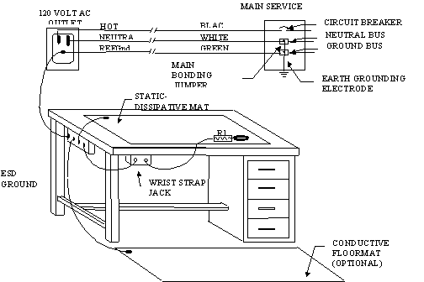
Figure 2-1. Example of Work Station Grounding
Note: Establishing an ESD ground by direct connection to an earth-grounding electrode is acceptable, providing the resistance between the earth grounding electrode and the ESD ground shall not exceed one ohm. When both the facility ground and earth ground are used, they shall be connected together.

2.3.10 Personnel Grounding

People are the greatest source of uncontrolled electrostatic discharge. Thus, all personnel within one meter of unprotected ESDS items must be grounded using an approved grounding device: either wrist straps or groundable footwear. If groundable footwear is used as the primary method for personnel grounding, a grounded flooring system is required. When personnel sit at ESD-protective workstations, they must be connected to the ESD ground using a wrist strap.

2.3.11 Wrist Straps

Wrist straps shall be used as the primary method to ground personnel when within one meter of unprotected ESDS items. Wrist straps must be worn in direct contact with the user’s bare skin. Wearing a wrist strap over clothing is prohibited. The ground connection end of the wrist strap cord must be securely connected to the ESD ground. Wrist straps must contain a 1 megohm ± 20% resistor.

CAUTION: Cloth wrist straps are prohibited. Although these wrist straps can ground personnel, they increase the risk of contamination. The conductive fibers in the cuff can become dislodged, leading to possible electrical shorting and/or contamination problems within electronic assemblies.

Each person handling ESDS items must electrically test their wrist strap and coiled cord at the start of each work shift. Wrist straps shall be tested while being worn. Only JPL calibrated touch-type “go/no-go” wrist strap testers that check for a total system resistance may be used. Wrist strap coiled cords that fail this test shall be discarded. A wrist strap test log (see Appendix F for template) shall be used to indicate that the wrist strap was checked each day that they are used. The test log shall contain the wearer’s name, building/room location, date, and a check mark for each day’s test. Continuous wrist strap monitors are acceptable for use. When continuous monitors are used, a wrist strap test log is not required.

2.3.12 ESD Safe Footwear-OPTIONAL

For personnel grounding, the use of ESD safe footwear in conjunction with a grounded conductive, or static dissipative, flooring system is an optional alternative to the wrist strap in situations where wrist straps are inappropriate or unsafe for use.

ESD safe footwear consisting of heel or toe grounders, shoes or shoe covers are acceptable for personnel grounding. A user is grounded only when direct contact exists between the user’s footwear device and a grounded flooring system. The resistance from the person through the footwear device and flooring system to ground shall be greater than 750 kilo ohm and less than 100 megohm. Dirt buildup on the footwear device can affect conductivity to the floors or mats, so they shall be kept acceptably clean. In conditions where groundable footwear is worn footwear grounding devices must be worn on both feet.

Footwear shall not be used as the primary ground for seated personnel.

Each person handling ESDS items shall be capable of, and responsible for, electrically testing their groundable footwear device at the start of each work shift. Groundable footwear shall be tested while being worn, with each foot tested separately. Only JPL calibrated “go/no-go” footwear testers that check for a total system resistance shall be used. Footwear devices that do not satisfy this resistance range shall be discarded. A footwear test log (see Appendix F for template) shall be used to indicate that the footwear strap was checked each day that they are used. The footwear test log shall contain the wearer’s name, building/room location, date, and a check mark for each day’s test.

WARNING!!
Possible electrical shock!! The lower resistance limit of a personnel grounding device (PGD) is important to protect the user from possible electrical shock. A person wearing a PGD containing less than 750 kilo ohms could place them at risk from electrical shock. The upper resistance limit is also important since it ensures that each person is discharged in a reasonable amount of time. PGDs must be tested before use.

2.3.13 Grounded Flooring-OPTIONAL

Grounded conductive or static dissipative floors or mats are an optional technique to ground personnel and furniture. When used for personnel grounding, flooring systems are only effective when used in conjunction with groundable footwear such as heel straps, toe grounders or shoes. The use of carpet in ESD controlled work areas is subject to the written approval of the ESD control engineer. The use of floor wax or other substances on an ESD protective floor is prohibited.

2.3.14 Work Surfaces, Tables, and Benches

The type of surface that contacts unprotected ESDS items must be controlled. Tabletops, bench tops and other similar places where unprotected ESDS items are placed, must be static-dissipative and must be hard grounded. The surface resistivity shall be verified for each new installation and during periodic ESD control surveys. Surfaces in contact with unprotected ESDS devices must have surface resistivity between 10⁶ and 10¹² ohms/square. Static-dissipative tablemats and benches must not be connected to others in series (daisy-chained). Each tablemat or bench shall be connected directly to the ESD ground. Excessively cut or damaged tablemats shall be discarded. An acceptable method for supporting exposed ESDS items is shown in Figure 2-2.

Figure 2-3 illustrates an acceptable use of a hard-grounded work surface. Hard-grounded work surfaces are acceptable only when there are no exposed (i.e. unprotected) ESDS items.
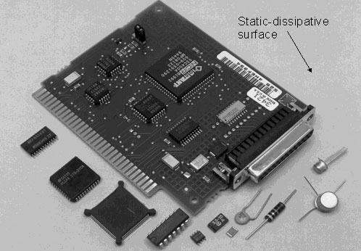

Figure 2-2. Example of an ESD Safe Work Surface

Notes: For unprotected ESDS parts, the supporting surface must be static-dissipative and hard grounded. A static-dissipative work surface is one that has a surface resistively between 10⁶ and 10¹² ohms/square.

2.3.15 Garments, Smocks and Coverall Suits

Personnel clothing can be a source of static charge. All personnel within one meter of ESDS items shall wear ESD protective smocks or overall suits. Zippers or snaps shall close the smocks or overall suits. Sleeves of personal clothing shall not protrude beyond the sleeve of the ESD protective clothing. Protective clothing that has been ripped or cut shall be repaired or discarded.
Only a laundry qualified to process ESD-protective garments shall launder ESD-protective clothing. Home laundering of ESD-protective clothing is prohibited. ESD-protective garments that exhibit static voltages greater than those shown in Table 1 during normal/intended use shall be removed from service.

2.3.16 Stools, Chairs and Other Furniture

Stools, chairs and other furniture that exhibit static voltages greater than that shown in Table 1 during normal/intended use shall not be used within one meter of unprotected ESDS items. Items failing these conditions shall be labeled with warning stickers as shown in Appendix D (JPL form # 11010).
2.3.17 Hand Tools

Plastic handled hand tools such as screwdrivers, wire strippers and pliers are acceptable for use near ESDS items.

CAUTION: Wrapping hand tools (e.g. screwdrivers, wire strippers, etc.) with conductive or static dissipative tape or other materials is prohibited. Over time and use, contamination may shed, leading to possible contamination problems within nearby assemblies.

2.3.18 AC Powered Tools

All AC powered tools such as soldering irons, thermal wire strippers and powered drivers, which may contact ESDS items, must be grounded. The resistance between the portion of the tool that contacts the ESDS item and the third wire ground shall not exceed twenty ohms. The voltage between these points shall be less than 20 mV_{ac} (0.020 V_{ac}). These measurements shall be made under operating conditions (i.e., at operating temperature and with a clean tip). These constraints apply equally to soldering pots. A powered tool test log (see Appendix F for template) shall be used to indicate that each soldering iron/wire stripper used on ESD sensitive items is checked each day they are used. The powered tool test log shall have as a minimum, the operator’s name, building/room, date, identification of the tool and a check mark to indicate that the tool meets the voltage and resistance requirements.

2.3.19 Relative Humidity Limits

a. Minimum Relative Humidity

The relative humidity shall be maintained above a minimum of 30% in areas where ESD protection is a requirement. If the relative humidity cannot be maintained above 30%, work shall be stopped. Work can continue if relative humidity falls below 30% in the work area only if air-ionization is used.

b.Maximum Relative Humidity

The maximum relative humidity limit is determined by the constraints of the equipment and ESDS items within the area and shall be established by the program/project personnel. Excessive humidity can cause problems such as corrosion, possible leakage paths for high voltages and moisture contamination within equipment. The relative humidity limits shall be verified using JPL calibrated recording hygrometers. Some conditions may occur in which enforcement of the relative humidity limits may be waived. These conditions include:

- Testing and/or processing of ESDS assemblies outdoors.
- Testing and/or processing of ESDS assemblies in environmental test chambers and/or ovens.
- System testing in which ESDS assemblies are safely protected against ESD.
2.3.20 Air Ionization

Air ionization is a technique to neutralize charges on insulators and ungrounded conductors. When required, only air ionizers that contain a current JPL calibration sticker shall be used. There shall be an unrestricted, straight-line air-flow between the ionizer and the ESDS items. The JPL ESD control lab, JPL IMTE lab, or outside vendor, shall verify performance of air ionizers “in-place” per Metrology Group Instruction SI-0363, Calibration Instruction for Air Ionizers. The charge decay time and float potentials shall be as specified in Table 1. Outside vendors may be used for repair of air ionizers.

CAUTION: An improperly adjusted air ionizer can actually charge ESDS devices and lead to possible damage to the device. Only calibrated air ionization systems shall be used.

2.3.21 Displays: Computer Monitors, Oscilloscopes and Other Displays

All displays producing electrostatic fields greater than that shown in Table 1 shall be located at least one meter from ESDS items and be labeled with an ESD warning sticker (JPL form # 11010). This requirement applies to all sides of the display, not just directly in front. Where relocation is not feasible, displays shall be replaced or shielded to meet the requirements of Table-1.

2.3.22 Gloves and Finger Cots - OPTIONAL

The use of gloves and finger cots is not mandatory. However, when required, only gloves and finger cots made of approved static-dissipative materials shall be used.

2.3.23 Adhesive Tape and Tacky Mats

Ordinary adhesive tapes such as duct tape, masking tape and cellophane tape can be highly chargeable. Only approved tape shall be used near or in direct contact with ESDS item. Peel tape slowly to avoid developing electrostatic charge; the use of air ionizers is recommended.
Tacky mats shall not be used or stripped within three meters of ESDS items.

2.3.24 Grounding of Support and Test Equipment

The chassis of all support and test equipment connected to ESDS equipment shall be hard grounded using the third wire ground.

2.3.25 Tooling and Fixtures

Tooling and/or fixtures used to hold ESDS items during processing, testing or storage shall be made of grounded conductive or static dissipative materials. If conductive tooling is used, it shall not be allowed to directly contact unprotected ESDS items. Exceptions are allowed for tweezers, wire cutters and powered driver bits where they are not available in static dissipative forms. Exceptions are allowed for optical benches and other precision work surfaces where the use of static dissipative treatments interfere with stability of alignment.
2.3.26 Environmental Test Chambers

All chambers, ovens and racks shall be constructed of metal and be hard grounded. Unprotected ESDS items used in test chambers shall not be allowed to directly contact hard grounded conductive surfaces (See Figure 2-3).
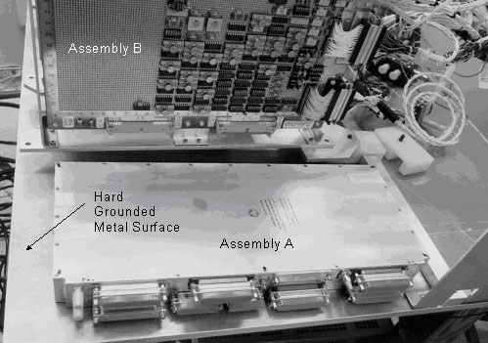

Figure 2-3. Acceptable Use of Metal Work Surfaces

Assembly A contains no exposed ESDS parts; it is acceptable for it to be placed in direct contact with the hard grounded conductive surface. Assembly B contains exposed ESDS items and must not be in contact with conductive surface.

2.3.27 Interconnect Cables

The conductors within unconnected interconnect cables can become charged. Cables to be connected or mated to ESDS items shall be grounded, either by contact to the bare hand of a grounded person or to a ground wire, prior to connection.

2.3.28 Cleaning and Coating Operations

The use of pressurized “air cans” directed onto ESDS items is acceptable. Particles within gases can transfer charge: do not shake or invert the can before or during use. Rubbing or sanding printed wiring boards, circuit card assemblies, terminal boards, or other surfaces containing ESDS items is prohibited.
2.3.29 ESD Protective Packaging

Note: For complete instructions, refer to QAP 61.12, Packing and Unpacking of ESDS Hardware.

a. All ESDS items shall be contained within approved ESD-protective containers for movement between ESD-protected areas, per the procedures of Packing and Unpacking ESD Sensitive Hardware, QAP 61.12 (JPL Rules DocID 61692). ESD and Contamination Control must approve package materials for use. The objective of ESD protection is to prevent ESD to the item contained within, to allow for dissipation of charge, and to prevent charging of the ESDS item by an external electrostatic field. ESD protective packaging shall display ESD warning signs. Symbols used in Appendix D are acceptable for use as packaging labels. If the packaging is not ESD safe, it shall be labeled with JPL Form 11015, as shown in Appendix E.

b. Figure 2-4 illustrates the minimum required container system for enclosing ESDS items for shipment out of JPL. The container shall provide:

(1) An outer shell that provides adequate mechanical protection for the contents.
(2) Foam or bubble wrap shock absorbing liners that have static shielding covers.
(3) A shielding package for the ESD sensitive contents.
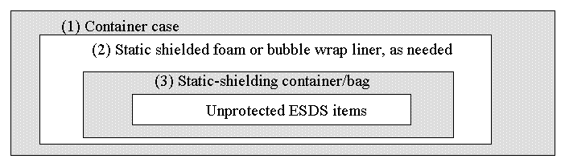

Figure 2-4. Minimum Requirements for an ESD-protective Container

2.3.30 Pink-Polyethylene (pink-poly)

The use of pink-poly bags, film, bubble-wrap or foam near any ESDS item or within an ESD protected area is prohibited. Pink-poly provides little protection against ESD events and voltage fields and is a contamination source. The preferred alternative is the metalized static-shielding bag.

2.3.31 Packing and Filler Materials

Shipping popcorn, foam liners and polystyrene foam shall not be used near ESDS items unless shielding overwrap protects them.
2.3.32 Receiving

Packages or containers received at JPL displaying ESD warning symbols or text shall be opened only by personnel certified in ESD Control at ESD-protected workstations. Packages or containers received that contain ESDS items that are not properly identified, or properly enclosed within static-shielding materials shall be treated as out-of-compliance and identified on an Inspection Report as discrepant material per QAPs 141.10 and 144.02.

2.3.33 Receiving Inspection

Personnel with current JPL ESD control certification shall perform inspection of ESDS items only at ESD-protected workstations.

2.3.34 Exposure of ESDS Items

ESDS items shall not be left exposed and/or unattended at a workstation, or elsewhere. ESDS items, which must be left unattended for short periods of time, (e.g., lunch break), shall be placed on an ESD-protective surface and wrapped or covered with static-shielding packaging material.

2.3.35 Storage of ESDS Items

When stored, ESDS items shall be contained within a static-shielding container. Direct contact of unprotected ESDS items with metal shelves or cabinets is prohibited. It is acceptable for metal storage cabinets to be ungrounded as long as the ESDS contents that are stored in the cabinet are safely enclosed within ESD shielding.

2.3.36 Movement and Handling of ESDS Items

Note: Refer to QAP 61.12, Packing and Unpacking of ESDS Hardware, for detailed instructions.

Unprotected ESDS items shall not be passed from one person to another unless both persons are properly grounded. ESDS items shall not be moved out of ESD protected rooms, work stations, or facilities without static-shielding protection as described in Packing and Unpacking ESD Sensitive Hardware, QAP 61.12 (JPL Rules DocID 61692). ESDS items being moved using rolling carts shall be enclosed within static-shielding packaging.

If conditions arise (e.g., field testing) in which wrist strap or floor grounding systems are unavailable, always touch grounded surfaces both before and during handling of ESDS items.
ESDS items delivered to JPL or contractor facilities shall not be opened or removed from their ESD-protective containers until they are within an ESD protected area.

2.3.37 Procurement

When procuring ESDS items, the requester and purchasing agent shall state that the merchandise is ESD sensitive. Designation that the item is ESD sensitive shall be included on the purchase requisition. Suppliers and/or JPL contractors shall be required to identify all ESDS packages that are delivered to JPL with an appropriate ESD warning/caution label(s) as described in Appendix D of this standard.

2.3.38 Waste Receptacles

Plastic waste containers and plastic liners shall not be allowed within one meter of unprotected ESDS items.

2.3.39 Topical Anti-Static Sprays

The use of any ESD spray, anti-static spray or anti-static glass cleaner is prohibited within ESD-protected areas. The chemicals within these sprays are a contamination source.

2.3.40 Plastic Notebooks

Certain plastic covered notebooks can be a source of static charge. Plastic notebooks that generate surface voltages greater than that in Table 1 under normal/intended use shall be neutralized. Acceptable neutralization techniques include: relocate to a distance greater than one meter from ESDS items, cover or use notebook with static-shielding sheet material or use notebooks constructed of static-dissipative plastics.

2.3.41 Plastic Connector Dust Caps

Plastic connector dust caps are acceptable for use on ESDS hardware or cables attached to ESDS hardware.

2.3.42 Plastic Fluid Bottles

Hand-held plastic bottles that are commonly used to hold fluids (e.g., deionized water, isopropyl alcohol) that emit a voltage field exceeding the limits specified in Table 1 after normal/intended use shall be removed from the ESD-protected area. An acceptable alternative is to use bottles constructed of static-dissipative plastics. It is not acceptable to wrap plastic bottles with metalized tape or static dissipative sleeves. Plastic fluid bottles shall be left untreated.

2.3.43 Conductive Hand Lotion

Only approved conductive hand lotions are permitted for use in ESD-protected areas. Chemicals in non-approved lotions may introduce contaminants.
2.3.44 ESD Control Web page

An ESD Control Web page shall be maintained allowing users access to JPL ESD related documents and information. The page shall contain as a minimum, the following:

- A link to download JPL D-1348, the JPL Standard for ESD Control.
- A link to download JPL Form # 2731, ESD Control Survey Report.
- An ESD approved materials list.

The ESD Control Web page or a link to the page is available at the following address: http://eis.jpl.nasa.gov/qa/esd/

2.3.45 Records

Records of the following items shall be maintained:

Record Title | JPL Form # | Certification Type | Record Location
ESD Control Certification | 10005 | Facility/Project ESD Control | Posted at entrance to surveyed area
ESD Control Survey Report | 2731 | Facility/Project ESD Control | ESD Control Engineer  QA Auditor  Project personnel
ESD Control and Auditing training | N/A | Personnel and QA personnel | Refer to QAP 21.0

2.4 Quality Assurance

The QA representative assigned to a program/project, ESD-protected facility, workstation, or handling ESDS items shall perform the following:

- Perform the ESD Control Survey for the subject area/project. Appendix C defines the ESD Control Survey process.
- Ensure that the ESD control environment, control disciplines, and ESD controls over personnel, furnishings, materials and/or equipment brought into or out of the area are maintained during the duration of work involving ESDS items.

Should it become established that ESDS items have been exposed to an ESD event, the QA representative shall enter a discrepancy to that effect into the Inspection Report for the hardware in question.
3.0 Contractor Requirements

3.1 Purpose

The purpose of this section is to provide guidelines for control of ESD at contractor locations, guidelines for preparation of ESD control plans and the implementation of ESD control requirements as specified by Section 2 of this standard.

3.2 Scope
When required by contract, contractors and other external suppliers furnishing ESDS items for delivery to JPL are subject to the same requirements and constraints as those specified in
Section 2.

  - Applicability

The requirements and constraints identified in Section 2 of this standard apply equally to ESDS
items procured by JPL from contractors and other external sources.

3.4 Responsibilities

It is the responsibility of the contractor to ensure that the requirements of this standard are implemented.

3.5 ESD Control Plan

3.5.1 When required by the contract, the contractor shall prepare and submit for JPL approval, an ESD control plan.

3.5.2 The contractor is encouraged to use their existing ESD control plan to the greatest extent possible. It is not necessary to create an entirely new document in response to this ESD control plan requirement.

3.5.3 JPL needs to understand how the requirements identified in Section 2 of this standard will be implemented within the contractor’s facility. It may be necessary to supplement contractor’s existing plans or procedures to handle any new JPL requirements that had not been previously addressed.

    - There is some flexibility in the Section 2 requirements. It is recommended that the contractor contact responsible JPL project personnel and request a review of the Section 2 requirements should any of the following conditions prevail:

- One or more of the requirements cannot be met.
- The cost/benefit ratio of compliance with the requirements is inappropriate.
- The contractor believes the requirement is unnecessary and compliance creates a hardship or disruption of the contractor’s normal operations.
- The contractor has an equivalent or better solution to the problem and prefers to use it in place of the Section 2 requirements.

Clarification and resolution of these issues prior to submission of the contractor’s ESD control plan will greatly facilitate the review and approval process at JPL.

3.6 Materials and Equipment

It is acknowledged that contractor facilities may already be equipped with ESD control devices and equipment. Performance data on these devices shall be made available to JPL for approval.

3.7 Implementation

The implementation of ESD control measures at the contractor shall be in accordance with the JPL approved contractor’s ESD control plan.
If the procurement documentation does not include a requirement for the submission of an ESD control plan by the contractor, but does reference this standard, then implementation of ESD controls at the contractor facility shall be in accordance with Section 2 of this Standard, subject to modification by the procuring JPL agency.

3.8 ESD Control Authority

The contractor will establish a responsible ESD control authority. This authority shall be responsible for the interpretation and implementation of the ESD control requirements within the contractor’s operational areas for JPL ESDS items that are supplied or procured.

This ESD control authority shall be identified in the contractor’s ESD control plans or procedures.

3.9 Quality Assurance

Survey, audit and surveillance activities are the responsibility of the contractor quality assurance/inspection operations, in conjunction with the ESD control authority.

In the current TQM environment, many responsibilities formerly assigned to QA have been transferred to other organizations. This notwithstanding, the ESD survey and surveillance requirements remain in effect.

In either event, where these responsibilities are located must be identified in the contractor’s ESD control plans or procedures. The implementation of contractor ESD control plans and/or procedures will be subject to survey and periodic audits by the assigned JPL quality assurance personnel.

Contractor work areas for JPL-ordered ESDS hardware may be certified in the same manner JPL internal facilities are certified. The contractor’s responsible ESD authority or JPL QA Representative may use the ESD Survey Worksheet, JPL Form 2731 (http://eis.jpl.nasa.gov/quality/qadc/templates/esdsurvey2731.pdf) in conducting the certification survey.
Appendix A - Example Visitors ESD Briefing

BUILDING ___ ROOM _____

1. All visitors must wear a wrist trap directly in contact with skin and be connected to an acceptable ESD ground when within one meter of unprotected ESD sensitive hardware.

2. Option: A pair of foot grounders may be worn in place of a wrist trap so long as you are not seated. If you sit down you must use a wrist strap as instructed in no.1.

3. All visitors must wear ESD protective garments when within one meter of unprotected ESD sensitive hardware.

4. Do not handle unprotected ESD sensitive hardware unless absolutely necessary and under the direct supervision of a person certified in ESD awareness control.

5. ESD sensitive packages may only be opened at the ESD safe workstation.

6. Be aware that there may be work surfaces in this room that are not approved for use with ESD sensitive items. These will be labeled with an appropriate sticker.
Appendix B - Standard Definitions

The following definitions are provided for information purposes and are applicable as used within this standard.

Air ionizer: Equipment that provides a charged atmosphere, consisting of both positive and negative ions. Air ionizers neutralize static charge accumulation on insulators and on ungrounded conductors. Air naturally contains ions. However, they are not sufficiently abundant in most cases to neutralize static charges rapidly enough to protect static sensitive devices. Further, air ions are completely removed by HEPA and ULPA filters in clean rooms. For this reason, ESD problems in clean rooms occasionally require that air ionization be used.

Antistat, antistatic agent: A chemical compound that is impregnated into or applied to the surface of a material to render the material more conductive and less prone to retain charge. Plastics made static dissipative through incorporation of topical antistatic agents become depleted by water and alcohol cleaning, rendering them ineffective. Most topical antistatic agents have significant vapor pressure. For this reason topical antistatic agents are not to be used in clean rooms.

Antistatic: A term no longer in use, primarily because a formal definition was never developed.

Cathode Ray Tube (CRT) field suppression screen: A device placed on the face of a CRT that blocks the electric field emanating from the face of the device. This device must be grounded, and does not reduce fields emanating from the top, bottom or sides of the CRT.

Charged Device Model (CDM): A model characterizing a particular ESD failure mechanism in which an electronic device isolated from ground is charged, and is subsequently discharged, causing a short duration discharge pulse.

Charged plate monitor: An instrument used to measure the charge neutralization effectiveness and balance of ionization equipment.

Conductive material: For ESD control purposes, materials with a surface resistivity less than 10⁶ ohms/square and a volume resistivity less than 10⁵ ohm-centimeter.

Decay time: Time required for voltage to reduce to a specified percentage of its initial value. One of the two principal criteria for evaluating acceptability of air ionizers and materials used in work stations provided with air ionizers.

Dielectric: A non-conductor that can sustain an electric field.

Dielectric breakdown voltage: The voltage at which an electrically conductive path is created through a dielectric.

Electrical Overstress (EOS): The exposure of an electronic part to a current and/or voltage beyond its maximum ratings.
Electrostatic charge: An excess or deficiency of electrons within or on the surface of a material, measured in units of coulombs.

Electrostatic discharge (ESD): Exchange of energy between objects at different electrostatic potentials, caused by direct contact or induced by an electrostatic field.

Electrostatic field: A voltage gradient between electrostatically charged surfaces of different potentials.

Electrostatic field meter: A noncontact used for measuring the potential and polarity of an electrical voltage field.

ESD component classification: A rating scheme used to classify ESDS components according to their ESD damage thresholds.

ESD controlled area: An area which is constructed and equipped with the necessary ESD protective materials, equipment, and procedures to eliminate or reduce electrostatic voltage fields and direct ESD.

ESD damage: The internal part damage or destruction resulting from an ESD event. Damage is caused by the application of excessive energy and/or voltage.

Electrostatic field: The lines of force surrounding an electrically charged object.

Electrostatic potential: The voltage difference between a point and an agreed-upon reference.

ESD protective clothing: Clothing manufactured from fabrics specially designed or treated to inhibit buildup and to allow rapid dispersal of electrostatic charge.

ESD protective flooring: A flooring system or floor covering constructed of conductive or static dissipative materials. The flooring provides a path to ground to effectively remove charges from grounded contacting personnel or objects. A conductive element is needed to electrically connect a person's body to the flooring system. Heel straps, toe straps, conductive booties and shoe covers are commonly used for this purpose.

ESD protective material: A property of materials capable of one or more of the following: limiting the generation of static electricity, dissipating electrostatic charges, or providing shielding from ESD or electrostatic fields.

ESD sensitive (ESDS): ESDS refers to the measure of the sensitivity of an item to ESD damage. Sensitivity is defined as that level of ESD that produces changes, such that the item fails to meet its specified parameters or looses reliability.

Electrostatic shield: A barrier or enclosure that limits the penetration of an electrostatic field.

Faraday cage: An enclosure that provides an electrostatic shield. Note: May or may not affect electromagnetic waves.

Field induced model (FIM): A standardized ESD test model characterizing an electrically floating ESDS device that is subjected to an electrostatic field.

Float Potential: The second measure of performance of an air ionizer. The highest positive and negative potential recorded during 60 seconds of monitoring using an uncharged, ungrounded charged plate monitor.

Ground:

ESD Ground: The point at a workstation where ESD control devices such as wrist straps, and table mats are connected. This point is in turn connected directly to the facility ground.
Earth Ground: A conducting body connected to Earth used as a return path for electric currents and as an arbitrary zero voltage reference point.
Equipment Ground: The ground point at which the equipment grounding conductor is bonded to any piece of equipment, at the equipment end of the conductor. The entire low impedance path from a piece of electrical equipment to a hard ground electrode.
Facility Ground: A system of bus bars, braided wire, metal strips or other installed conductors that form a path to a common grounding system within a facility.
Hard Ground: A direct low resistance (typically less than one ohm) connection to facility ground.
Soft Ground: A connection to ground through a resistance intended to limit current flow.
Third Wire Ground: The green third wire terminal of an electrical receptacle. This point is common with the equipment and facility grounding system

Grounded: Connected to ground.

Ground fault circuit interrupter (GFCI): A device intended for the protection of personnel that functions to de-energize a circuit when leakage current exceeds a specified value.

Ground strap: An item intended to provide a conductive path to ground.

Groundable footwear tester: A device used to measure the functional effectiveness of groundable footwear. A go/no-go device.

Hardware: A system, assembly, subassembly, component or part.

Human Body Model: A model representing the ESD from a human body.

Induction: The process by which an electrical field causes charge separation within a nearby object without physical contact.

Input Protection: Structures, devices or networks connected at the terminals of an item to prevent damage due to ESD.

Ionizer verifier: An instrument used in place of a charged plate monitor to periodically verify performance of an air ionizer.

Insulator: For ESD control purposes, a material exhibiting a surface resistivity of greater than 10¹² ohms/square or a volume resistivity greater than 10¹¹ ohm-cm. Insulators do not conduct electricity. Also known as a "dielectric" material.

Ionization: The process by which neutral atoms or molecules, such as those found in air or on surfaces, acquire positive or negative charges.

Latent failure: An impending or possible failure at a weakened or damaged location in a device. Often used in the context of ESD damage that did not cause immediate part failure.

Resistivity:

Surface resistivity: The ratio of DC voltage to DC current that passes across the surface of a material. The unit of measurement is generally given in ohms/square.
Volume resistivity: The ratio of the DC voltage to the DC current passing through a material. The unit of measurement for volume resistivity is generally given in ohm-centimeters.

Sensitive electronic device symbols: The symbols placed on hardware assemblies and documentation for identification of ESDS items. Refer to Appendix E.

Shall: Indicates a mandatory requirement.

Should: Indicates a recommendation that is advised but not required.

Shunting bar: A device that shorts the terminals of an ESDS item forming an equipotential surface.

Spark: An electrical discharge of very short duration, normally between two objects separated by a gas (such as air).

Static charge: (See "Electrostatic charge")

Static decay test: A procedure which specifies contact-charging a material and measuring the decay time to a specific voltage. Decay to 10% of the initial voltage is frequently used.

Static-dissipative material: For ESD control purposes, a material with a surface resistivity greater than 10⁶ and less than 10¹² ohms/square or a volume resistance of greater than 10⁵ but less than 10¹¹ ohm-centimeter.

Static electricity: Electrical charge at rest.

Static Eliminator, Electrical: Electrical static eliminators generally consist of one or more electrodes and a high voltage power supply. Ion generation from electrical static eliminators occurs in the air space surrounding the high voltage electrodes. (See Air Ionizer, Ionization.)

Static Eliminator, Induction: A passive device having an electric field of sufficient intensity to supply ions for static elimination.

Static Eliminator, Nuclear: Nuclear static eliminators create ions by the irradiation of air molecules. Most models use an alpha particle emitting isotope to create ion pairs to neutralize static charges. (See also Ionization, Air Ionizer).

Static meter: (See "Electrostatic Field Meter”)

Static shielding bag: A material that provides protection against triboelectric charging, external electrostatic fields and ESD. These bags are typically of multiple layer construction and usually include a heat sealable inside surface, an embedded metal layer and an external antistatic film.

Surface Resistivity : The ratio of d.c. voltage to the current that passes across the surface of the system. In this case, the surface consists of a square unit of area. In effect, the surface resistivity is the resistance between two opposite sides of a square and is independent of the size of the square or its dimensional units. Surface resistivity is expressed in ohms/square.

Note: This particular term is in review by EOS/ESD Standards Subcommittee 11.0.

Surfactant: (See “Antistat, Antistatic agent)

Tacky mat: A small floor mat with an adhesive surface, used to remove loose contamination from soles and heels of footwear.

Topical antistat: (See "Antistat, antistatic agent)

Triboelectric charging: The generation of electrostatic charges when two pieces of material in intimate contact are separated (where one or both is an insulator). Substantial generation of static electricity can be caused by contact and separation of two materials or by rubbing two substances together. (See also Triboelectric Series.)

Triboelectric series: A list of substances arranged so that one can become positively charged when separated from one farther down the list, or negatively charged when separated from one farther up the list. The series’ main utility is to indicate likely resultant charge polarities after triboelectric generation. However, this series is derived from specially prepared and cleaned materials tested in very controlled conditions. In everyday circumstances, materials reasonably close to one another in the series can produce charge polarities opposite to that expected.

Voltage Suppression: A phenomenon where increasing the capacitance of the object rather than decreasing the charge on the object reduces the voltage from a charged object. The following relation describes this phenomenon:
Q = CV or V = Q/C
Where:
Q = Charge in coulombs
C = Capacitance in farads
V = Voltage in volts

Wrist strap tester: A device used to measure the functional effectiveness of a wrist strap. A go/no-go device.
Appendix C - ESD Control Surveys

General

A valid ESD Control Certification is required for all hardware meeting the Applicability requirements (Section 1.3). An ESD Control Certification is obtained after successful completion of the ESD Control Survey process.

The ESD Control Survey is based on the requirements identified in Section 2 of this Standard.
The assigned QA representative or alternate shall perform the ESD Control Survey. In situations where a QA representative is not assigned to a project, the ESD Control Engineer can perform the survey. The QA representative and ESD Control Engineer shall be trained and have current certification as an ESD Control Auditor by the JPL QA Training Center.

Surveys shall be performed using an ESD Audit kit. The Audit kit shall contain the necessary equipment to physically verify the Section 2 requirements of this Standard.

ESD Control Survey Process

The ESD Control Survey Report (JPL Form # 2731) shall be used to conduct the survey and to document the results. A blank ESD Control Survey Report can be downloaded from the ESD Control Web page. The requirements are audited and identified with “yes”, “no”, or “not applicable (n/a)” responses on the survey report. Corrective actions are required when a “no” response is indicated.

Each ESD Control Survey Report shall have an assigned survey number. The survey number will be assigned by the ESD Control Engineer or by an authorized QA representative.

Every attempt should be made to correct violations of Section 2 requirements on the spot during the survey. When a violation cannot be corrected on the spot, it shall be noted on the ESD survey report, under the “corrective action needed” heading. For times when ESDS hardware has been exposed in areas with corrective action needed identified during a survey, the problems shall be entered on the hardware Inspection Report (IR) in order to document conditions in which the hardware was processed.

The responsible facility supervisor and/or project personnel, as identified on the survey report, shall perform corrective action. The means by which the corrective action is resolved or eliminated, is at the discretion of facility supervision and/or the program/project personnel.
The QA representative shall verify that appropriate corrective actions have been incorporated and closed before ESDS items are exposed within the subject area. To continue work involving ESDS items while a survey remains open during the thirty-day period, the QA representative shall enter each corrective action needed into the PR system. The Cog E or alternate shall disposition each corrective action. The ESD control engineer shall be responsible for closure approval of each item.
Upon completion of the ESD Control Survey, the QA representative shall send a hard copy of the survey report to the appropriate facility supervisor, cognizant engineer and applicable project personnel listing all corrective action needed, if any is required.

Discrepancies noted during the survey that require definition and explanation shall be listed in the “Additional Notes” section of the survey report and referenced to the item where the discrepancy was noted. Recommended corrective action requirements shall also be indicated.
Should any ESD hazard(s) be discovered that are not addressed within this Standard, the particulars of the hazard shall be identified in the “Additional Notes” section, as noted above.
The ESD Control Survey Report shall be submitted to the ESD Control Engineer after completion of the corrective actions, or after completion of the survey form, if no corrective actions were noted.

The ESD Control Engineer shall determine the appropriateness of the corrective actions. If the corrective actions are acceptable, or if none are required, the ESD Control Engineer shall issue an ESD Control Certification (JPL Form # 10005).

The ESD Control Engineer shall send the ESD Control Certification to the QA representative. The QA representative shall ensure that the ESD Control Certification is posted in plain view near the entrance to the surveyed facility, laboratory or workstation.

A database of closed ESD Control Survey Reports shall be kept either in hard copy form by the ESD Control Engineer or electronically through the ESD Control web page. The QA representative or ESD Control Engineer shall cancel the ESD Control Certification if the ESD control requirements are not properly maintained.

The ESD Control Survey shall be repeated per the requirements of Section 2 of this Standard.
Appendix D - Personnel Training and ESD Control Survey Certifications

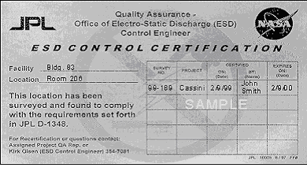 |  | ESD Control Certification, JPL Form 10005  Required of all areas where ESDS hardware is exposed.  Identifies a JPL or contractor work area as a certified ESD controlled area. Issued by the QA representative after successful completion of the ESD Survey per Appendix C. Must be posted in plain view at the entrance to the surveyed facility, laboratory or workstation “outside the outermost locked entrance to the facility” (ref. Sections 2.3.7.b, ESD Control Certification, and 2.3.7.d, Contractor Facilities).  When an area is no longer in use as an ESD protected area, the certificate should be removed. In the case of multiple projects, the appropriate survey line should be crossed out. (ref. Section 2.3.7.e, Abandonment of Facilities).
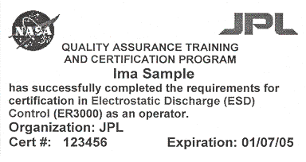 | Personnel ESD Control Certificate, JPL Form maintained by the QA Training Center  Required for ALL who have access to an ESD Controlled Area  Initial and recurrent ESD control training is required of all personnel, including QA representatives, who have access to an ESD protected work area. Personnel who exhibit poor attention to ESD controls may be decertified by QA personnel (ref. Section 2.3.3.a, All Personnel).
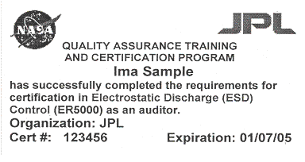 |  | Personnel ESD Control Auditor Certificate, Form maintained by QA Training Center  Required for ALL who conduct ESD Surveys  The QA representative, conducting an ESD survey, shall be trained and certified as an “ESD Control Auditor” by the JPL QA Training Center and have current certification status (ref. Section 2.3.7.a, JPL Facilities).

Appendix E - ESD Caution and Warning Stickers

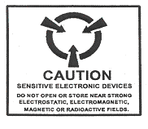 | DOD ESD Sensitivity Symbol.  Devices and Packaging  This symbol is required by MIL-STD-129J to be on ESD sensitive devices. This symbol may be seen on devices and packaging of devices normally sold to the US military.  Note: All ESD device packaging received at JPL is subject to rejection if not properly ESD labeled (ref. Sections 2.3.29. ESD Protective Packaging and 2.3.32, Receiving).
 | ESD Association “ESD Susceptibility Symbol”  Devices and Packaging  This symbol is the official Electrostatic Discharge Association identification for ESD sensitive devices. It is established by ANSI ESD S8.1-1993: ESD Awareness Symbols.  Note: All ESD device packaging received at JPL is subject to rejection if not properly ESD labeled (ref. Section 2.3.29, ESD Protective Packaging and 2.3.32, Receiving).
 | ESD Association “ESD Protective Symbol”  Packaging  This symbol is the official Electrostatic Discharge Association identification for ESD protective packaging. It is established by ANSI ESD S8.1-1993: ESD Awareness Symbols.  Note: All ESD device packaging received at JPL is subject to rejection if not properly ESD labeled (ref. Sections 2.3.29, ESD Protective Packaging and 2.3.32, Receiving).
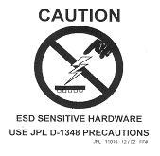 | JPL ESD Sensitive Symbol, JPL Form 11016.  Devices and Packaging  This symbol is proprietary to JPL for identification of JPL developed or identified ESDS device.  Note: All ESD device packaging received at JPL is subject to rejection if not properly ESD labeled (ref. Sections 2.3.29, ESD Protective Packaging and 2.3.32, Receiving).  Yellow vinyl stock with adhesive backing, 3 inches square.
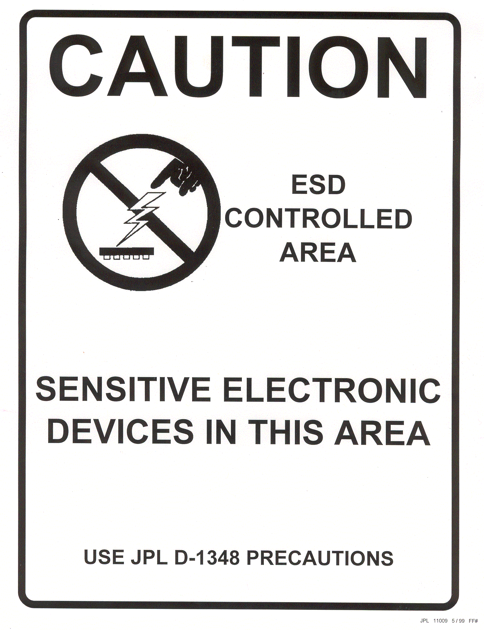 | JPL ESD Control Area Symbol, JPL Form 11009.  ESD Controlled Areas Doorways  This symbol is proprietary to JPL for identification of ESD controlled areas. It is established by D-1348, JPL ESD Control Standard. It is printed on yellow vinyl stock with adhesive backing, and is 8 ½ x 11 inches.  Note: Use of this placard is not a substitute for the requirement that a completed ESD Control Certification, Form 10005 must be displayed as specified in Sections 2.3.7 b, d, e.  Yellow vinyl stock with adhesive backing, 8 X 11 inches.
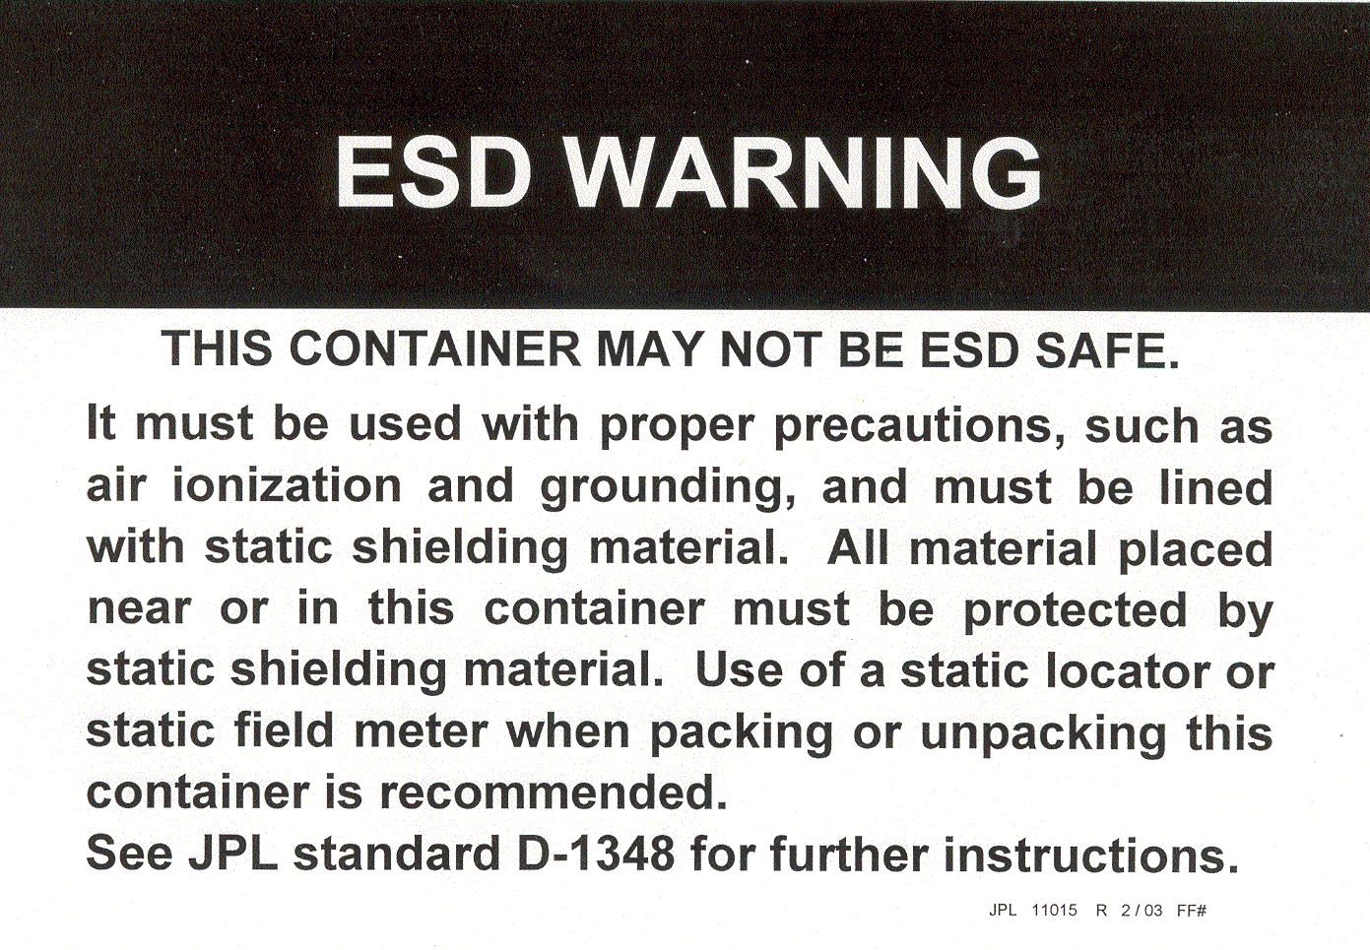 | JPL Unsafe ESD Container Warning,  JPL Form 11015 (large) /-1 (small)  Unsafe ESD Containers  For use on all ESDS hardware containers. Place one large label per container on top (preferred), or near handle. Use smaller label only for small containers.  Packing and unpacking of ESDS hardware, and transport from one ESD controlled area to another, must follow Packing and Unpacking ESD Sensitive Hardware, QAP 61.12 (JPL Rules DocID 61692) (ref. Section 2.3.29 ESD Protective Packaging).
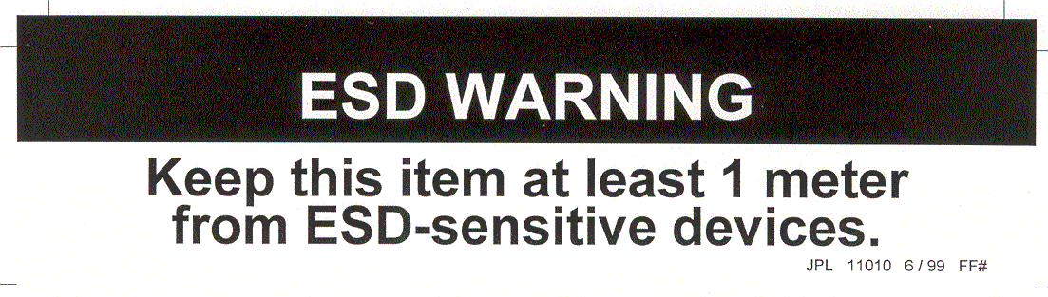 | JPL ESD Generating Device Warning, JPL Form 11010  ESD generating devices  Identifies operations, materials, or equipment, which generate voltages greater than specified in Table 1. Such static generators can include stools (ref. Section 2.3.16, Stools, Chairs and other Furniture) and displays (ref. Section 2.3.21, Displays et. al.). To neutralize such static generators, see Section 2.3.8, Static Generating Sources).  Yellow vinyl with permanent adhesive.
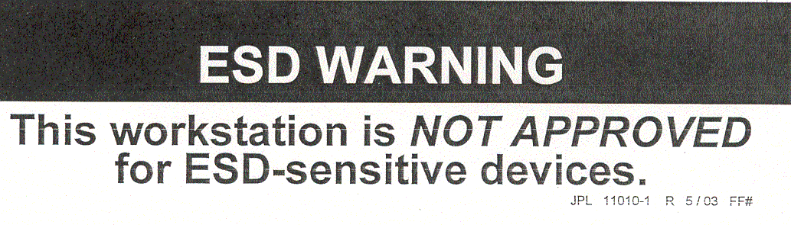  APPROVED | JPL ESD Safe Workstation, JPL Form 11010-1  ESD safe workstations  For use on workstations that form whole or part of an ESD controlled area per per D-1348, Appendix C.  Note: Use of this placard is not a substitute for the requirement that a completed ESD Control Certification, Form 10005 must be displayed as specified in Sections 2.3.7 b, d, e.  Yellow vinyl with permanent adhesive.
 | JPL ESD Ground, JPL Form 11006 (large) / -1 (small)  ESD safe ground  Indicates ground through which ESDS items, personnel, and other conductors are at the same electrical potential. Such grounds must be established in all ESD controlled areas (ref. Section 2.3.9, Grounding).  Yellow vinyl with permanent adhesive.
 | Electrostatic Discharge Association ESD Ground  ESD safe ground  Symbol is established by ANSI ESD S8.1-1993: ESD Awareness Symbols.

Appendix F - Example Test Log

Example Wrist Strap/Footwear/Hand Tool Test Log.
Click here for template file: http://eis.jpl.nasa.gov/quality/qadc/templates/esdtestlog.doc

Wrist Strap/Footwear/Hand Tool/ ___________________________ Test Log

Project(s)__________________________ Building_____ Room_______

Name | Day of the month
Name | 1 | 2 | 3 | 4 | 5 | 6 | 7 | 8 | 9 | 10 | 11 | 12 | 13 | 14 | 15 | 16 | 17 | 18 | 19 | 20 | 21 | 22 | 23 | 24 | 25 | 26 | 27 | 28 | 29 | 30 | 31

