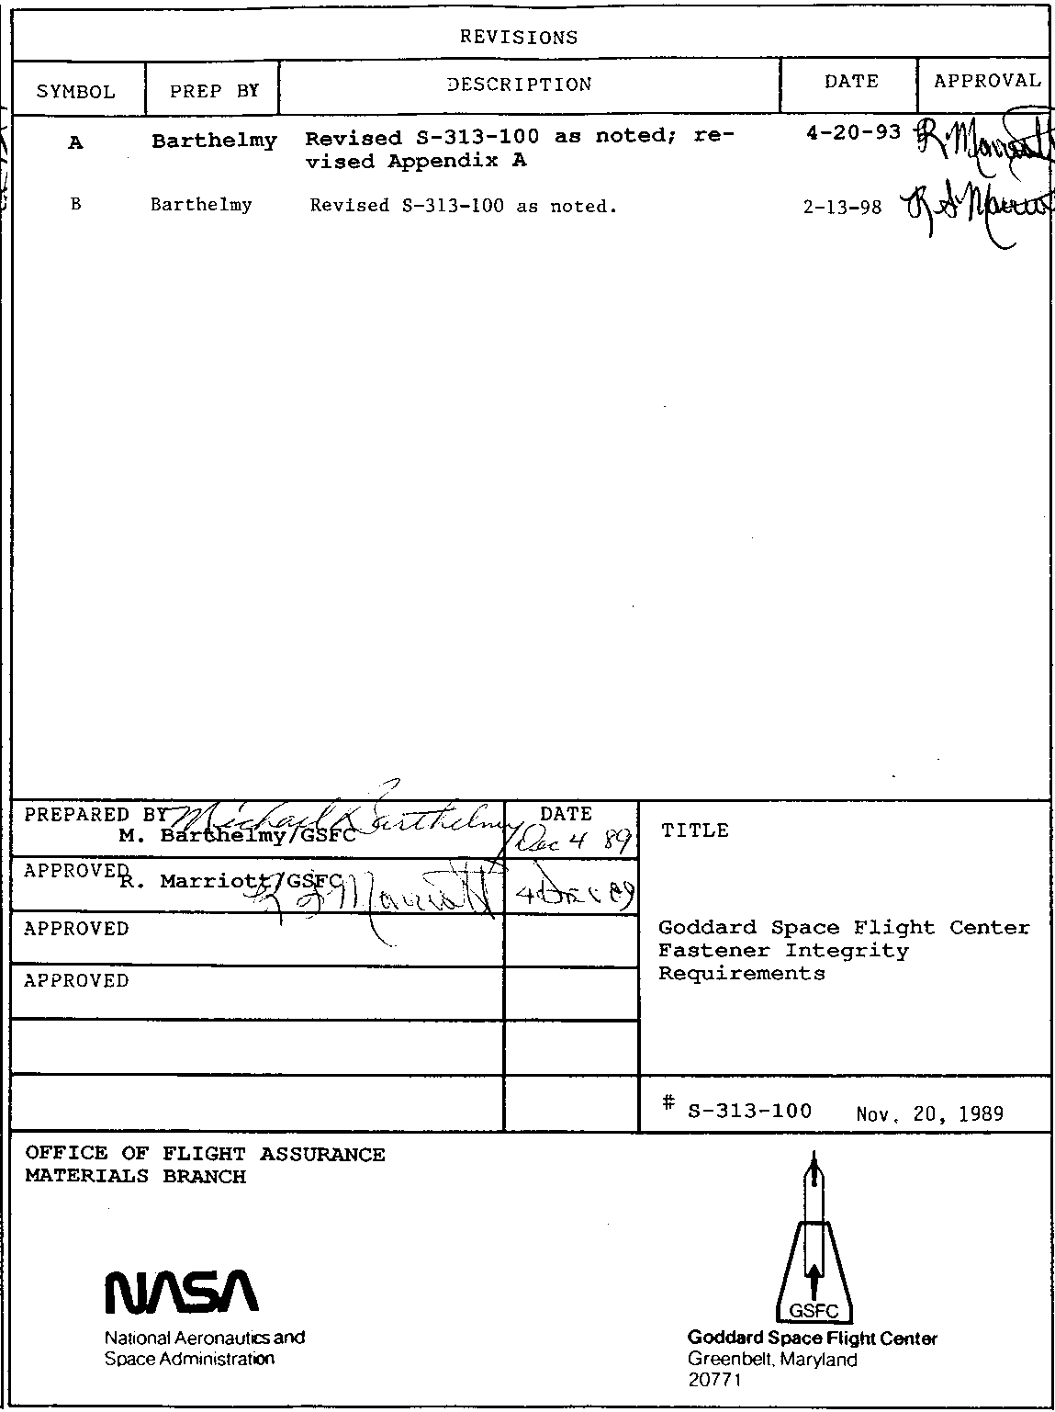
CONTENTS
1.0 Scope.................................................1

2.0 Documents/Definitions.................................1
2.1 Applicable Documents..............................1
2.2 Definitions.......................................1

3.0 Requirements..........................................2
3.1 Material Selection...............................2
3.2 Approved Manufacturers Products..................2
3.3 Material Test Reports............................3
3.4 Screening........................................3
3.5 Traceability.....................................3
3.6 Procurement......................................3
3.7 Specialized Fasteners............................4
3.8 Audits...........................................4

4.0 Quality Assurance Provisions..........................4
4.1 Discrepant Fasteners..............................4
4.2 Screening Inspections and Tests...................4

5.0 Responsibilities......................................7
5.1 Project Manager..................................7
5.2 Reliability and Quality Assurance................7
5.3 System Safety....................................7
5.4 Materials and Processes..........................7
5.5 Contracting Officers.............................7
5.6 Cognizant Engineers..............................7

Tables

Table I Fastener Procurement, Documentation, and
Screening Requirements for Flight Hardware.....8

Table II Fastener Documentation and Screening
Requirements for Ground Support Equipment......9

Table III Screening Summary for Flight Hardware and
Critical Ground Support Equipment Fasteners...10

Appendix A GSFC-Approved Manufacturers List
1

1.0 SCOPE

1.1 This specification defines fastener integrity requirements for all fasteners used in flight hardware and for critical nuts and bolts used on ground support equipment, including all flight hardware/GSE interfaces.

1.2 The following products are exempt from the requirements of sections 3.2 through 3.8: washers, spring pins, cotter pins, retaining rings, cable ties, safety wire, and non-metallic fasteners.

2.0 APPLICABLE DOCUMENTS/DEFINITIONS

2.1 The latest revision of the following documents forms a part of this specification to the extent specified herein.

MILITARY STANDARDS

FED-STD-H28/ Screw-Thread Standards for Federal Services,
20A Inspection Methods for Acceptability of UN, UNR,
UNJ, M, and MJ Screw Threads
DOD-STD-1312 Fastener Test Methods, Metric Method 108, Tensile
Strength
MIL-STD-1312 Fastener Test Methods, Method 8, Tensile Strength

NASA SPECIFICATIONS

MSFC-SPEC-522 Design Criteria For Controlling Stress
Corrosion Cracking
GSFC 731-0005 General Fracture Control Plan for Payloads
Using the Space Transportation System
NSS/GO-1740.9 NASA Safety Standard for Lifting Devices and
Equipment
KHB 1700.7 Space Transportation System Payload Ground
Safety Handbook

2.2 Definitions

Approved manufacturer - An approved manufacturer is a manufacturer that has passed an audit intended to verify that the company's processes and products meet the requirements of applicable specifications.

Audit - An inspection performed at a manufacturer's facility to verify that the company's processes and products meet the requirements of applicable specifications.

Bolt - For the purposes of this document, a category of fasteners including tensile and shear bolts, shoulder bolts, screws, HiLoks, HiTigues, and lockbolts.

2

Critical GSE fasteners - Nuts or bolts where a single failure could result in injury to personnel or damage to property or flight hardware by dropping or losing control of the load.

Developer - Any organization that designs or builds flight hardware.

Distributor - An enterprise that stocks the products of various manufacturers for resale and does not engage in manufacturing activity.

Fail safe (STS) or redundant load path (non-STS) – An approach in which the structure is designed with sufficient redundancy so that the failure of one structural element does not cause general failure of the entire structure. The fasteners in a multi-fastener joint of a non-STS payload are considered by this specification to be redundant load paths.

Fastener - items, such as bolts, screws, nuts, anchor nuts, rivets, shear pins, helical and cylindrical inserts, and setscrews, that join components and transfer load.

Material Test Report (also referred to as chemical and physical report) - A document initiated by the fastener manufacturer that records, among other information, the raw material and fastener manufacturers, the fastener lot number and the results of tests and inspections required by the procurement specification.

Proof test - A test conducted by a single load application to demonstrate the structural integrity of a fastener.

Safe life (STS) or single point failure (non-STS) – An approach where the failure of one element could endanger the success of a mission or could result in injury to personnel or damage to property or flight hardware. GSFC 731-0005 requires that the largest undetected flaw that could exist in a safe life part will not grow to failure when subjected to the cyclic and sustained loads and environments encountered in four mission lifetimes.

3.0 REQUIREMENTS

Specific requirements are contained in this section. In addition, some of the requirements are summarized in Table I for flight hardware fasteners and in Table II for critical GSE fasteners. Specialized fastener requirements are in section 3.7.

3.1 Material Selection. Metallic fastener materials for flight hardware and critical ground support equipment applications shall be selected from Table I, Highly Resistant Materials, of MSFC-SPEC-522, Design Criteria for Controlling Stress Corrosion Cracking.

3.2 Approved Manufacturers Products. All safe life (STS) or single point failure (non-STS) flight hardware bolts shall be the products of manufacturers who have been approved by an on-site
3

product audit conducted by the procuring organization (see 3.8). Developers that do not audit manufacturers shall procure the products of GSFC-approved manufacturers (Appendix A). No other
fastener types covered by this specification (see Tables I and II) are required to be the products of approved manufacturers.

All safe life or single point failure flight hardware nuts and bolts must be size #10 (5mm) or larger. The use of size #8 (4mm) or smaller must approved by GSFC.

Since manufacturers normally do not handle small orders, fasteners often are purchased through distributors. Developers may purchase fasteners from manufacturers or distributors.

3.3 Material Test Reports. For flight hardware use, each lot of nuts and bolts of size #10 (5mm) and larger and each lot of rivets 3/16" diameter (5mm) and larger shall be accompanied by the fastener manufacturer's material test report. Material test reports shall also be obtained for each lot of critical GSE nuts and bolts.

Material test reports are not required for nuts and screws of size #8 (4mm) and smaller nor for rivets of size 5/32” (4mm) and smaller nor for shear pins, cylindrical and helical inserts, or setscrews. However, these fastener types shall be procured as unmixed lots to maintain the statistical significance of the sampling plan of section 4.2.1.

3.4 Screening. All nuts and bolts for flight hardware and critical GSE applications, as well as all flight hardware rivets, helical and cylindrical inserts, shear pins, and setscrews shall be subjected to inspection and testing per Table III and 4.2 to check conformity with specification requirements regarding strength and dimensions. The inspections and tests shall be performed by an organization that is independent of the manufacturer and distributor.

3.5 Traceability. The traceability of flight hardware nuts and bolts (size #10 or 5mm and larger), rivets (size 3/16” or 5mm and larger), and critical GSE nuts and bolts shall be maintained into and including stores. Traceability shall include vendor, manufacturer, lot number, and screening level (safe life/single point failure or fail safe/redundant load path).

Traceability shall be maintained into flight hardware and GSE at each project's discretion. Storage of fasteners shall be controlled to assure traceability.

3.6 Procurement. The following procurement requirements are applicable.

3.6.1 Approval by Reliability and Quality Assurance. In order to ensure compliance to the requirements of this specification and permit proper screening, procurement documents for all flight and ground support equipment fasteners shall be reviewed and approved

4

by the purchaser's Reliability and Quality Assurance personnel prior to issue. R and QA shall ensure that procurement documents include notes that, at a minimum, require the following:

a. flight hardware fasteners shall be identified on the purchase request as being safe life (or single point failure) or fail safe (or redundant load path).

b. if safe life or single point failure flight hardware screws or bolts are being ordered, they shall be the products of approved manufacturers.

c. GSE nuts and bolts shall be noted on the purchase request as being critical or non-critical.

d. a material test report is required for each lot of the specific fastener types so identified in Table I and Table II.

e. fastener types that require screening per Table I and Table II shall be sent to Incoming Test & Inspection.

3.7 Specialized Fasteners. The following fastener products shall be evaluated by the procuring engineer and the purchaser's Materials and Processing activity to establish appropriate material, design, processing, and screening requirements: custom manufactured fasteners, pyrotechnic fasteners, eyebolts, clevises, hooks, wire rope, turnbuckles, and those not otherwise specified. Test and inspection of certain ground support equipment items is required by NSS/GO-l740.9 and KHB 1700.7.

3.8 Audits. Audits are intended to verify that a company's processes and products meet the requirements of applicable specifications. An audit performed by any branch of the procuring organization is considered valid for the entire organization. Audit approval is limited to the audited location and product and not to affiliated companies nor dissimilar products. An audit is considered valid for a maximum of 3 years, unless quality problems are noted in received hardware or via Alerts.

4.0 QUALITY ASSURANCE PROVISIONS

4.1 Discrepant Fasteners. Discrepant fasteners shall be dispositioned per the developer's nonconforming material control procedures.

4.2 Screening Inspections and Tests. The screening inspections and tests summarized in Table III shall be conducted on the specified fastener types by an organization that is independent of the manufacturer and distributor. The following information supplements Table III.

5

4.2.1 Sampling.

4.2.1.1 Approved Manufacturers' Products. Sample size and acceptance criteria shall be as follows for approved manufacturers' products:

Lot Size Samples Accept Criteria
1 to 50 2 0 defective
51 to 100 3 0 defective
101 to 500 5 0 defective
501 to 1200 6 0 defective
1201 and over 7 0 defective

4.2.1.2 Non-Approved Manufacturers' Products. Sample size and acceptance criteria shall be as follows for non-approved manufacturers' products:

Lot Size Samples Accept Criteria
1 to 50 3 0 defective
51 to 100 5 0 defective
101 to 500 7 0 defective
501 to 1200 8 0 defective
1201 and over 9 0 defective

4.2.2 Visual Inspection.

4.2.2.1 A preliminary visual inspection to assure lot uniformity shall be performed at 1X on the entire fastener lot.

4.2.2.2 Visual inspection for finish and other characteristics requiring visual inspection by the appropriate procurement specification shall be performed at 10X minimum magnification, on a sampling basis per 4.2.1.

4.2.3 Tensile Test.

4.2.3.1 Tensile test per the latest revision of MIL-STD 1312 Method 8 or DOD-STD-1312 Metric Method 108.

Record ultimate load, or determine and record ultimate strength, whichever is required by the specification. Record the specification minimum for comparison.

4.2.3.2 When bolts or screws are too short to tensile test (when the length is less than 4 times the diameter), perform hardness testing.

4.2.3.3 Saving load plots is not required.

4.2.4 Locking/Breakaway Torques. Locking torque and breakaway torque shall be verified on lot samples of size #10 (5mm) and larger self-locking nuts and nutplates. Values shall comply with the applicable product specification. Sampling shall be per section 4.2.1. Nuts or nutplates shall be subjected to one installation/removal cycle only and shall not be subjected to bakeout nor be seated prior to or during the test.
6

4.2.5 Non Destructive Evaluation. One hundred percent (100%) means every safe life or single point failure fastener must be inspected. Acceptable NDE methods include penetrant, eddy current, and magnetic particle inspections and proof testing (4.2.8).

4.2.6 Dimensional Inspection. One hundred percent (100%) means every safe life or single point failure fastener must be inspected. Thread dimensional inspection shall be performed on the threaded products specified in Table III to System 21 of FED-STD-H28/20A (go and no go ring or plug thread gauges). Dimensional inspection shall include verifying that the socket depth and head height of socket head cap screws are within specification requirements.

Dimensional inspection of non-threaded products specified in Table III shall consist of measurement to determine that diameter and length conform to specification requirements.

4.2.7 Hardness Test.

4.2.7.1. When a hardness test is required, it shall be performed on the thread end of the bolt or screw, and is considered to be nondestructive.

4.2.7.2. The purpose of hardness testing safe life or single point failure fasteners is to verify that the hardware is of the proper strength. All safe life or single point failure fasteners from a given lot, including the tensile test samples, shall be hardness tested.

4.2.8 Proof Test. Proof testing of safe life or single point failure fasteners may be performed as a substitute for tensile, NDE, and hardness testing provided:

Flight Hardware
a. the proof test load is determined in accordance with a
fracture control plan (STS payloads) or in accordance
with the applicable procurement specification.

b. safe life or single point failure fasteners from a given
lot are proof tested 100%, not on a sampling basis.

c. the fasteners show no yielding as determined by the load
plot or a length measurement.

d. a subsequent visual inspection reveals no defects.

Ground Support Equipment
a. the proof test and subsequent inspections are performed
in accordance with NSS/GO-1740.9 or other applicable
specifications.
7

5.0 RESPONSIBILITIES

5.1 Project Manager. The Project Manager shall ensure that the provisions of this policy are implemented for Center projects, their contractors, and their sub-tier suppliers.

5.2 Reliability and Quality Assurance. The purchaser's Reliability and Quality Assurance organization shall:

5.2.1 Review and approve all procurement documents for flight hardware and critical GSE fasteners and ensure the requirements of this document are satisfied.

5.2.2 Perform receiving and acceptance testing of all flight hardware and critical GSE fasteners per 4.2.

5.3 System Safety. The purchaser's System Safety organization shall verify that procured flight hardware and critical GSE fasteners meet applicable requirements and that the final status of review is included in the final STS safety package.

5.4 Materials and Processes. The purchaser's Materials and Processes group shall provide assistance to the purchaser's R and QA organization or to the procuring engineer for applications that are not clearly defined by this fastener policy.

5.5 Contracting Officers. Contracting Officers shall:

5.5.1 Ensure requirements provided by the project manager in response to this specification are included in all applicable contracts.

5.5.2 Ensure that all fastener procurements have been reviewed by the purchaser's R and QA organization in accordance with this specification prior to their release.

5.6 Cognizant Engineers. Cognizant engineers shall ensure that drawings for STS payloads are properly identified with respect to safe life or fail safe fasteners and that drawings for ground support equipment are properly identified with respect to critical or non-critical nuts and bolts.
8

TABLE I FASTENER PROCUREMENT, DOCUMENTATION, AND SCREENING
REQUIREMENTS FOR FLIGHT HARDWARE

APPROVED
MANUFACTURER'S OBTAIN
FASTENER PRODUCT TEST SCREEN
TYPE (1) REQUIRED REPORT

Bolt (2)
Single point failure Y Y Y
or safe life (3)

Nut
Single point failure N Y Y
or safe life (3)

Bolt (2) or nut
Redundant load path
or fail safe

#10 (5mm) and larger N Y Y

#8 (4mm) and smaller N N Y

Rivet
3/16" (5mm) dia. and N Y Y
larger

<3/16" (5mm) dia. N N Y

Shear Pin N N Y

Helical or Cylin- N N Y
drical Insert

Setscrews N N Y

(1) Exempt: washers, spring pins, cotter pins, retaining rings, ties, safety wire, and non-metallic fasteners.

(2) Category includes bolts, shoulder bolts, screws, HiLoks, HiTigues, and lockbolts.

(3) Usage shall be #10 (5mm) or larger. Use of size #8 (4mm) or smaller must be approved by GSFC.

9

TABLE II FASTENER DOCUMENTATION AND SCREENING REQUIREMENTS
FOR GROUND SUPPORT EQUIPMENT FASTENERS

OBTAIN
FASTENER TEST
TYPE REPORT SCREEN (1)

Critical bolt(2) or nut(3) Y Y
Noncritical fastener N N

(1) Applicable screening tests are given in Table III.

(2) Category includes bolts, shoulder bolts, screws, HiLoks,
HiTigues, and lockbolts.

(3) Specialized critical fasteners shall be treated per section 3.7.

10

TABLE III SCREENING SUMMARY FOR FLIGHT HARDWARE AND
CRITICAL GROUND SUPPORT EQUIPMENT FASTENERS

FASTENER
TYPE CATEGORY SCREENING (1)

Bolt or Single point failure or visual
nut safe life (2, 3) tensile
locking/breakaway torques (4)
100% NDE
100% hardness
100% dimensional

Bolt or Redundant load path or
nut fail safe

#10 (5mm) and larger visual
tensile (5)
locking/breakaway torques (4)
dimensional

#8 (4mm) and smaller visual

Rivet, visual
Shear Pin hardness (6)
dimensional

Helical Insert visual

Cylindrical Insert, visual
Setscrews dimensional

(1) Inspections/tests are on a lot sampling basis unless otherwise indicated. See sect. 4.2 for supplemental information.

(2) Proof testing is an acceptable substitute for tensile, NDE, and hardness. See section 4.2.8.

(3) Usage shall be #10 (5mm) or larger. Use of size #8 (4mm) or smaller must be approved by GSFC.

(4) Self-locking nuts and nutplates only.

(5) Acceptable to substitute hardness testing on bolts or screws if they are too short to tensile test (when the length is less than 4 times the diameter) or on fail safe or redundant load path nuts.

(6) Hardness test waived on <3/16" (5mm) diameter and on all blind rivets.
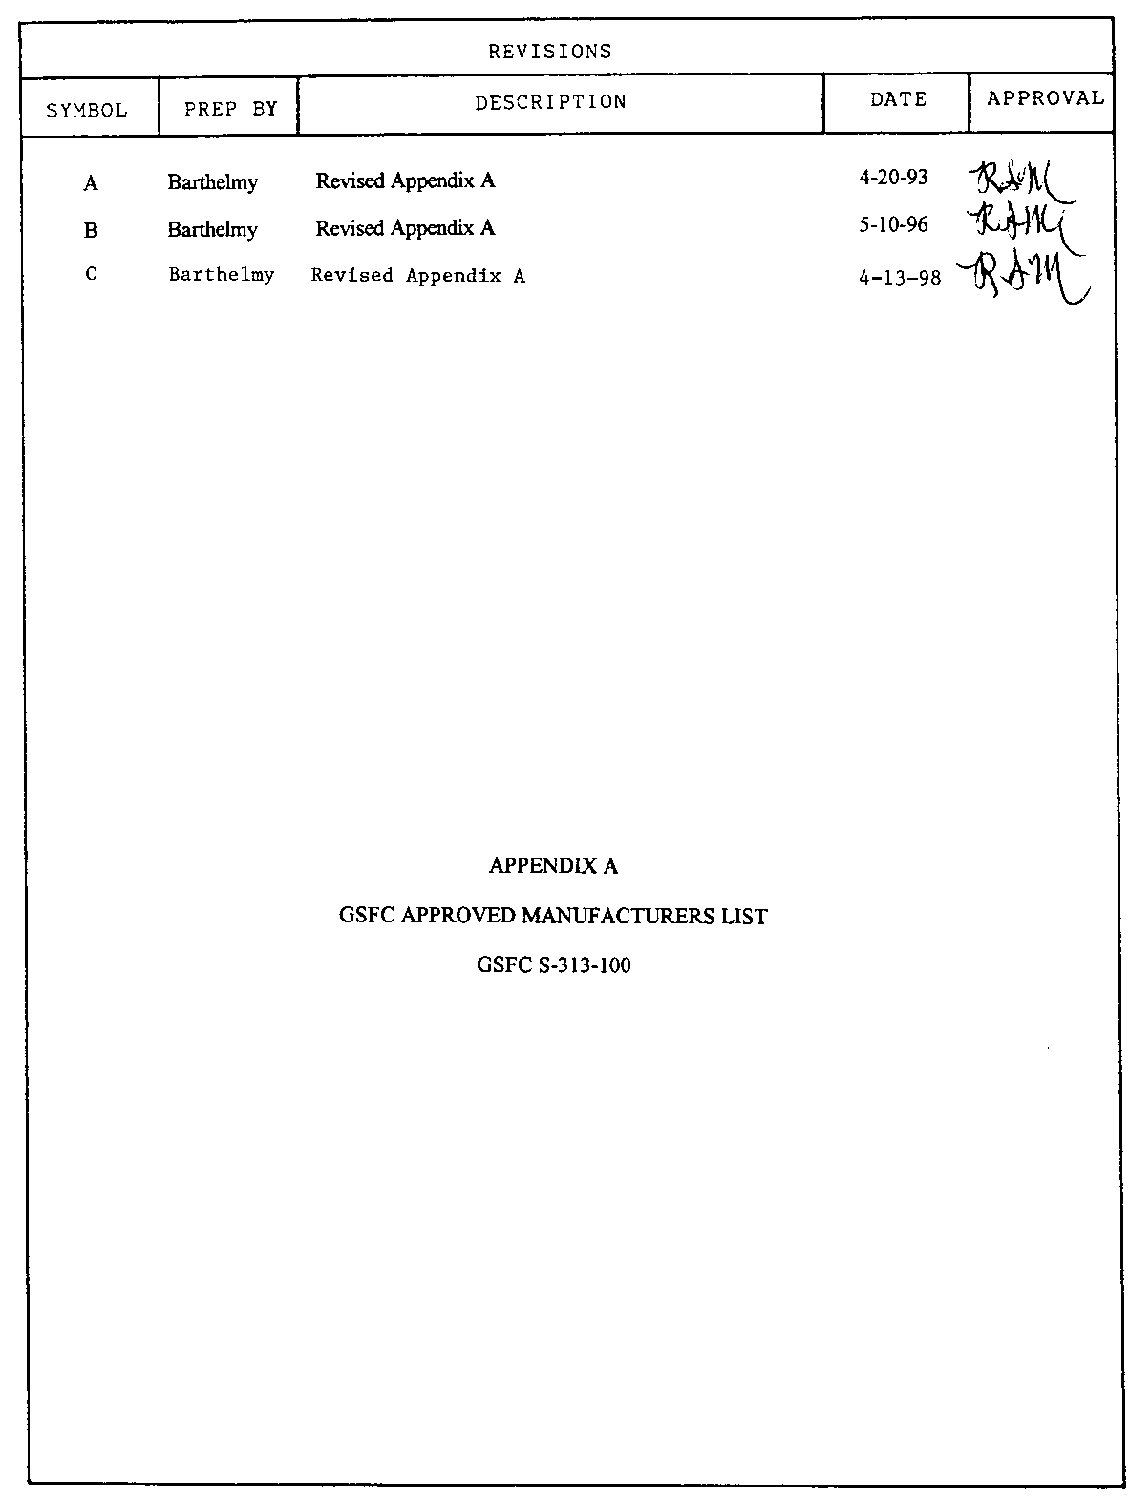
1.0 GSFC APPROVED MANUFACTURERS

Safe life or single point failure screws and bolts as defined in section 2.2 must be made by these manufacturers or by manufacturers that are audited by the developer. Screws or bolts may be purchased directly from the manufacturer or from any distributor. The following manufacturers typically will produce aerospace bolts and screws to NAS, MS, or NA specifications, as well as custom fasteners.

Air Industries, Garden Grove, CA. (714) 892 5571

Ameritech Fastener Mfg. Inc., Houston, TX (713) 939 7638

B&B Specialties Inc., Anaheim, CA. (714) 993 1600

BEK Level 1 Inc., Huntington, WV (304) 697 2323

NDT certs from BEK Level 1 Fasteners not acceptable.

Butler Inc., Gardena, CA (310) 323 3114

California Screw Products, Paramount, CA. (213) 633 6626

CBS Fasteners, Anaheim, CA (714) 779 6368

Champion Fasteners, Inc., Mount Holly, NJ (800) 755 2693

Fairchild Fasteners, Torrance, CA (310) 784 3453

Fastener Innovation Technology (FIT) Inc., Gardena, CA (310) 538 1111

Fastener Technology Corp., N. Hollywood, CA. (818) 764 6467

Federal Manufacturing Corp., Chatsworth, CA (818) 341 9825

Hi-Shear Corp., Torrance, CA (310) 326 8110

Huck Aerospace Fasteners, Lakewood, CA (310) 421 3711

Ideal Fasteners Inc., Anaheim, CA (714) 630 7840

J.I. Morris Co., Southbridge, MA (508) 764 4394

LFC Industries, Inc., Arlington, TX (817) 640 1322

Maney Aircraft, GS Aerospace Division, Ontario, CA (909) 390 2500

Mercury Aerospace Fasteners, N. Hollywood, CA (818) 982 4800
Use of fasteners currently in stock only

MS Aerospace, Burbank, CA (818) 953 9080

P.B. Fasteners, Gardena, CA (310) 323 6222

Pilgrim Screw Corp., Providence, RI (401) 274 4090
1.0 GSFC APPROVED MANUFACTURERS, continued

Quality Aircraft Screw, Corona, CA (909) 270 3210

Rocket Air Supply, Inc., Arlington, TX (817) 640 5340

Saturn Fasteners, Burbank, CA (818) 846 7145

Screwcorp/Fairchild, City of Industry, CA (818) 369 3333

SPS Technologies, Jenkintown, PA (215) 572 3133

SPS Technologies-Western, Santa Ana, CA (714) 545 9311

Valley Todeco, Sylmar, CA (818) 367 2261

Van Petty, Inc., Newberry Park, CA (805) 498 4594

3V Fasteners, Corona, CA (909) 734 4391

West Coast Aerospace, Wilmington, CA (310) 518 3167

This list was derived from DQA Memo 97-349, “Flight Systems Mechanical and Propulsion Quality Assurance (MPQA) List of Approved Fastener Suppliers”, Jet Propulsion Laboratory, Sept. 17, 1997 and the Ames Research Center DQA Approved Fastener Manufacturers List, Nov. 19, 1997.

