COMPLIANCE IS MANDATORY

Responsible Office: |  | 170/Independent Technical Authority Governance and Systems Management Office
Title: | Systems Engineering
Table of Contents

Preface
- Purpose
- Applicability
- Authority
- References
- Cancellation
- Safety
- Training
- Records
- Metrics
- Definitions

Procedures
- Roles and Responsibilities
- The Systems Engineering Life Cycle
- Communications
- Key Systems Engineering Functions
- Configuration Management and Documentation
- Systems Engineering Management Plan

Figures
- Systems Engineering Functions
- Systems Engineering Lifecycle Overview
- Lifecycle – Formulation Details
- Lifecycle – Implementation Details

Tables
Table 1 - Systems Engineering Key Functions Matrix

Appendices
Appendix A - Systems Engineering Requirements
Appendix B - System Engineering Management Plan Outline
Appendix C - Tailoring Guidelines
Preface

- PURPOSE
This directive outlines a process for the systems engineering of Goddard Space Flight Center (GSFC) Missions. The intent is to outline a set of requirements that provide a consistent method for performing systems engineering across GSFC projects. The requirements for system engineering outlined in this directive are universal principles that, when followed, should result in sound systems.
This directive defines the minimum set of systems engineering functions for GSFC Missions. These functions, from a product perspective, are defined and described. All phases of the mission lifecycle, and systems of interest, from mission, through major system element, to subsystem, to component or assembly are considered. The system engineering functions described in this directive are universal and generally apply across the board. What varies from project to project is who does them, to what degree they are performed, and to what degree there is insight by the customer as to how the functions are accomplished.
This directive is concerned with what must be done, along with insight into why it is done, rather than how it is done. The referenced SP-6105 provides detailed guidance on how to perform systems engineering functions. The required functions are described by shall statements. Tailoring of how, when, where, and by whom these functions are performed is described in a project unique Systems Engineering Management Plan (SEMP). An example of a SEMP outline is listed in Appendix B.
Principles for tailoring systems engineering activities are listed in Appendix C. The tailoring guidelines address who performs the functions and to what degree the functions are performed.
This directive defines systems engineering terminology (Section P.10). Roles and Responsibilities (Section 1) and the systems engineering lifecycle (Section 2) are defined. Communications and the systems engineering team (Section 3) are discussed. Systems engineering functions and products, and critical function flow and process operations, are discussed in Section 4. Section 5 discusses Configuration Management and Documentation. The required plan for systems engineering implementation is given in section 6. Appendix A contains a list of the systems engineering requirements defined within this directive. It may be used as a sample validation matrix.
- APPLICABILITY
This systems engineering procedure shall be tailored and applied to all missions (e.g., projects) for which GSFC is responsible, as well as to deliverable instruments, spacecraft and other GSFC mission products. This procedure applies to all concept studies, mission formulation, and implementation sub-processes, including mission operations, decommissioning and disposal.
- AUTHORITY
NPD 7120.4, Program/Project Management
- REFERENCES
- NPR 7120.5, NASA Program and Project Management Processes and Requirements
- GPG 1410.2, Configuration Management
- GPG 1060.2, Management Review And Reporting for Programs and Project
- GPG 1280.1, The GSFC Quality Manual
- GPG 5340.2, Control Of Nonconformances
- GPG 7120.1, Program and Project Management
- GPG 7120.4, Risk Management
- GPG 8700.1, Design Planning and Interface Management
- GPG 8700.4, Integrated Independent Reviews
- GPG 8700.6, Engineering Peer Reviews
- General Environmental Verification Specification - GEVS-SE

References on the performance of system engineering
- NASA Engineering Management Council, NASA Mission Design Process, 1992
- JSC 49040, NASA Systems Engineering Process
- SP-6105, NASA Systems Engineering Handbook
- CANCELLATION
GPG 7120.5, Systems Engineering
- SAFETY
None
- TRAINING
Training for Systems Engineering is available. The Office of Human Resources maintains information on regular and special offerings in systems engineering and related areas.
- RECORDS
None
- METRICS
None

DEFINITIONS
- Architecture and Design – A description of the mission elements, their interfaces, their logical and physical layout, and the analysis of the design to determine expected performance and margins. Includes System Design Synthesis, System Design Analysis, and System Design Validation products.
- Configuration Management – A systematic process for establishing and maintaining control and evaluation of all changes to baseline documentation, products (Configuration Items), and subsequent changes to that documentation which defines the original scope of effort. The systematic control, identification, status accounting, and verification of all Configuration Items throughout their life cycle.
- Development Risk – Risk of not delivering a quality product on time and within cost.
- Instrument Concept – A concept that defines the characteristics of the instruments needed to execute the measurement concept.
- Interface Control Document (ICD) - A specification of the mechanical, thermal, electrical, power, command, data, and other interfaces that system elements must meet.
- Lead Subsystem Engineer – The engineer responsible for the overall development and implementation of the subsystem products. This person may also serve as the Product Manager or Product Design Lead.
- Lead System Engineer – The system engineer responsible for leading and integrating the efforts of the systems engineering team and the overall development and implementation of the mission or project design.
- Level 1 Requirement – A Project’s fundamental and basic set of requirements levied by the Program or Headquarters on the project.
- Measurement Concept – A concept that defines what measurements must be taken to achieve the Science Objectives. Includes characteristics of measurements, such as, spectral band, resolution, sample rate, duration of observation, type of observation, vantage, and others. This includes New Technology Validation Concepts.
- Objectives – A set of goals and constraints that define the purpose of the mission and the programmatic boundaries, and provide a basis for the Level I requirements and mission success criteria. Usually captured as Science Objectives and New Technology Validation Objectives.
- On Orbit Mission Success Risk – Risk of not meeting on orbit mission success criteria.
- Operations Concept – A concept that defines how the mission will be verified, launched, commissioned, operated, and disposed of. Defines how the design is used to meet the requirements.
- Product Breakdown Structure (PBS) – A hierarchical tree that shows the composition of the system, sub-systems, assemblies, components, and other mission products (see Section 4.3). The PBS is used to ensure that all elements are accounted for in the design and development activities; including the development of the Work Breakdown Structure (WBS).
- Project Life cycle – Formulation, Approval, and Implementation.
- Requirement – A statement of a function to be performed, a performance level to be achieved, or an interface to be met.
- Requirements Document – An organized hierarchy of requirements that provides a validation basis for a system or system element.
- Risk Analysis – The activity of identifying risks, and the analysis of the probability of occurrence and the consequence of occurrence.
- Risk Reduction – The activities performed to reduce the likelihood of a risk occurring, the consequence should the risk occur, or both.
- Resource Tracking – The activity of tracking and maintaining technical resource allocations, estimates, and margins for system elements. Technical resources include, mass, power, volume, area, pointing accuracy and knowledge, link margin, and others.
- Safety Risk – Risk of injury to personnel, facilities or hardware.
- Space Environment & Specialty Engineering – Engineering to analyze the mission space environment and establish the design, implementation, and verification policies and requirements appropriate to the environment.
- Specification – A detailed requirements document that provides a verification basis for a system or system element.
- System of Interest – The identified part of the system hierarchy, whether a part, assembly, or subsystem, that is assigned to the engineering team.
- Systems Engineering Life-Cycle – Concept Studies (Phase A), Preliminary Analysis and Definition (Phase B), Design (Phase C), Development (Phase D), Mission Operations (Phase E) and Disposal (Phase F) are the systems engineering life-cycle phases. Development includes Acquisition, Fabrication, and Integration; Verification and Preparation for Deployment; and Deployment and Operations Verification.
- Systems Engineering Management Plan (SEMP) – An implementation plan for the performance of systems engineering functions and the development of systems engineering products. This plan identifies what, when, where, by whom, and how the functions are performed. It specifies the schedule for the development, and the resources required.
- Validation – Proof that the Operations Concept, Requirements, and Architecture and Design will meet Mission Objectives, that they are mutually consistent, and that the “right system” has been designed. May be determined by a combination of test or analysis. Generally accomplished through trade studies and performance analysis by Phase B and through tests in Phase D.
- Validation Basis – A set of requirements that provide the success criteria for a system or system element.
- Verification – Proof of compliance with requirements and that the system has been “Designed and Built Right.” May be determined by a combination of test, analysis, and inspection.
- Verification Basis – A set of specifications that define details of implementation, function, and performance to be verified.

Procedures

In this document, a requirement is identified by "shall," a good practice by "should," permission by "may" or "can," expectation by "will," and descriptive material by "is."

- ROLES AND RESPONSIBILITIES
Systems engineering is the responsibility of all engineers, scientists, and managers working on GSFC missions. Most share some portion of the overall Systems Engineering effort.
  - The product manager for the systems development function, typically a Study Manager, Project Formulation Manager, Project Manager, or Instrument Manager, shall work with Goddard Organizations to assign a Lead System Engineer.
  - The Product Manager and the Lead System Engineer shall develop the plan for the systems engineering effort and establish a system engineering team along with roles and responsibilities.
This plan, along with the roles and responsibilities, are captured in the SEMP (Section 6).
The Lead System Engineer, often referred to as the Mission System Engineer, has responsibility for the systems engineering functions and products for the overall mission. Other members of the system engineering team, discipline, subsystem, or specialty engineers have responsibility for their part of the total effort. Product Development engineers have a responsibility to understand and apply systems engineering functions, as appropriate, to the development of their products. All have the responsibility to communicate, coordinate, and validate tasks and products across the mission.
The Lead System Engineer coordinates the efforts of the systems engineering team. The team recommendations are provided to the Product Manager who makes decisions that balance technical performance and programmatic performance. For the rest of this directive, the term system engineer will be used to represent anyone responsible for systems engineering, at any level, as defined above.

THE SYSTEMS ENGINEERING LIFECYCLE
The project lifecycle is defined as a set of phases: Formulation, Approval, and Implementation. This directive defines systems engineering phases within the familiar Pre-phase A, Phase A, Phase B, Phase C/D, and Phase E/F terminology, described by the NASA Systems Engineering Handbook SP-6105. Each Systems Engineering phase consists of functions and a work flow that produce the products needed for completion of the phase. The mission review is the validating event for the phase and results in a revised mission baseline.
Figure 1, Systems Engineering Functions, shows the interrelationship of the major system engineering functions described in Section 4. Table 1, Systems Engineering Key Functions Matrix, provides a view of the evolution, in maturity and fidelity, of the systems engineering functions over the systems engineering lifecycle.
Figure 2 shows the Systems Engineering Lifecycle’s relationship with the project lifecycle and describes the major goal of each phase. Figure 2 also shows the lifecycle phase relationship with critical milestone reviews.
Figure 3 further describes the Formulation Phase.
Figure 4 describes the Implementation Phase.
The lifecycle accommodates the objective of systems engineering by considering implementation alternatives in Phase A, completing a preliminary design and validating that the right system has been designed in Phase B, performing a detailed design and verifying that the system is designed right in Phase C, building and verifying the system in Phase D, and operating and disposing it in Phases E and F.

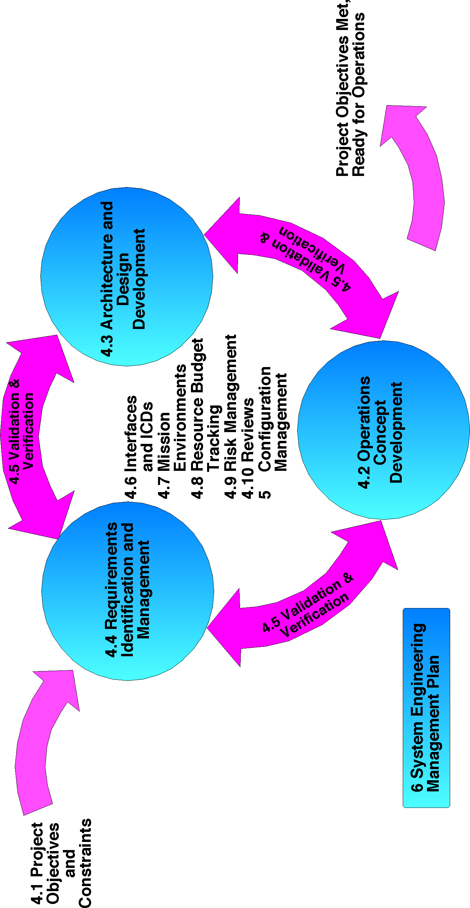
Figure 1. Systems Engineering Functions
Accomplishing mission objectives requires a consistent set of requirements, design and an operations concept. The operations concept uses the design to meet the requirements. Producing the design and then operating it to meet the requirements must be done within the cost and schedule constraints. Validation, Performance Predictions, Analysis, and Trade Studies are used to develop and optimize the total system.
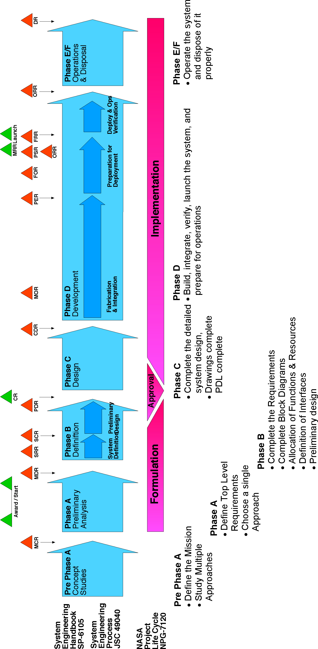
Figure 2. Systems Engineering Lifecycle Overview
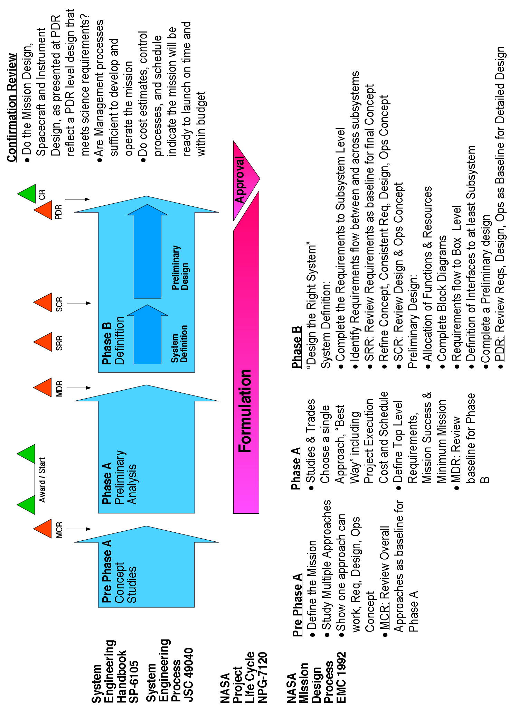
Figure 3. Lifecycle - Formulation Details
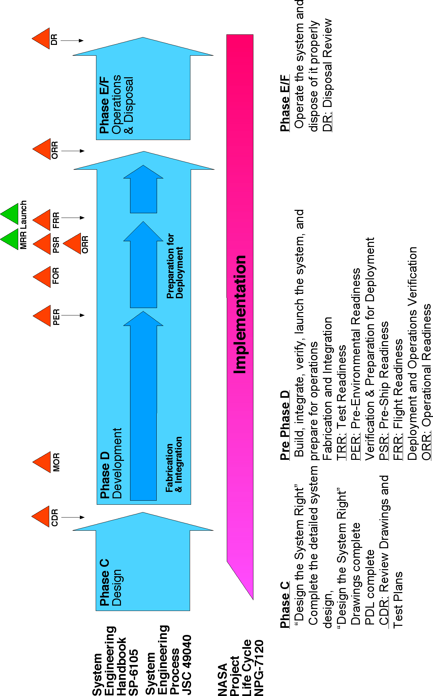
Figure 4. Lifecycle - Implementation Details
Table 1 - Systems Engineering Key Functions Matrix
Key Function | Concept Studies  Pre-Phase A | Preliminary Analysis  Phase A | Definition  Phase B | Design  Phase C | Development  Phase D | Operations  Phase E / F
- Understanding the  Objectives | Concept | Baseline | Complete  (Note 1) | Track Changes | Track Changes | Track Changes
- Operations Concept  Development | Concept | Baseline | Refine | Complete | Operations Plan | Track Changes
- Architecture &  Design Development | Concept | Baseline | Complete | Track Changes | Track Changes | Track Changes
- Requirements  Identification and  Management | Concept | Top Level Baseline | Complete | Track Changes | Track Changes | Track Changes
- Validation and  Verification | Concept | Initial | Assign Method | Develop Plans | Complete
- Interfaces and ICDs | Concept | Initial  (Note 2) | Baseline | Complete | Track Changes
- Mission  Environments | Initial | Baseline | Complete | Track Changes | Track Changes | Track Changes
- Technical Resource  Budget Tracking | Concept | Initial | Baseline | Track Changes | Track Changes | Track Changes
- Risk Management | Estimate | FTA, RBD | FMEA, 2nd FTA, RBD | FTA, FMEA, RBD, PRA | Update Changes | Update Changes
- System Milestone Reviews (Note3) | MCR | MDR | SRR, SCR, PDR, CR | CDR | MOR, PER, FOR, PSR, FRR, ORR | DR
- Configuration Management and Documentation | Informal CM | Control Level 1 Requirements | Start Formal CM | Track Changes | Track Changes | Track Changes
- Systems Engineering Management Plan | Concept | Baseline | Complete | Track Changes | Track Changes
Note 1: The Level 1 Requirements and Mission Success Criteria (Level I Requirements) must be complete by the end of Phase B.
Note 2: In the case of long-lead items and when instruments are developed early before project is identified, draft ICD’s must be written during Phase A.
Note 3: MCR – Mission Concept Review, MDR – Mission Definition Review, SRR – System Requirements Review, SCR – System Concept Review, PDR – Preliminary Design Review, CR – Confirmation Review, CDR – Critical Design Review, MOR – Mission Operations Review, PER – Pre-Environmental Review, FOR – Flight Operations Review, FRR – Flight Readiness Review, ORR – Operations Readiness Review, DR – Disposal Review.

- COMMUNICATIONS
The systems engineering effort is distributed across the many system elements that comprise the mission. The coordination of the many disciplines needed to develop, implement, and deliver the elements, and integrate them into an operational system, is both the great challenge and the great reward of systems engineering.
Good systems engineering teams start with a commitment to the delivery of the final product - the successful mission. Such a focus promotes open communications, consensus building, and a problem solving culture. There is added value in the participation of product engineers in the discovery, development, and allocation of the mission requirements, architecture and design, and operations concept. Such participation communicates an understanding of the trades, compromises, and optimizations needed to formulate and implement the space mission. The resultant buy-in, by the product leads, results in a focused effort. An advantage of good communications is the collection of the best ideas from the team.
This principle of participation, consensus building, and requirements buy-in is appropriate at all levels, from mission design through assembly and component design. It is the responsibility of system engineers to foster this philosophy, to support each other through peer reviews, and when called upon, to provide expert support in problem solving.
Information needed for the entire spacecraft team, such as, the mission space environment, the flight segment electrical system, mechanical system, and thermal system requirements, must be developed and clearly communicated and available to the entire team. The systems engineering information products, expected from each team member, should be clearly defined.
Methods used include periodic team meetings, concurrent engineering work sessions, email, centralized document control and distribution, peer reviews and formal reviews.
Teamwork is the essence of systems engineering. It is only through the success of the mission team that mission success is achieved.

KEY SYSTEMS ENGINEERING FUNCTIONS
“Systems Engineering is a robust approach to the design, creation, and operations of systems”, NASA Systems Engineering Handbook SP6105
This directive seeks to identify the major functions that lay the groundwork for a robust approach. This directive defines key systems engineering functions that are the minimum necessary for GSFC projects.
The following sections describe the functions and define what system engineering functions need to occur and to some degree when it should be done. The when part is tied to the system engineering lifecycle and critical project milestones. Implementation of the systems engineering functions, the where, when, by whom, and how is left up to each project to tailor via the Systems Engineering Management Plan (section 6). References such as the SP-6105, JSC-49040, and The NASA Mission Design Process describe approaches to performing these functions.
Accomplishing this objective requires a consistent set of requirements, design and operations concept.
“The objective of systems engineering is to see to it that the system is designed, built, and operated so that it accomplishes its purpose in the most cost-effective way possible, considering performance, cost, schedule and risk.” NASA Systems Engineering Handbook SP-6105
The operations concept uses the design to meet the requirements. Producing the design and then operating it to meet the requirements must be done within the cost and schedule constraints. Trade studies, performance predictions and analysis results are used to optimize a systems requirements, design and operations concept. There are generally several approaches that can work. Determining the optimum is the result of engineering.
The three major systems engineering functions: Operations Concept Development, Architecture and Design Development, and Requirements Identification and Management, flow from the objectives. These functions, and the resultant products, are interdependent, and must be consistent with each other. The relationship of these three major functions, along with the other key functions, is shown in Figure 1, Systems Engineering Functions. Validation, Performance Predictions, Analysis, and Trade Studies are used to develop and optimize the total system. During the systems engineering lifecycle phases further refinement and definition of the requirements, design and operations concept occurs to lower and lower levels until a detailed design is produced.
The Systems Engineering effort begins during the Pre-Phase A concept study by clearly identifying and understanding the Mission Objectives. Multiple approaches for requirements, design and operations concepts are developed, with at least one credibly meeting project objectives and constraints.
During Phase A, analysis activities and trade studies consider multiple approaches. A single approach is chosen for preliminary design in Phase B. Phase B activities seek to allocate the necessary functions to hardware elements and software along with a preliminary design. Phase C takes the allocated functions and produces a design with drawings for production in Phase D.
Phase D verification activities seek to assure that the system elements that are produced actually meet the requirements using the Operations Concept.

Understanding the Objectives
Clearly describing and documenting the mission objectives is important to making sure that the project team is working toward a common goal. The Science Objectives and any New Technology Validation Objectives form the basis for performing the mission and they need to be clearly defined and articulated. A Measurement Concept, that describes the characteristics of the measurements to be made, and an Instrument Concept, that describes what instrument characteristics are needed to make the measurements, often provides additional basis for mission design. The program constraints, appropriate to the mission, are also captured and used to validate the mission design.
- Each Project shall work with the customer community and the appropriate Enterprise Office at NASA Headquarters to prepare a set of Mission Level 1 Requirements that form the validation basis for the overall mission requirements. Level 1 requirements represent a contract between the project and headquarters or between a project and the program.
- By the end of phase B, each project shall define a set of mission success criteria that is then approved by center management and headquarters.

Operations Concept Development
The Operations Concept describes how the implemented mission is verified, launched, deployed, commissioned, operated, and disposed of. An Operations Concept serves as a validation reference for the design, throughout the life cycle. The operations concept describes how the design can accomplish the mission described by the objectives. Later in the design cycle the operations concept evolves into the mission or flight operations plan. An operations concept is necessary for the Identification and Management of Requirements (Section 4.4) and generating the Architecture and Design (Section 4.3).
- The Operations Concept shall address ground versus flight allocation of function.
- The Operations Concept shall describe the various mission operational modes and configurations including Verification, Launch and Acquisition, In Orbit Checkout and Calibration (Commissioning), in addition to normal mission mode, and disposal if required.
- The Operations Concept shall include a time ordered sequence of mission activities. This sequence forms the baseline for other engineering activities that need a mission timeline as an input.
- The Operations Concept shall identify facilities, equipment, and procedures needed to ensure the safe development and operation of the system.
- The Operations Concept shall describe functions that cut across various subsystems such as the Observation Strategy, Data Collection Storage and Downlink, Ground Station Utilization, Mission Orbit Maintenance and Maneuvers, Power and Battery Management.
- The Operations Concept shall include a set of performance predictions that indicate requirements (Section 4.4) can be met given the architecture and design (Section 4.3).
- The Operations Concept shall describe the operations team, size staffing, and extent of automation.
- The Operations Concept shall describe the ground segment functions, including data flow, primary interfaces, data processing algorithm development, level to which data will be processed, data archiving, data distribution, quantity of data with throughput and data latency.
- The Operations Concept shall include Contingency Concepts that could include topics such as recovery from Loss of Communications, Attitude Control System (ACS) Safing, and Load Shed.
- The Operations Concept shall include ground test configurations necessary to accomplish verification (Sections 4 & 5) including Ground Support Equipment (GSE), Bench Test Equipment (BTE), Simulators and non-flight articles such as Engineering Test Units (ETUs).
- The Operations Concept shall include operations to control hazards and maintain safety.
- The Operations Concept shall take into account coordination with other missions and operating agencies. The Operations Concept is initially developed as a draft concept during Pre-phase A, with refinement throughout the lifecycle, until the flight operations plan is completed in Phase D.
- The outcome and decisions for key operations concept trade studies and optimizations shall be documented, (Section 5). Trade studies and analyses are used to demonstrate that the operations concept will meet the mission requirements including cost and schedule and are consistent with the architecture and design.
- The Operations Concept shall be validated to the Level 1 requirements, Mission Objectives, the Measurement Concept, and the Instrument Concept.

Architecture and Design Development
The major goal of Systems Engineering is coordinating the engineering, design, and development of an Architecture and Design that meets the Requirements (Section 4.4), is consistent with the Operations Concept (Section 4.2), operates in the mission environment (Section 4.7), and can be developed on schedule and within cost. Block Diagrams are the key mechanism for documenting and communicating the architecture and design to the team.
- The Architecture and Design shall include the spacecraft, the ground systems, and the launch vehicle.
- The Architecture and Design shall decompose the total system into its major parts to form the hierarchy (PBS) for lower level interfaces and specifications. The major parts of a system include the separate subsystems and boxes and their embedded hardware and software functions.
- The Architecture and Design shall be analyzed, the analytical models maintained, and the analytical results used to establish an estimated performance baseline.
- The Architecture and Design shall include any special test interfaces and test equipment necessary for verification, (Section 4.5).
- The outcome and decisions of key architecture and design trade studies and optimizations shall be documented, (Section 5).
- New technologies necessary for mission success shall be identified and potential risks identified and included in risk management, (Section 4.9).
- The Architecture and Design shall identify hazards and safety requirements and implement necessary controls. The Architecture and Design are first generated in Pre-phase A and defined and refined until the end of Phase B, at the PDR. Initially the architecture should start out as functional or logical blocks. As the design matures the architecture should mirror the physical Product Breakdown Structure. Once Block Diagrams and Interfaces are defined then detailed design (Phase C) can proceed, without the risk of a major change induced by an architectural block diagram change.
- The Architecture and Design shall be validated to the Operations Concept and the Mission Requirements.

Requirements Identification and Management
Requirements communicate what functions a system must perform and how well it must perform them. They describe the interfaces a system must meet.
Requirements shall be organized into a hierarchy that flows down through the systems of interest. The levels of requirements are typically shown in a document tree. The mission level 1 requirements, usually defined in the project plan, define mission success criteria and serve as the top level for the requirements hierarchy.

Requirements Identification
Document the requirements appropriate to the complexity of the system element.
- Requirements shall be organized into Functional and Performance categories. Functional Requirements describe what the system must do. Performance requirements are attached underneath their respective Functional Requirement. Performance requirements describe and document how well the function needs to be performed. Performance requirements are written in a verifiable manner.
- Requirements shall specify the interfaces or reference configured interface specifications.

Requirements Management
- The Requirements flow hierarchy shall be consistent with the Product Breakdown Structure. Requirements are decomposed and allocated to products down through the PBS. Ideally, this continues until a single engineer is responsible for the product. Some shared requirements may flow between and across subsystem elements.
- Shared requirements shall be documented either within the requirements tree, or in a separate specification such as Electro-Magnetic Interference (EMI), Environmental, Electrical Systems, Contamination, etc., or as part of Resource Budgets.
- Shared requirements shall be referenced by all elements to which they apply. By the end of Phase C, and the CDR, the requirements flow, down to build-to specifications, should be complete.
- The outcome and decisions for key requirements trade studies and optimizations shall be documented, (Section 5). Trade studies and analysis are used to refine the requirements along with the Operations Concept and the Architecture and Design to meet the mission requirements including cost and schedule.

Validation and Verification
Validation and Verification work together over the systems engineering lifecycle to show that the system of interest meets its objectives.

Validation
Validation is used to assure that the mission design will meet the mission objectives. It is a continuing process that encompasses the validation of the Operations Concept, the Architecture and Design, the Requirements, the mutual consistency of these three elements, and the verification program.
Mission Objectives define the mission goals. The Measurement Concept defines the measurements and measurement characteristics that meet the goals. The Instrument Concept defines the instrument characteristics needed to achieve the measurements. These three provide a Mission Validation Basis for the mission design.
The Operations concept is validated to the Mission Validation Basis. This validation assures that the operational design will operate the spacecraft and instruments in a way that will achieve the Mission Objectives.
- The Operations Concept shall be validated to assure that the operation of the system will meet Mission Objectives by achieving the Measurement Concept and accommodating the Instrument Concept. The Requirements are validated to the Mission Validation Basis. This assures that all of the functions needed to meet objectives are defined and that the required performance of each function is captured.
During the design phases performance predictions, trade studies, analyses are used to validate that the chosen design meets the requirements, when utilized according to the Operations Concept.
Validation also establishes requirements tracing to ensure that the higher-level requirements flow to a lower level or child requirement. Requirements validation also makes sure that the lower level requirements have a parent requirement. Orphan requirements, ones without a higher-level parent, are evaluated to determine if they are needed.
- Requirements shall be validated to assure that the system will meet the Mission Objectives, be capable of performing the Measurement Concept, accommodate the Instrument Concept, and operates as defined in the Operations Concept.
- Each project shall decide on the mechanism for tracking the requirements and who is responsible for the requirements flow and verification. The Architecture and Design is validated to the Mission Validation Basis. This assures that the design will accommodate the instruments, implement the required functions, and achieve the performance needed to meet Mission Objectives.
- The Architecture and Design shall be validated to assure that the operation of the system will meet Mission Objectives by implementing the functions and achieving the performance needed to achieve the Measurement Concept and accommodate the Instrument Concept.
The Operations Concept, Architecture and Design, and Requirements are validated to assure mutual consistency. Each of these elements affects the others. The Operations Concept determines the partitioning of function between the space element, the ground element, and the launch element. It defines modes of operation and timing which drive both the requirements and design. The requirements capture the functionality and performance the design must achieve. This includes operationally driven requirements. The design must be able to operate according to the Operations Concept and must implement the requirements. This mutual dependency is strongly coupled, thus mutual consistency must be validated.
- The Operations Concept, Requirements, and Architecture and Design shall be validated to assure mutual consistency. The methods, inspections, analyses, and tests; facilities, GSE and BTE, test levels, and test activities together define a verification program which defines how the system will be verified. The verification program is validated to the requirements to assure that every requirement is verified. Validation of the verification program to the Operations Concept assures that the system will operate as required.
- The Verification Program shall be validated to assure that all requirements are verified, and that the system operates as required by the Operations Concept.
Phase A and Phase B validation activities strive to show that the right system design has been chosen before detailed design proceeds in Phase C. Validation that the requirements are consistent with the design and operations concept, early in the lifecycle, minimizes the chance that the wrong system is designed. Phase C and D verification activities show that the chosen system design is implemented correctly. Validation also occurs during later in the life cycle when mission simulations, end-to-end tests, and other activities show that the system design correctly meets the customer’s intent.

Verification
Verification includes those functions that make sure the team builds the system right, by verifying the design and implementation against the requirements. Tests and simulations function as the last line of defense against design and implementation defects that may compromise mission success. Verification is an important risk reduction function that attempts to uncover issues before they become problems on orbit.
- Requirements shall be verified.
- Verification shall include identification of the verification item, the method (analysis, inspection, or test), and review and approval of the verification results.
- Each project shall identify "What is not tested in flight configuration" and ascertain the risk associated with a non-flight like test configuration. The desire is to "test the way you fly it, and then fly it the way you test it" so that all functions are performed, and all environments are encountered, prior to launch. Where elements are tested in pieces or tested separately, attention to the interfaces and assumptions are critical to uncover hidden problems.
- Once the verification method is chosen, the responsible engineer shall verify the appropriate support equipment (GSE, BTE, ETUs), tools, and facilities are available. By CDR all of the requirements are assigned a verification method.
- Test Planning documents shall be prepared that identify the environmental exposure as well as requirements for comprehensive, functional, aliveness, end-to-end, and mission simulation testing.
Included are any other special or one-time tests necessary to verify hardware or software functionality. Special test equipment and test interfaces, that are necessary for verification, should be considered and documented along with the Architecture and Design, (Section 4.3).
Every effort should be made to perform a system end-to-end test, all the way from the input to the instruments, through the spacecraft, transmitted to receiving antennas, and into the ground processing facility. This is the true test of the functionality of the system. Often such an end-to-end test cannot be fully achieved because of difficulties and expense in closing some of the links, or operating some of the flight segment in a one-g environment. In such cases, breaks in the chain are permitted, as long as the proper analysis and interface checks are performed to ensure the integrity of the overall end-to-end performance.
- Non-conformances identified during requirements verification shall be documented and dispositioned, consistent with GPG 5340.2, using either a problem reporting system or a configuration management system such as Configuration Change Requests, Waivers, or Deviations.
- Environments identified under Section 4.7, Mission Environments, shall be verified according to test guidelines established by the General Environmental Verification Specification - GEVS-SE.
- Performance measurements and test results shall be used to update the expected performance model in order to assess the margin between required and expected performance. During Phase D, verification results are compared against the requirements to track conformance and compliance. Most requirements should be verified by the Pre-Ship Review and all by the Flight Readiness Review.
- The system engineer shall assign responsibility for reviewing and approving the results of verification activities. The review of verification results is particularly effective in identifying and correcting problems. Verification status reporting is used to track conformity, performance, and completeness.
- Verification status and results shall be tracked back to the requirements using a method or tool chosen by the project.
- Verification shall include the effort necessary to make sure the end item performs as intended by design. End-to-end testing and mission simulations are the intended methods.
- Verification shall include the effort necessary to show redundant or backup functions operate as intended, to enable fault recovery or graceful degradation modes.
This verification includes verifying that procedures or onboard fault protection features actually protect the system, should faults occur.
Verification includes making sure the end item, and its support or ground equipment, functions in the intended operational scenario. When verifications are performed by analysis, the analytical models must be validated for correctness and the required fidelity. Detailed design features that are developed in the design process must also be verified. Verifying mission requirements alone is generally not sufficient for launch readiness.
- The GSE and BTE, facilities, plans and procedures shall be validated to the verification methods.

Interfaces and ICDs
ICDs describe where and how various system elements need to connect or communicate with each other and also where isolation is required to prevent interference or undesired interaction. Interfaces and ICDs, between elements of the block diagram, describe the topologies of the interfaces. Defined interfaces allow multiple detailed designs to proceed in parallel. Defining interfaces is an important outgrowth of requirements allocation. Once requirements and functions have been partitioned, the interfaces can be defined.
- All interfaces shall be defined and documented.
- The project team shall decide which ICDs are necessary, given the complexity, organization structure, and participants. Interface requirements should be well defined before PDR, to allow detailed design to proceed with minimal risk of changes.
- The ICDs shall be validated to the Architecture and Design and the Requirements.

Mission Environments
Each space mission has a unique set of environmental requirements that apply to all flight segment elements. It is a critical function of systems engineering to define and communicate all the anticipated environments to the team.

External Environments
- Each project shall identify the external environments for the mission, analyze and quantify the expected environment, establish design guidance, and establish a margin philosophy against the expected environment.
- The expected environments and the required margin shall be documented.
- The environments shall envelope what can be encountered during ground test, storage, transportation, launch, deployment and normal operations from beginning of life to end-of-life.
The environments may include Vibration, Shock, Static Loads, Acoustic, Thermal, Humidity, Contamination, Total Dose Radiation, Singe Event Effects (SEE), Surface and Internal Charging, Orbital debris, Atmospheric (atomic oxygen), ACS Disturbance (Atmospheric Drag, Gravity Gradient, Solar Pressure), Magnetic, and Radio Frequency (RF) exposure on the ground and on orbit.

Internal Environments
- Each project shall identify the internal environments for the mission, analyze and quantify the expected environment, and establish a margin philosophy against the expected environment.
- Specialty Engineering disciplines that apply across project elements shall be addressed in the requirements structure.
These discipline areas levy requirements to multiple system elements. The discipline areas often include: Electrical Systems, Electromagnetic Interference & Electromagnetic Conductance (EMI/EMC) and Grounding, Mechanical Systems, Thermal, Radiation Shielding, Parts Engineering, Contamination Engineering, Reliability Analysis, Charging, Timing and Time Distribution, Data Rates, and on Orbit Debris Assessment.
- Requirements derived from the mission environments shall be included in the system requirements.

Technical Resource Budget Tracking
- Each project shall identify the mission resources to be allocated and tracked.
- Each project shall define acceptable resource margins and then set up a margin management philosophy based on design maturity and time.
The margin philosophy includes a process for reducing required margin through out the project's life. For example at PDR 30% margin may be appropriate. At CDR a 10% margin could be appropriate. And close to Flight a 0% to a 3% margin. Another factor in margin tracking is the precision of the estimate. Estimated, calculated and measured numbers can carry different uncertainties and may require different margins.
Resource budgets may include, Mass, Power, Battery, Fuel, Memory, Processor Usage, Data Rate and Volume, Telemetry, Commands, Data Storage, RF Link, Contamination, Alignment, Total Dose Radiation, SEE, Surface and Internal Charging, Meteoroid, Atmospheric (atomic oxygen), ACS Pointing and Disturbance (Atmospheric Drag, Gravity Gradient, Solar Pressure), and RF exposure on the ground and on orbit.
Care must be taken that margins are not added to margins. The lead systems engineer holds the overall system margins. Some margin may be allocated to subsystem engineers in order to meet their design requirements. This hierarchy of margins must be taken into account so that the overall system margins do not unnecessarily drive the design and the cost.

Risk Management
Risk management is an organized, systematic decision-making process that efficiently identifies, analyzes, plans (for the handling of risks), tracks, controls, communicates, and documents risks to increase the likelihood of achieving program/project goals. GPG 7120.4 provides procedures and guidelines for applying risk management to GSFC projects.
The senior managers of the project team, particularly the Project Manager, Lead System Engineer and System Assurance Manager, are expected to personally and actively lead the risk management decision-making process. The Lead System Engineer and the system engineering team perform a particularly vital role in the identification, analysis, planning, tracking, controlling, communicating and documenting of risks relative to achieving the success criteria.
The contributions of the system engineering team are crucial to the discussion of the acceptable risk level for the mission and the development of a reliability philosophy commensurate with the agreement on acceptable risk. The acceptable risk and reliability philosophy shape the mission assurance requirements necessary to achieve mission success. The reliability philosophy encompasses everything that is done to assure a reliable system (e.g., parts selection and screening, analysis and simulations, test program, reviews, contingency planning) and what reliability analyses are planned to look for problems and investigate what could go wrong.
Paragraphs 2.5 through 2.8 of GPG 7120.4 provide risk management requirements particularly applicable to the responsibilities of the Lead System Engineer:
- A Failure Modes and Effects Analysis (FMEA) shall be performed early in the design phase to identify system design problems (flight and ground, hardware and software). Refer to paragraph 2.5 of GPG 7120.4.
- Fault Tree Analyses (FTA) shall be performed to address both mission failures and degraded modes of operation. Refer to paragraph 2.6 of GPG 7120.4.
- Comparative numerical reliability assessments and/or reliability predictions, such as Probabilistic Risk Assessment (PRA), should be used to evaluate and optimize the system. This includes:
- Evaluate alternative design concepts, redundancy and cross-strapping approaches, and part substitutions;
- Identify the elements of the design that are the greatest detractors of system reliability;
- Identify those potential mission limiting elements and components that will require special attention in part selection, testing, environmental isolation, and/or special operations;
- Assist in evaluating the ability of the design to achieve the mission life requirement and other reliability goals and requirements as applicable; and
- Evaluate the impact of proposed engineering change and waiver requests on reliability.
- The Risk Management Plan shall document the project decision on utilizing PRA and similar techniques in the project systems engineering process. Refer to paragraph 2.7 of GPG 7120.4
- The results of FMEA’s, FTA’s and any numerical reliability assessments or predictions shall be reported at system-level critical milestone reviews. Refer to paragraph 2.8 of GPG 7120.4. The first FTA is appropriate during Phase A. Reliability analyses and results should be presented in preliminary form at PDR, with updates at CDR, and final products consistent with the as-built configuration.

System Milestone Reviews
Reviews are held to validate the quality and completeness of a systems engineering phase or portion thereof. Reviews are a tool for communication within the team. The preparatory integration and structured presentation of requirements, design information, analyses, engineering products, test and operations plans, etc., facilitates knowledge sharing and identification and resolution of challenges and issues. Reviews are a source of validation, ideas, best practices and lessons learned from experts outside of the project team.
- Engineering Peer Reviews, including systems engineering peer reviews, shall be planned and conducted in accordance with GPG 8700.6.
- Integrated Independent Reviews shall be planned and conducted in accordance with GPG 8700.4.

CONFIGURATION MANAGEMENT AND DOCUMENTATION
The project's configuration management system functions as a library for documentation control, access, and dissemination. Documents are placed into the library to serve as a single, configured, point-of-reference for the project team.
- Each project shall choose the Systems Engineering documents necessary for inclusion in its Configuration Management Office, and the degree of formality assigned to document change control. Each project establishes a mechanism to disseminate the latest information and to archive the results of System Trade Studies, Reports and Analysis.
- Documents stored in the library shall include the configured, single point of reference for the Operations Concept, Architecture and Design, Requirements, Resource Budgets, Mission Environments, and the Systems Engineering Management Plan (SEMP).
The project decides what is necessary for future reference, or in support of the review process, documenting what was done, or why it was done. Documents can be placed under formal configuration management or stored in an information system for access. A process for the identification and use of latest revisions is required, in accordance with GPR 1410.2.
The System Engineer participates in the establishment of the Configuration Control Board (CCB) and is assigned to the CCB.
- The system engineer shall generate a document tree that shows the requirements hierarchy. Other documents, such as the In-Orbit Checkout (IOC) Report and the End of Mission and Disposal Report, should be considered for configuration management.

SYSTEMS ENGINEERING MANAGEMENT PLAN
The SEMP as outlined in Appendix B is generated during Phase A and baselined in Phase B. The SEMP should be updated as necessary when major changes occur. The details of schedule, workflow, and the order of activities should be continuously updated as part of ongoing planning.
    - Each project shall prepare a SEMP that addresses the requirements of this directive and describes What, When, Where, by Whom, and How each are to be implemented.
    - The SEMP shall include:
      - An organization structure along with responsibilities for the System Engineering Team.
      - The major trades identified.
      - A schedule and list of resources required for the systems engineering effort.

Appendix A - Systems Engineering Requirements

Paragraph & Requirement | Requirement
1. | ROLES AND RESPONSIBILITIES
a. | The product manager for the systems development function, typically a Study Manager, Project Formulation Manager, Project Manager, or Instrument Manager, shall work with Goddard Organizations to assign a Lead System Engineer.
b. | The Product Manager and the Lead System Engineer shall develop the plan for the systems engineering effort and establish a system engineering team along with roles and responsibilities.
4.1 | Understanding the Objectives
a. | Each Project shall work with the customer community and the appropriate Enterprise Office at NASA Headquarters to prepare a set of Mission Level 1 Requirements that form the validation basis for the overall mission requirements.
b. | By the end of phase B, each project shall define a set of mission success criteria that is then approved by center management and headquarters.
4.2 | Operations Concept
a. | The Operations Concept shall address ground versus flight allocation of function.
b. | The Operations Concept shall describe the various mission operational modes and configurations including Verification, Launch and Acquisition, In Orbit Checkout and Calibration (Commissioning), in addition to normal mission mode, and disposal if required.
c. | The Operations Concept shall include a time ordered sequence of mission activities.
d. | The Operations Concept shall identify facilities, equipment, and procedures needed to ensure the safe development and operation of the system.
e. | The Operations Concept shall describe functions that cut across various subsystems such as the Observation Strategy, Data Collection Storage and Downlink, Ground Station Utilization, Mission Orbit Maintenance and Maneuvers, Power and Battery Management.
f. | The Operations Concept shall include a set of performance predictions that indicate requirements can be met given the architecture and design.
g. | The Operations Concept shall describe the operations team, size staffing, and extent of automation.
h. | The Operations Concept shall describe the ground segment functions, including data flow, primary interfaces, data processing algorithm development, level to which data will be processed, data archiving, data distribution, quantity of data with throughput and data latency.

Paragraph & Requirement | Requirement
i. | The Operations Concept shall include Contingency Concepts that could include topics such as recovery from Loss of Communications, Attitude Control System (ACS) Safing, and Load Shed.
j. | The Operations Concept shall include ground test configurations necessary to accomplish verification including Ground Support Equipment (GSE), Bench Test Equipment (BTE), Simulators and non-flight articles such as Engineering Test Units (ETUs).
k. | The Operations Concept shall include operations to control hazards and maintain safety.
l. | The Operations Concept shall take into account coordination with other missions and operating agencies.
m. | The outcome and decisions for key operations concept trade studies and optimizations shall be documented.
n. | The Operations Concept shall be validated to the Level 1 requirements, Mission Objectives, the Measurement Concept, and the Instrument Concept.
4.3 | Architecture and Design
a. | The Architecture and Design shall include the spacecraft, the ground systems, and the launch vehicle.
b. | The Architecture and Design shall decompose the total system into its major parts to form the hierarchy (PBS) for lower level interfaces and specifications. The major parts of a system include the separate subsystems and boxes and their embedded hardware and software functions.
c. | The Architecture and Design shall be analyzed, the analytical models maintained, and the analytical results used to establish an estimated performance baseline.
d. | The Architecture and Design shall include any special test interfaces and test equipment necessary for verification.
e. | The outcome and decisions of key architecture and design trade studies and optimizations shall be documented.
f. | New technologies necessary for mission success shall be identified and potential risks identified and included in risk management.
g. | The Architecture and Design shall identify hazards and safety requirements and implement necessary controls.
h. | The Architecture and Design shall be validated to the Operations Concept and the Mission Requirements.

Paragraph & Requirement | Requirement
4.4 | Requirements Identification and Management
a. | Requirements shall be organized into a hierarchy that flows down through the systems of interest.
4.4.1 | Requirements Identification
a. | Requirements shall be organized into Functional and Performance categories.
b. | Requirements shall specify the interfaces or reference configured interface specifications.
4.4.2 | Requirements Management
a. | The Requirements flow hierarchy shall be consistent with the Product Breakdown Structure.
b. | Shared requirements shall be documented either within the requirements tree, or in a separate specification such as Electro-Magnetic Interference (EMI), Environmental, Electrical Systems, Contamination, etc, or as part of Resource Budgets.
c. | Shared requirements shall be referenced by all elements to which they apply.
d. | The outcome and decisions for key requirements trade studies and optimizations shall be documented.
4.5.1 | Validation
a. | The Operations Concept shall be validated to assure that the operation of the system will meet Mission Objectives by achieving the Measurement Concept and accommodating the Instrument Concept.
b. | Requirements shall be validated to assure that the system will meet the Mission Objectives, be capable of performing the Measurement Concept, accommodate the Instrument Concept, and operates as defined in the Operations Concept.
c. | Each project shall decide on the mechanism for tracking the requirements and who is responsible for the requirements flow and verification.
d. | The Architecture and Design shall be validated to assure that the operation of the system will meet Mission Objectives by implementing the functions and achieving the performance needed to achieve the Measurement Concept and accommodate the Instrument Concept.
e. | The Operations Concept, Requirements, and Architecture and Design shall be validated to assure mutual consistency.
f. | The Verification Program shall be validated to assure that all requirements are verified, and that the system operates as required by the Operations Concept.

Paragraph & Requirement | Requirement
4.5.2 | Verification
a. | Requirements shall be verified.
b. | Verification shall include identification of the verification item, the method (analysis, inspection, or test), and review and approval of the verification results.
c. | Each project shall identify "What is not tested in flight configuration" and ascertain the risk associated with a non-flight like test configuration.
d. | Once the verification method is chosen, the responsible engineer shall verify the appropriate support equipment (GSE, BTE, ETUs), tools, and facilities are available.
e. | Test Planning documents shall be prepared that identify the environmental exposure as well as requirements for comprehensive, functional, aliveness, end-to-end, and mission simulation testing.
f. | Non-conformances identified during requirements verification shall be documented and dispositioned, consistent with GPG 5340.2, using either a problem reporting system or a configuration management system such as Configuration Change Requests, Waivers, or Deviations.
g. | Environments identified under section 4.7 Mission Environments shall be verified according to test guidelines established by the General Environmental Verification Specification GEVS-SE
h. | Performance measurements and test results shall be used to update the expected performance model in order to assess the margin between required and expected performance.
i. | The system engineer shall assign responsibility for reviewing and approving the results of verification activities.
j. | Verification status and results shall be tracked back to the requirements using a method or tool chosen by the project.
k. | Verification shall include the effort necessary to make sure the end item performs as intended by design. End-to-end testing and mission simulations are the intended methods.
l. | Verification shall include the effort necessary to show redundant or backup functions operate as intended, to enable fault recovery or graceful degradation modes.
m. | The GSE and BTE, facilities, plans and procedures shall be validated to the verification methods.

Paragraph & Requirement | Requirement
4.6 | Interfaces and ICDs
a. | All interfaces shall be defined and documented.
b. | The project team shall decide which ICDs are necessary, given the complexity, organization structure, and participants.
c. | The ICDs shall be validated to the Architecture and Design and the Requirements.
4.7.1 | External Environments
a. | Each project shall identify the external environments for the mission, analyze and quantify the expected environment, establish design guidance, and establish a margin philosophy against the expected environment.
b. | The expected environments and the required margin shall be documented.
c. | The environments shall envelope what can be encountered during ground test, storage, transportation, launch, deployment and normal operations from beginning of life to end-of-life.
4.7.2 | Internal Environments
a. | Each project shall identify the internal environments for the mission, analyze and quantify the expected environment, and establish a margin philosophy against the expected environment.
b. | Specialty Engineering disciplines that apply across project elements shall be addressed in the requirements structure.
c. | Requirements derived from the mission environments shall be included in the system requirements.
4.8 | Technical Resource Budget Tracking
a. | Each project shall identify the mission resources to be allocated and tracked.
b. | Each project shall define acceptable resource margins and then set up a margin management philosophy based on design maturity and time.
4.9 | Risk Analysis and Management
a. | A Failure Modes and Effects Analysis (FMEA) shall be performed early in the design phase to identify system design problems.
b. | Fault Tree Analyses (FTA) shall be performed to address both mission failures and degraded modes of operation.
c. | Comparative numerical reliability assessments and/or reliability predictions, such as Probabilistic Risk Assessment (PRA), should be used to evaluate and optimize the system.

Paragraph & Requirement | Requirement
d. | The Risk Management Plan shall document the project decision on utilizing PRA and similar techniques in the project systems engineering process.
e. | The results of FMEA’s, FTA’s and any numerical reliability assessments or predictions shall be reported at system-level critical milestone reviews.
4.10 | System Milestone Reviews
a. | Engineering Peer Reviews, including systems engineering peer reviews, shall be planned and conducted in accordance with GPG 8700.6.
b. | Integrated Independent Reviews shall be planned and conducted in accordance with GPG 8700.4.
5 | CONFIGURATION MANAGEMENT AND DOCUMENTATION
a. | Each project shall choose the Systems Engineering documents necessary for inclusion in its configured library and the degree of formality assigned to document change control.
b. | Documents stored in the library shall include the configured, single point of reference for the Operations Concept, Architecture and Design, Requirements, Resource Budgets, Mission Environments, and the Systems Engineering Management Plan (SEMP).
c. | The system engineer shall generate a document tree that shows the requirements hierarchy.
6 | SYSTEMS ENGINEERING MANAGEMENT PLAN
a. | Each project shall prepare a SEMP that addresses the requirements of this directive and describes What, When, Where, by Whom, and How each are to be implemented.
b. | The SEMP shall include an organization structure along with responsibilities for the System Engineering Team.
c. | The SEMP shall include the major trades identified.
d. | The SEMP shall include a schedule and list of resources required for the systems engineering effort.

Appendix B - System Engineering Management Plan Outline
Section
1. INTRODUCTION
1.1 Purpose
1.2 Applicable Documents
1.3 Mission Overview
1.4 System Segment Overview
1.5 Definitions
1.6 Project Schedule
2. SYSTEM ENGINEERING LIFE CYCLE, GATES, AND REVIEWS
(Describe the overall lifecycle including the major systems engineering activities for each phase irrespective of who does them. Describe critical decisions and activities. Include approach for performing the system engineering activities especially where subcontracts are planned.)
3. COMMUNICATION
(Describe methods utilized for communicating systems engineering activities, progress, status and results. Include any periodic meeting or working groups. Reference communication methods like meeting makers, tracking tools, email, websites, etc. that are planned.)
4. KEY SYSTEMS ENGINEERING FUNCTIONS
  - Mission Objectives
(Describe who is responsible for developing the Level 1 Requirements, Mission Success Criteria, and the definition of Minimum Mission. List which document will contain each of these. Define when each of these is due.)
4.2 Operations Concept Development
(Define who develops the operations concept, what format is planned and when it is due. Define who develops the ground based verification concept, what format is planned and when it is due.)
4.3 Mission Architecture and Design Development
(Define who develops the Architecture and Design, what format is planned and when it is due. Define who develops and maintains the Product Breakdown Structure. Sometimes the total system architecture is prepared by several groups. Defining the roles of each of the participants is important).
4.4 Requirements Identification and Analysis
(Define who develops the requirements hierarchy, define who is responsible for each part of the hierarchy, define who identifies and is responsible for the crosscutting requirements. Define what format is planned and what tools if any are to be used for documenting and tracking the requirements. Define when requirements identification is due and when formal configuration control is expected to start.)
  - Validation and Verification
(Define who is responsible for the validation activities and how this is accomplished. What analysis or performance predictions are planned, who performs each and how they will be accomplished.)
(Define who is responsible for performing the verification activity and tracking the progress for each level within the requirements hierarchy. Define who has approval authority for verification at each level within the requirements hierarchy. Define what tools if any are planned to track verification status. Define the due dates for showing requirements compliance.)
4.6 Interfaces and ICDs
(Define which ICDs are planned, what interfaces are to be included, who is responsible for developing the ICDs and who has approval and configuration management authority.)
4.7 Mission Environments
(Define the applicable mission environments, who is responsible for determining the mission specific environmental levels or limits, and how each environmental requirement is to be documented.)
4.8 Resource Budgets and Error Allocation
(List the resource budgets Systems Engineering will track, the margin philosophy, who will collect the inputs, how often they will be collected, and when allocation of the budgets are due and when they will be placed under formal configuration management.)
4.9 Risk Management
(Define who is responsible for defining acceptable risk and where this is documented. Define the role of systems engineering in risk management and how the systems engineering management plan and the risk management plan are related. Define the reliability philosophy and what reliability analyses are planned, who is responsible and how the analyses are to be accomplished, including any special tools. Define when and how often reliability analyses are due.)
4.10 System Engineering Reviews
(Define which system engineering reviews are planned, who is responsible for organizing them.)
5. CONFIGURATION MANAGEMENT
(Define what systems engineering documentation is required and when it is to be placed under formal configuration management. Define the method to archive and distribute System Engineering information generated during the course of the lifecycle.)
6. SYSTEM ENGINEERING MANAGEMENT
(Define the Systems Engineering Organization Chart and Job Responsibilities. If the responsibility includes contractor work, define the scope of the work. Define Trade studies, topic, who does them and when they are due. Include a top-level schedule for the system engineering activities including major work previously identified.)

Appendix C - Tailoring Guidelines
C.1 Tailoring At What Point in a Project Lifecycle This GPG Applies
This GPG applies to each project going forward from the current state of the project’s lifecycle. There is no intent to require retroactive compliance with activities that have already occurred in the project’s life cycle.
C.2 Tailoring Who Performs the Functions Listed in This GPG
An important part of Systems Engineering is planning the systems engineering activities, what is done, who does them, how it is to be done, and when the activities are expected to be complete. The purpose of the Systems Engineering Management Plan is to document the results of the planning process. The planning is especially important when systems engineering activities are spread out over multiple organizations and contractors.
The basic principles behind the major functions described in this GPG are more or less universal. Tailoring addresses who is responsible and the degree to which the customer has insight into how the functions are accomplished.
When work is performed via contracts, each project needs to make clear the delineation of responsibility between contractors and customers, and the degree of insight, verification and approval authority of the customer. It is critical that the statements of work include the expected systems engineering activities, and appropriate deliverable products that provide customer insight into progress and results.
Guideline for choosing the degree of verification for system engineering activities:
- Consider the project unique acceptable risk when deciding whether to require documentation or verification that the systems engineering activities have occurred. If the particular systems engineering activity has a large impact on mission success, if not performed properly, then customer verification may be necessary.
- Insight should scale with the potential loss of the Government Furnished Equipment (GFE) or loss of customer investment. With a large potential loss, there may be a need for insight into systems engineering activities.
- Insight could also scale with the required timeliness of the data provided by the end product. For critical data loss there may be a need for insight into systems engineering activities.
C.3 Tailoring Systems Engineering Functions to the “System of Interest”
The decision whether certain systems engineering functions should not be performed should be consistent with the acceptable level of risk agreed to by the project and its customer.
The basic principles behind the major functions are more or less universal. Generally it is not a question whether a function is to be performed, but who is responsible and the degree to which the customer has insight into how the functions are accomplished. See Appendix C.2 above.
There are cases where the system of interest is a portion of a total space mission and hence the systems engineering functions are appropriately tailored to the system of interest.
CHANGE HISTORY LOG

Revision | Effective Date | Description of Changes
Baseline | 06/29/04 | Initial Release
A | 01/10/05 | As directed during the FY04 Center Rules Review, the Responsible Office modified this document to remove requirements that were no longer needed and to clearly distinguish requirements from supporting information. Administrative changes were made throughout to correct responsible organization names and codes, and to retitle Goddard Procedures and Guidelines (GPG) to Goddard Procedural Requirements (GPR). All changes were reviewed and approved by the Goddard Quality Management System Council (QMSC).

